Introduction

The world is continually changing, and one of the fundamental drivers is the digital transformation which leads to the emergence of a new concept called the digital economy. The digital economy can be defined as the economic activity resulting from billions of online connections among people, businesses, devices, data, and processes. As we enter the digital era, disruptive innovations in the digital economy have significantly changed production methods and ways of life in a way that brings more welfare, productivity, quality of life, and living standards and less cost and time spent for having the same services and products. Moreover, the digital economy provides facilities for unexpected users who were not possessing these conveniences in traditional structures. That’s why we say the digital economy has created unprecedented values.

Although the digital economy is backed by the ongoing spread of information and communications technologies (ICTs), the development of the digital economy is something beyond ICT or IT. Without a doubt, it’s a new, complex, large-scale phenomenon that requires a paradigm shift in almost every field, including policy-making and regulation, co-creation, etc., since the conventional approaches seem inefficient or incompatible with the nature of this new trend. Along with many scholars and experts, the emerging arrangements of the digital economy will serve mainly as a window of opportunity for governments. It allows ample room for national policy development and extensive reliance on more inclusive knowledge-based innovations. The government plays a key role in promoting digital economy development, in particular in creating a favorable environment for ICT infrastructure development and digital innovation. The coordination among national regulators, private sector, SMEs and academia is also vital to producing workable governance arrangements.

Our purpose in this report is to show what could be done relying upon a realistic grasp of the multifaceted status of the digital economy in Iran. The main structure of the report was initiated by China Academy of Information and Communications Technology (CIACT). As an independent local think tank, the Data and Governance Lab (D4G) has accompanied the report as a contributor to content development and policy recommendation. We aim to reach these objectives throughout the report:

Building an evidence-based depiction of Iran’s digital economy: A central goal of preparing this report is to provide a clear picture of Iran’s current situation regarding ICT infrastructures and the digital economy to provide accurate information for stakeholders to accelerate digital economy development in Iran.

Consensus formation: Since there are discords about some statistics and there is no consensus on, such as the share of the digital economy in Iran’s GDP and other similar cases, this report tries to provide reliable integrated information by removing the ambiguities. Information validation is the report’s target to provide reliable data for decision-making and stakeholder consensus. As a result, a more remarkable agreement is needed on incorporating and strengthening policy initiatives, thereby establishing an integrated national vision proactively toward digital economy development.

Providing a practical roadmap: Considering the undoubted importance of the digital economy’s development, one of this report’s main goals is to provide a road map for the development of the digital economy in Iran. With the current situation analysis and international case studies, policy recommendations for Iran’s digital economy development will be proposed.

Disclaimer

This is an unofficial draft of the report compiled to be reviewed by the authority and will not be published. The report might be issued after approval by the Ministry of ICT.

Chapter 1: IRAN’S DIGITAL ECONOMY JOURNEY

# 1.1_ ICT is a Key Driver of Economic and Social progress

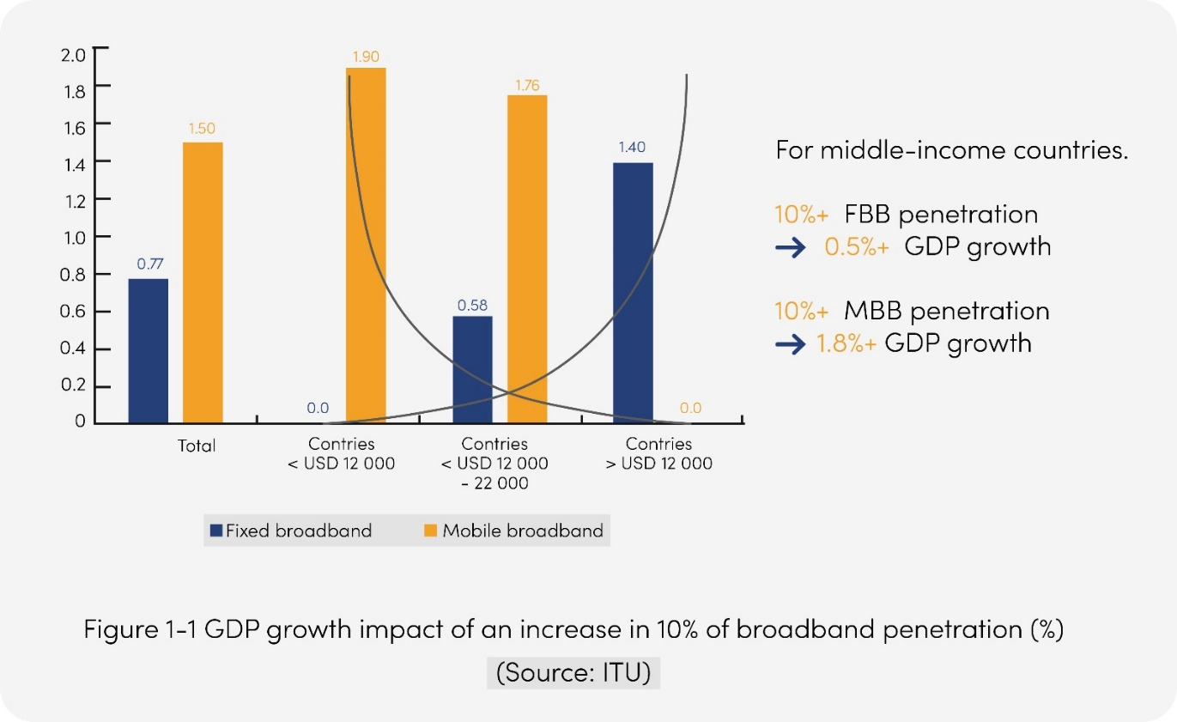ICT infrastructure and services are the foundation for countries to develop digital economy and to increase their overall economic well-being and competitiveness. Broadband infrastructure is now a vital infrastructure, as essential as water and electricity networks. ITU’s analysis of more than 200 studies on broadband impact notes that a 10% increase in broadband penetration yields an increase in GDP ranging between 0.25% and 1.5%. OECD estimates that a 10% increase in broadband penetration can raise labor productivity by 1.5%. An EIB study asserts that a doubling of broadband speeds can result in 0.3% GDP growth.

In recent years, all major economies have released their digital strategies. For example, European Gigabit Society of EU, Industry 4.0 Strategy of Germany, Digital Economy Development Strategy of China, New Deal of Korea, Smart Japan ICT Strategy of Japan. Many of Iran’s neighboring countries are committed to enhancing national competitiveness through digital transformation. For example, Saudi Arabia’s Vision 2030 aims at becoming one of the world’s top 20 digitally innovative nations; Egypt’s Vision 2030 aims at building a competitive, balanced, diversified and knowledge-based economy; UAE’s Digital UAE covers the efforts of the federal and local governments to make the UAE a smart country. The COVID-19 pandemic further highlighted the importance of the digital economy. More countries are accelerating their timelines of digitalization to fight economic downturn and secure sustainable development. To lead in the next round of international competition in the digital era, Iran needs to further commit itself to nurturing the ICT industry and promoting digital transformation.

# 1.2_ ICT is at the Core of Iran’s National Development Plan

## 1.2.1 Iran’s National Development Plans Hold ICT as a Main Topic

### 1.2.1.1 The Sixth Development Plan

On 19 March 2017, the “Law on the Sixth Five-Year Economic, Cultural, and Social Development Plan for 1396-1400 (2016–2021)” (the “Sixth Development Plan”) was approved by the Iranian Parliament. The general policies of the Sixth Development Plan (2016-2021) are based on the three pillars of development of a resilient economy, progress in science and technology, and promotion of cultural excellence and cover eight topics ranging from economy to ICT.

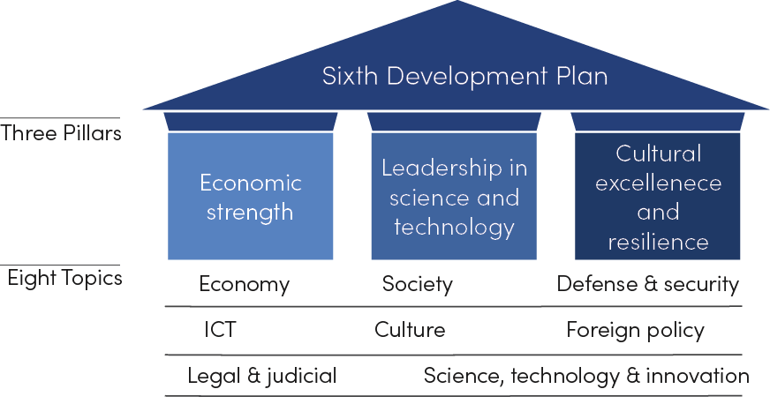

Figure 1-2 “3+8” Framework for Iran’s Sixth Development Plan

The Sixth Development Plan recognizes the strategic value of ICT development. ICT is not only one of the priorities of Iran’s national development and an integral part of its leadership in science and technology but also a key enabler of all the other pillars and topics.

### 1.2.1.2 The Seventh Development Plan

The general policies of the 7th development program have been also compiled and publicly declared on September 2022 by the Iranian supreme leader. One of its fundamental clauses is directed to the digital economy, cyberspace and its goals including digital sovereignty. Clause 19: “Establishing national sovereignty and protection of Iranian Islamic values in cyberspace by completing and developing the national information network and providing appropriate content and services and promoting cyber power at the level of global powers with an emphasis on the strengthening and security of the country’s vital infrastructure and big data.”

Emerging initiatives and the Special Working Group on the Digital Economy

The working group of the digital economy was established in December 2021 by the First Vice President with the aim of developing the digital economy and achieving a 10% share of the digital economy in the country’s economy.

The main goals of the working group include developing digital economy infrastructure, removing obstacles and accelerating the formation of the digital economy ecosystem in the country, supporting digital platforms and businesses and basic technology in the country, creating a platform for developing the basic technology in the country, removing barriers for the operation of Iranian platforms at the international level and the development of digital economy skills.

This working group consists of Iranian ministries and personas including;

1. Communications and Information Technology

2. Economic Affairs and Finance

3. Industry, Mine and Trade

4. Cooperatives, Labor and Social Welfare

5. Defense and Armed Forces Logistics

6. The scientific and technology vice president

7. Head of the Central Bank of the Islamic Republic of Iran.

So far, this working group has held three meetings. These meetings’ main focus has been emphasizing achieving a 10% share of the digital economy. In doing so, the combination of the working group and the limits of delegated powers were determined, the critical priorities of the working group, specialized committees, and approving the members were done, and committees are responsible for presenting reports and preliminary actions.

To be more specific, one of the most prominent achievements of the working group so far has been the withdrawal of the case of the Amitis system proposed by Iran’s Central Insurance Organization; “an integrated system/gateway which led to the creation of a monopoly in providing licenses and services, as well as complicated regulation in the field of insurance businesses (InsurTechs)”. The working group has become responsible for such interventions and making decisions in this field and so adopted a policy preventing the bottleneck and artificial forms of monopoly from being legitimated by the government.

## 1.2.2 Iran’s ICT/Digital Development Vision

The government of Iran has recognized ICT as a key driver to enhance economic competitiveness and promote social inclusion. In January 2017, the government of Iran laid down a series of reform targets for the telecoms sector under its Sixth Development Plan. For example, it wanted internet bandwidth increased to 30TB by March 2021, with school networks and e-government services to be digitized. The Ministry of Information and Communication Technology (MICT) is also being urged to attract further private sector collaboration and foreign investment to the telecoms industry.

The MICT sets a few goals in line with the Sixth Development Plan, including:

* First position in the region in terms of e-government development in national information network
* Local content enhancement according to cultural map of country
* Establishment and enhancement of national information network of country and enhancing the security
* Transform Iran to the center of postal and traffic communication and information of region
* Influential presence in international transactions in cyberspace
* Increase investment in infrastructure
* Spatial technology development

The ICT Minister Mr. Zarepour proposed the Intelligent Iran program, which covers 8 areas ranging from infrastructure to digital economy and governance:

* Digital governance and international interactions
* Smart government and digital transformation
* National information network and sustainable development of communication infrastructures
* Regulation of communication and information technology
* Digital economy
* Privacy and security of information exchange space
* Acceleration of space industry growth
* Post services

## 1.2.3 Digital Transformation Framework

The digital transformation framework integrates various applications, services, resources, and physical infrastructure. It provides a map for all stakeholders to embrace and develop the digital economy.

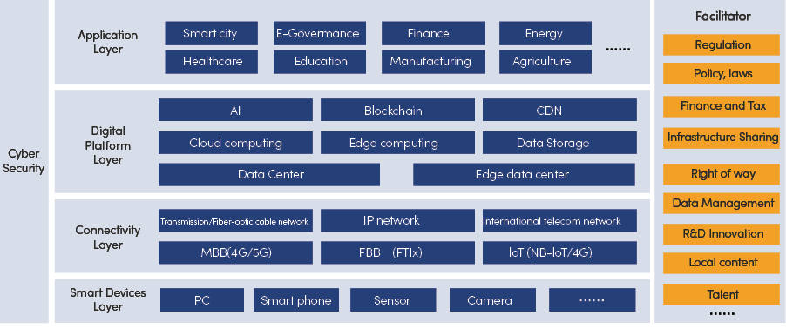

Figure 1-3 Iran’s digital transformation framework

* Smart devices layer : A better connected country has the potential to be a smarter nation and it is at the smart devices layer that many of the key connections take place. This layer is intertwined with smart terminals and the Internet of Things (IoT).
* Connectivity layer : The connectivity layer represents various networks provided by telecommunication operators, as well as other networks provided by city stakeholders or enterprise private communication networks. This layer is responsible for carrying all the data produced by the sensors as well the communications between each of the elements of the ICT infrastructure such as – the data centers, platforms, end user devices and applications. It has fixed and wireless components.
* Digital platform layer : The digital platform includes computing and storage infrastructure based on the data center and edge data center. The layer, integrates cloud computing, edge computing and intelligent computing, to provide high-efficiency computing power. New technologies, such as AI and block-chain, are evolving to form infrastructure in the form of platforms.
* Application layer : Leverage the capacity of ICTs to enable the vertical social and economic sectors.

# 1.3_ Iran’s Digital Economy Development

## 1.3.1 Measuring Digital Economy

According to UN’s definition for digital economy[1], different technologies and economic aspects of the digital economy can be broken down into three broad components:

* Core aspects of the digital economy, which comprise fundamental innovations (semiconductors, processors), core technologies (computers, telecommunication devices) and enabling infrastructures (Internet and telecoms networks).
* Digital and information technology (IT) sectors, which produce key products or services that rely on core digital technologies, including digital platforms, mobile applications, and payment services.
* A wider set of digitalizing sectors, which includes those where digital products and services are being increasingly used (e.g., for e-commerce). Even if change is incremental, many sectors of the economy are being digitalized in this way. Examples include finance, media, tourism, and transportation.

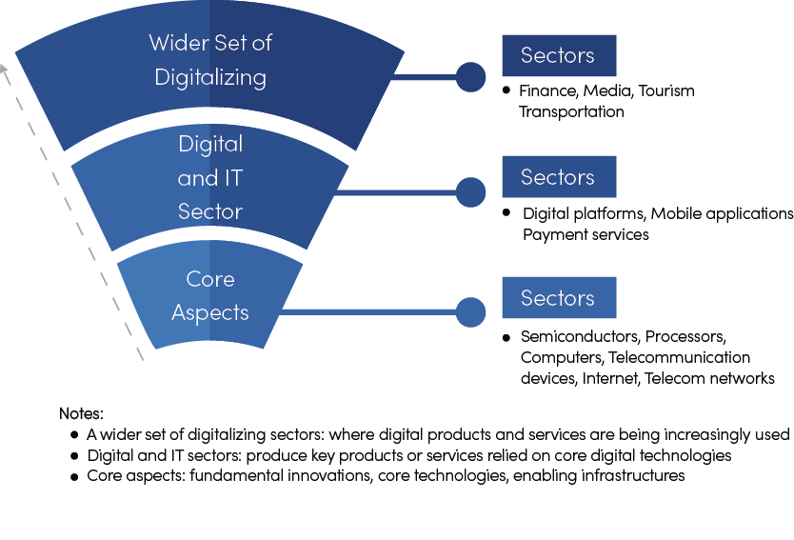

Figure 1-4 UN’s definition of digital economy

Currently, many organizations and countries have developed various methodologies to measure digital economy[2].However, there is still not a globally-accepted methodology that can be used for measuring or benchmarking the digital economy of all countries. According to UNCTAD, the share of the ICT sector (core of the digital economy) and the total share of the digital economy in the global economy in 2019 was estimated at 4.5% and 15.5%, respectively[3].CAICT also measured the value of digital economy of 47 countries in 2021[4]. The study shows that digital economy in broad sense accounts for 8%~68% of a country’s GDP, with an average of around 26.5%.

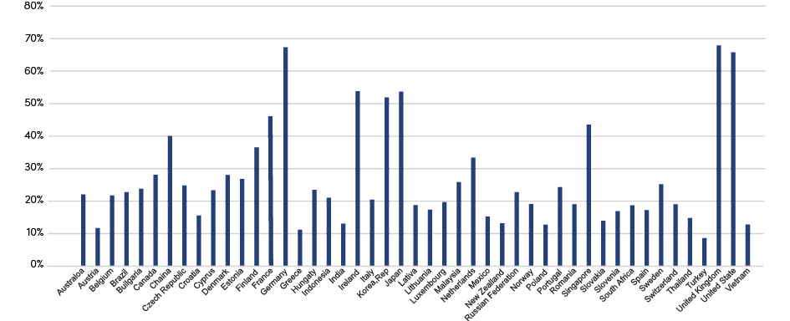

Figure 1-5 Digital economy as % of GDP in selected countries, 2021

(Source: CAICT)

## 1.3.2 Current Status of Iran’s Digital Economy Development

ICT is one of the fastest growing industries in Iran. Currently, ICT comprises a remarkable 10.3% share in the total number of employed throughout the country. This is while the figure stood at 0.8% at the beginning of the Fifth Five-Year Development Plan (March 2011-16). [5]In 2019, it is estimated that the share of Iran’s ICT sector in its total GDP was 4.2% and that of digital economy in broad sense was 6.5%. The share of the ICT sector is almost approaching maturity, but that of the total digital economy is still far below the world average. By comparison, in 2020, ICT sector accounted for 7.3% of China’s total GDP and digital economy’s share in GDP reached 38.6%.

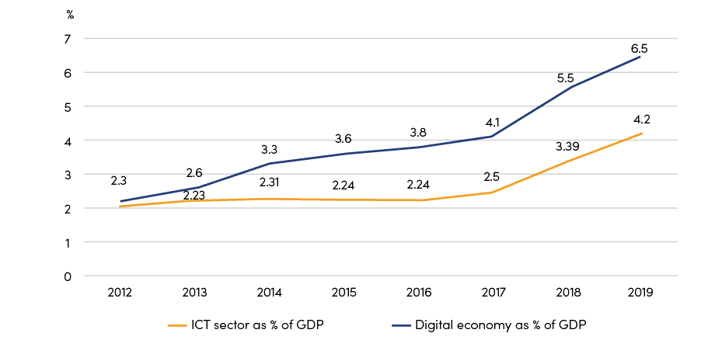

Figure 1-6 ICT sector and digital economy as % of GDP in Iran, 2012-2019

(Source: MICT)

To recap, the potential of ICT in promoting digital economy development is yet to be unleashed. Iran needs to further promote digital transformation in various social-economic sectors.

## 1.3.3 Potentials of Iran’s Digital Economy Development

Although Iran has not yet emerged as an ICT giant in the new digital era, it has great potential and capacity to become a major digital economy in the Middle East region and an ICT center in Persian-speaking countries. It has a dynamic and growing economy and ICT market, offering significant opportunities for telecoms growth. Its population is one of the largest in the Middle East, it has a youthful, tech-savvy demographic and there is an unmet demand for both fixed and mobile telecoms services. It is now dedicated to building the NIN with customized infrastructures to ensure the security and stability of global Internet traffic and has made great achievements in developing local/ regional ecosystems.

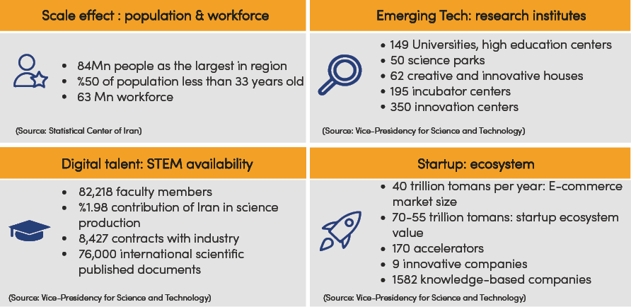

Figure 1-7 Iran’s strengths in developing into a major digital economy

Chapter 2: Current status of Iran in meeting the requirements of the digital economy development

# 2.1_ Overview

Iran is trying to keep pace with the world in the field of ICT. Today, 98.5% of villagers and 100% of Iranians [in cities] have access to the Internet [6]. By June 2022, Iran’s MBB and FBB penetration rates have reached 116% and 13% respectively. By November 2022, Iran has deployed 71315km of fiber network through Telecommunication Infrastructure Company of Iran; its international bandwidth has reached 5489Gbps[7].In terms of quality and price indices, Iran has one of the cheapest broadbands in the world. Currently, 76,000 schools are connected to NIN, and more than 95% of them are receiving service free of charge[8].With the development of infrastructure, the innovation and entrepreneurship movement has started in Iran. Over the years, the number of applications has grown to 345,000[9].

Iran ranks 79th out of the 134 economies included in the Network Readiness Index (NRI) 2021. The NRI released by the Portulans Institute is grounded in four fundamental dimensions of Technology, People, Governance, and Impact, each comprised of three sub-pillars. The NRI covers issues ranging from future technologies such as AI and IoT to the role of the digital economy in reaching Sustainable Development Goals (SDGs). Iran’s main strength relates to Governance. The greatest scope for improvement, meanwhile, concerns Impact. When it comes to sub-pillars, the strongest showings of Iran relate to Governments, Trust, and Inclusion, among others. More could be done, though, to improve the economy›s performance in the Quality of Life, Regulation, and Future Technologies sub-pillars.

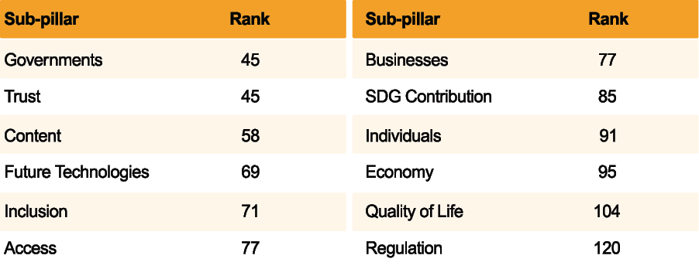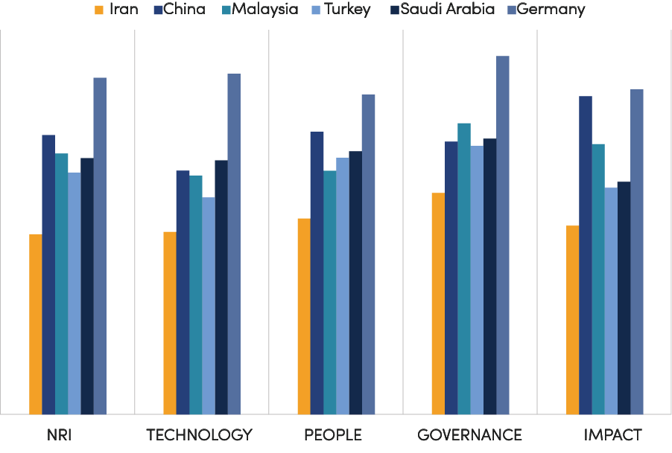

Figure 2-1 Iran’s performance in NetAwork Readiness Index 2021 and benchmarking

(Source: Portulans Institute)

The measurement results show that Iran still has a big room to enhance its ICT development, especially when it has fallen behind peer countries which are all dedicated to developing the ICT sector and realizing digital transformation.

# 2.2_ ICT Infrastructure Development

## 2.2.1 Mobile Broadband

By 2022Q2, Iran’s MBB subscription has reached over 84 million, with penetration of 116.4%. Among the MBB subscribers, 3G and 4G account for 48% and 29% respectively. As for MBB speed, Iran ranked 69 among 137 countries with a download speed of 28.4Mbps. Iran’s National Information Network (NIN) Master Plan and Architecture targeted coverage of 100% of the country’s population for mobile broadband access with an average speed of 10 megabits per second. From benchmarking, the targeted access speed of 10Mbps of MBB is not enough compared to other countries experience. Iran needs to set higher goals and targets.

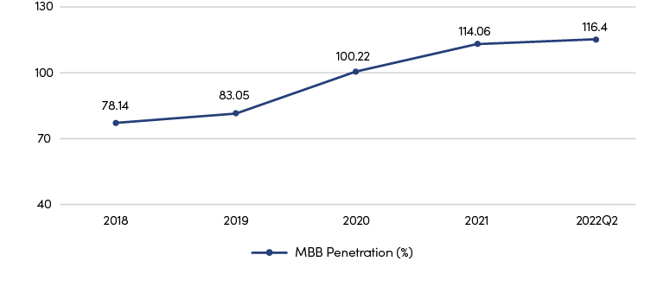

Figure 2-2 MBB penetration, by 2022Q2

(Source: CRA)

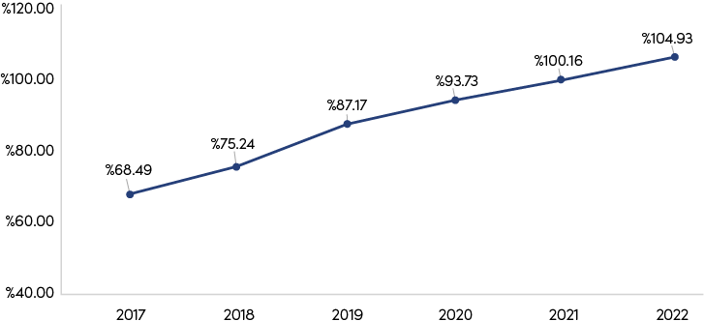

Figure 2-3 Market penetration; smartphone connections (%)

(Source: GSMA)

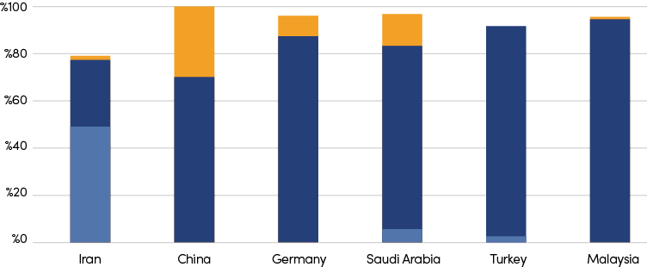

Figure 2-4 Benchmarking of MBB subscriber share by technology, 2022Q2

(Source: GSMA)

Note: No data is available for the 3G share of Germany and Malaysia. No data is available the for 5G share of Turkey

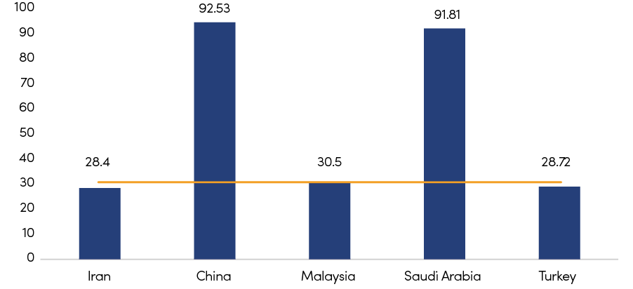

Figure 2-5 Benchmarking of MBB speed, 2022[10]

(Source: Speed test)

According to GSMA, 5G will contribute economic value of approximately $960 bln to various industries in 2030. Besides, 5G scale commercialization can improve operators’ finance. Compared to 4G, 5G drives DOU growth by 29% increase ARPU by 10%. 5G can also help to grow in FTTX growth rate by solving the last mile issue through FWA. Therefore, Iran needs to accelerate 5G deployment and it is highly recommended to start the auction of 3.5GHz which is the most selected band for 5G.

Despite the trade sanctions imposed by the US and the availability of spectrum in lower bands, Iranian government is proactively preparing regulations for 5G deployment and considering suitable bandwidth allocation. In February 2021, the MICT announced that it was planning to auction 3.5GHz spectrum to support commercial launch of 5G mobile services in the country. In the same month, MTN Irancell launched limited commercial 5G network in Tehran using existing spectrum. However, Iran’s 5G program has remained shrouded up till now, with no detailed action plan being made public.

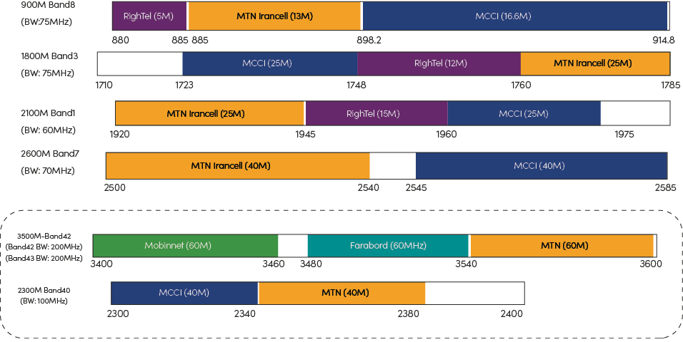

Figure 2-6 Spectrum Map of Iran

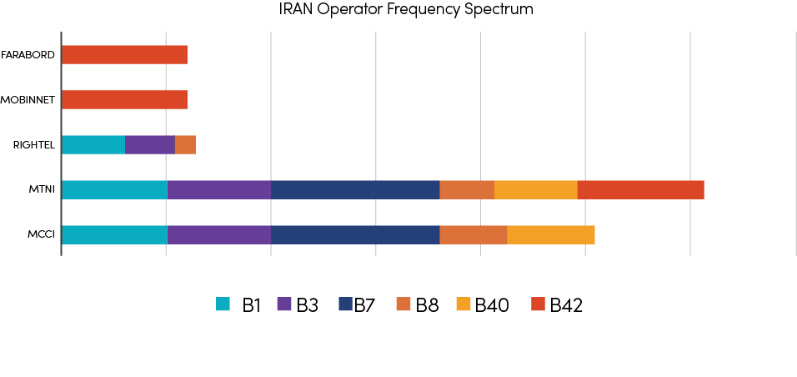

Figure 2-7 Frequency plan of Iran

|  |
| --- |
| Saudi Arabia: Concentrated effort made by both government and industry  Public sector  2018, government established the “National 5G Task Force” to speed up the availability of 5G;  2019, the MCIT launched Saudi Arabia’s ICT strategy2019-23 ; released an additional 400 MHz in mid-band (3.5 GHz) spectrum, taking the combined spectrum available for mobile services, including 5G, to around 1,000 MHz;  2020, CITC launched National Transformation Program (NTP) 2020 as part of Saudi Arabia’s Vision 2030 to make available more spectrum for the provision of mobile broadband or IMT services;  2021, CITC launched Spectrum Outlook for Commercial and Innovative Use 2021- 2023 to allocate or improve 23 GHz of spectrum to boost 5G speeds and coverage.  Private sector  Operators have been deploying 5G after successfully completing trials.  Zain has so far launched commercial 5G services in 38 cities, and recently launched 5G roaming service between KSA and Kuwait;  STC is deploying 5G home broadband services in a number of cities;  Mobily has signed a memorandum of understanding with Huawei for the development 5G in the Kingdom;  Huawei, Nokia, Cisco and Ericsson are all important players in providing the required radio access and core infrastructure for KSA’s 5G rollouts. |

## 2.2.2 Fixed Broadband

### 2.2.2.1 FBB service development

In Iran, FBB development has been quite slow in recent years. In Q2 2022, FBB subscription and penetration stood at 10.979 million and 12.96% respectively.

Regulator’s latest quarterly report, which has been published in September 2022, shows infrastructure development situation related to bandwidth and Internet quality and the indicators in this field have dropped compared to the previous quarterly report.

For example, according to this report, fixed broadband subscribers decreased from 11.33 million subscriptions in the first quarter of the year to 10.979 million subscriptions in the second quarter of the year, which shows a decrease of 0.49%.

On the other hand, the fixed broadband penetration rate also decreased from 13.03% in the first quarter of the year to 12.96% in the second quarter; That is, a 0.54% decrease in the field of fixed broadband penetration.

The share of home users from FBB subscribers in Q2 2022, is 89.87 and the enterprise segment share is 10.13%. The comparison of fixed internet usage also shows that in the second quarter of the year, the amount of data consumption in fixed internet has decreased compared to the first quarter.

While the fixed internet data consumption was 1,099,580,799 gigabits in the first quarter of the year, it reached 1,084,701,628 gigabits in the second quarter of the year; That is, a 1.35% reduction in consumption.

Based on the resolution of the Supreme Council of Cyberspace in 2021, by 2025, 80% of households and 100% of businesses should have access to fixed broadband with an average speed of 25 Mbps, and 20 million households and 5 million businesses should have access to fixed broadband Internet based on optical fiber. In May 2022, the Regulatory and Communications Commission reviewed and approved the “Governing Principles for Supporting the Development of Optical Fiber-Based Access Networks” as one of the priority projects of the Ministry of Communications and Information Technology.

The fiber optic development program is explained by the following motivations:

Increasing employment rate,

* Improving access quality,
* Establishing an infrastructure for the future,
* Reducing the digital divide,
* Increasing the share of the digital economy,
* Increasing access speed,
* Improving environmental conditions, and
* Traffic reduction in mobile communication network.

The main objective of the Iran’s Network Development Plan is to ensure access for all Iranian residences and businesses to a high-speed broadband service. The following requirements have been announced of Iran’s Network Development Program in terms of Key Performance Indicators (KPIs):

* 80% of households in each province must be covered
* At least 50% of users can use fiber optic access service (FTTP) and up to 50% of users can use high-speed access service through wired access with a minimum speed of 50 Mbps and authorized radio access with a minimum speed of 30 Mbps.
* For at least 10% of users, it is possible to use fiber optic access service with a minimum speed of one gigabit per second.
* A point of presence (PoP) is required in every city.

In terms of technology, DSL continues to account for the bulk of high-speed fixed accesses, while fixed wireless links are also widely used. However, the share of fiber subscribers is very low compared with benchmark countries. Fiber has the advantages of ultra-high bandwidth and ultimate experience. Besides, mobile infrastructure relying on fiber can be upgraded to higher-speed 5G applications at a faster pace if fiber infrastructure is in place. Therefore, it is important for Iran to further promote the construction of fiber.

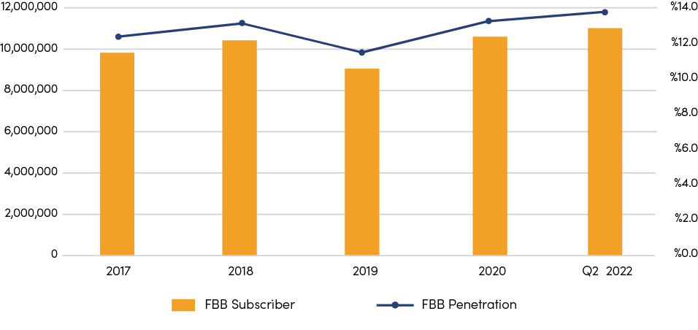

Figure 2-8 FBB subscription and penetration, 2022

(Source: CRA)

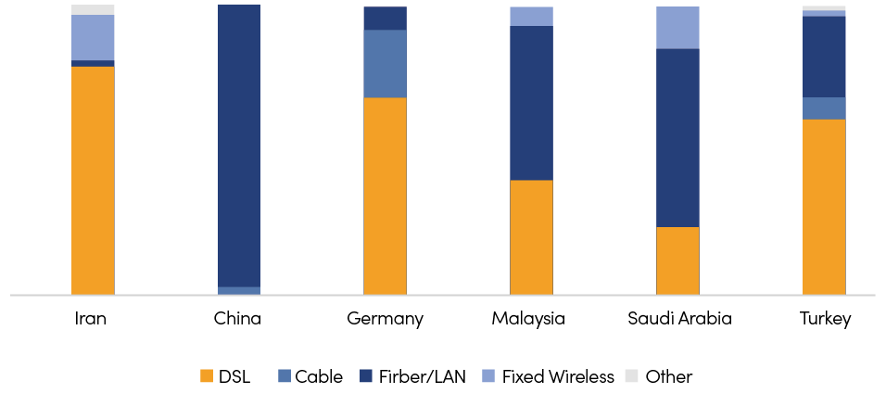

Figure 2-9 Benchmarking of FBB subscriber share by technology, Q2 2022

(Source: TeleGeography)

In terms of FBB speed, according to Speed test’s data in August 2022, the median download speed of Iran is about 10Mbps, which is far below the global average of 69Mbps.

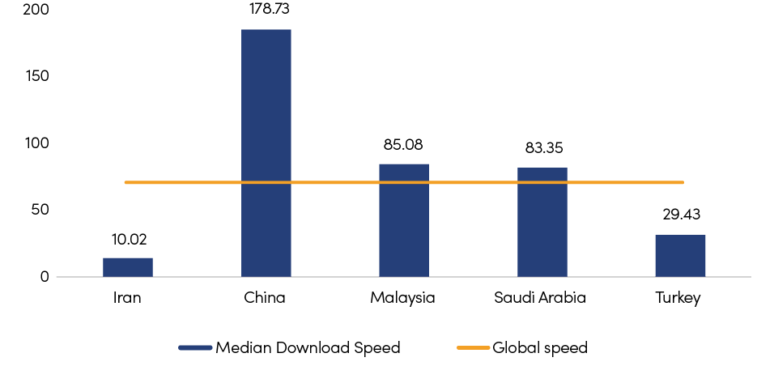

Figure 2-10 Benchmarking of FBB speed, 2022[11]

(Source: Speed test)

Currently, more than 60% of FBB users have access to less than 10Mbps, and only 45% of businesses in Iran enjoy internet speeds of 30Mbps and more. By comparison, by March 2022, 93.3% of FBB subscribers have a speed of 100Mbps and above in China.

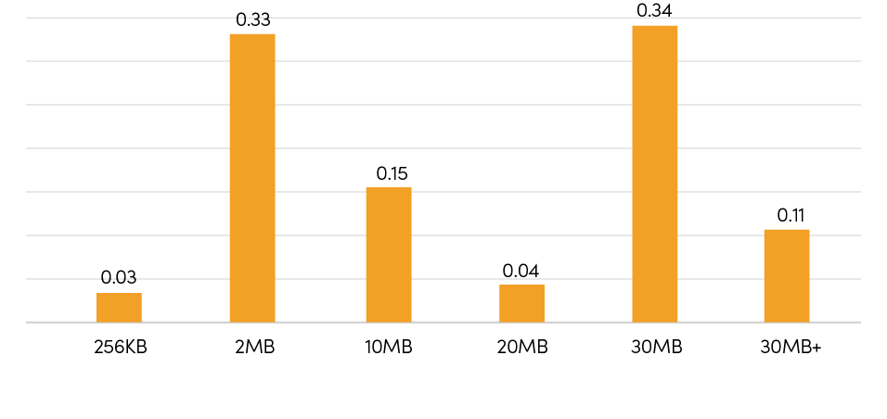

Figure 2-11 Internet speeds of businesses in Iran

(Source: CRA)

To recap, Iran still needs to invest more in developing FBB, in particular fiber-based FBB, in order to provide better broadband service speed and quality and meet the needs of both business and household costumers.

### 2.2.2.2 Fiber optic network development

With the rapid development of the fiber-optic access technology, the construction of fiber-optic network has been accelerated globally. For example, China has been vigorously promoting the transformation to “all fiber-optic network” since 2013. From March 2021 to March 2022, China built 1.11 million km of new fiber-optic cable, bringing the total length to 55.6 million km. In Philippines, PLDT is still expanding its fiber infrastructure during the COVID pandemic, with 61,000 km fiber-optic network built in the first 10 months of 2020[12].

Iran has built quite good fiber backbone network. In recent years, it has accelerated the pace of constructing fiber network. The fiber optic capacity of the national information network increased to more than 240,000 km across the country.

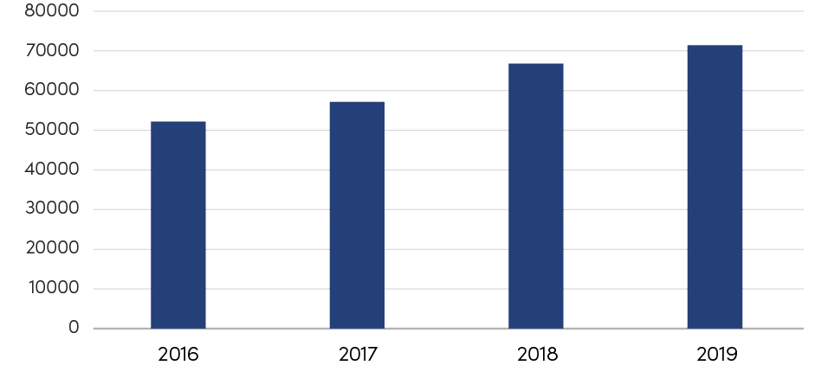

Figure 2-12 Development of Iran’s national fiber optic network (km), 2016-2019

(Source: Smart Iran report)

After the finalization of enactment 329 dated January 2022 by the regulator, the expansion of FTTX in Iran has been accelerated. In May 2022, by signing a memorandum of understanding, the regulator entrusted the development of high-speed internet based on optical fiber to 9 operators. The statistics of the Iran FTTX site, which shows the progress of the project of covering and connecting households to the Internet based on optical fiber, indicate that since the beginning of this project; That is, from February 2022 to the end of August 2022, there are more than 1,500,000 planned ports in this field, and more than 363,000 users use VDSL and fiber optic services in the country.

The statistic called “ports assignment” means the number of available ports. Based on a request from the end user, the service from the serving operator will be ready within a maximum period of one month.

The statistic is named “number of covered households or household pass” where the figure means the number of covered households in a distance of 300 meters.

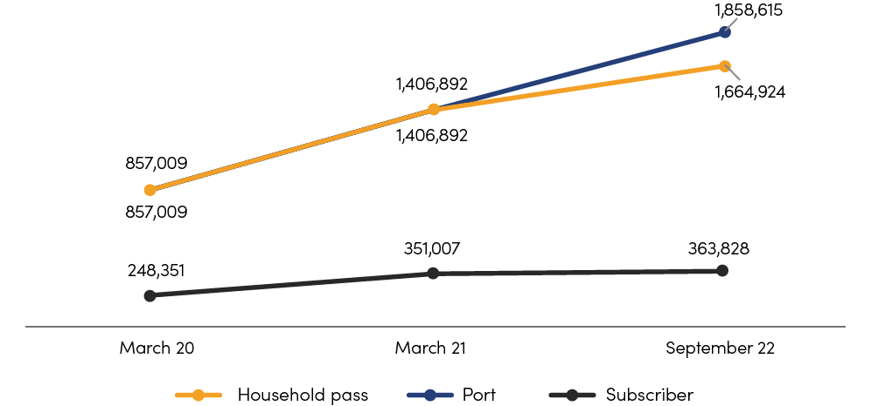

Figure 2-13 FTTX Deployment progress

## 2.2.3 International Connectivity

In terms of international connectivity, Iran is linked to the Trans Asia Europe (TAE) terrestrial network, which connects China with Germany. Iran is connected to its neighbors in the Persian Gulf via the Kuwait-Iran, UAE-Iran, FALCON and Gulf Bridge International submarine cable systems.

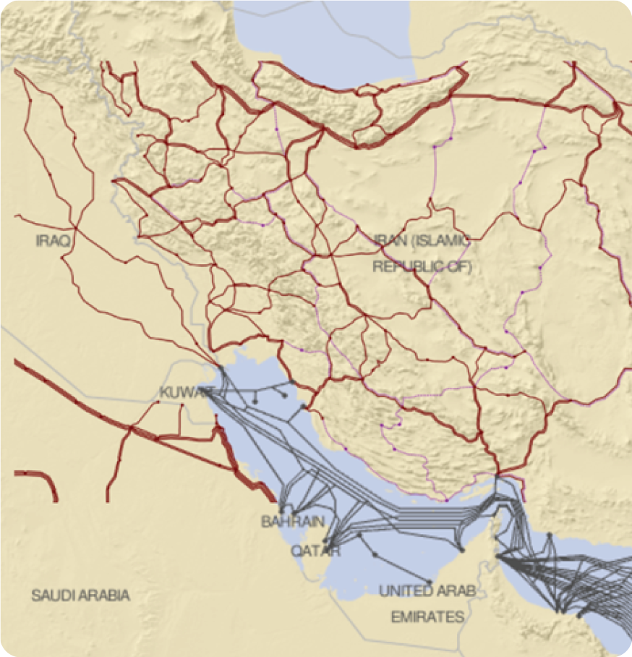

Figure 2-14 Iran’s submarine and terrestrial connections

(Source: ITU)

According to CRA, Iran’s capacity of international bandwidth has reached 5489 Gbps by June 2021. According to TeleGeography, in 2022, Iran’s international internet bandwidth accounted for 7% of that of Middle East. The CAGR between 2018-2022 is 33%. Traffic between Iran and Europe and between Iran and other Middle-Eastern countries account for the majority.

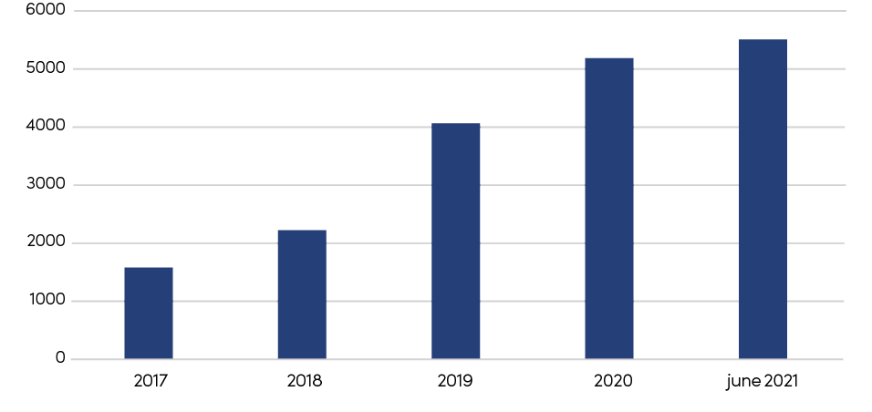

Figure 2-15 Iran’s capacity of international bandwidth (Gbps)

(Source: CRA)

## 2.2.4 Data Center & Cloud

New-generation information technologies, such as 5G, cloud computing, and artificial intelligence, are developing rapidly, the integration of information technology and traditional industries is accelerating, and the digital economy is booming. As the foundation of the digital economy and emerging technologies, the data center has become an essential infrastructure for economic and social development .

### 2.2.4.1 Trends of data center development

The scale continues to grow. Companies in various industries, including financial, internet, and media have adopted cloud services. As an important carrier of cloud and other emerging technologies, the scale of data centers continues to expand. The overall scale of global data centers has grown steadily. In 2019, the number of racks in data centers worldwide reached 7.5 million racks, with 63 million servers installed. It is expected that the number of rack and its average power will continue to grow steadily in the next few years.

Location and regional distribution. Data centers are mainly located in North America, Asia-Pacific and Western Europe. Specifically, North America as the source of Internet traffic and content provider, has the largest rack size, accounting for more than 40%. In the Asia-Pacific region, the broadband and Internet have developed rapidly in recent years, leading to the growth of new data center which global share exceeded 30%. It is expected that in the next few years, with the rapid improvement of informatization, the scale of data centers in the Middle East, South America, Africa and other places will grow rapidly.

Large-scale and centralized. In order to better control and manage energy consumption, the scale of racks in a single data center is increasing. For example, according to MIIT of China, the number of data centers in China is 74,000, of which the number of large and super large accounts for 12.7% but ratio of new-built large data centers is 36.1%. This trend could be seen from the number of global data centers and the number of racks. According to Gartner statistics and estimate, the number of data center decreased from 450,000 in 2015 to 422,000 in 2020, while the number of racks increased from 4,797,000 in 2015 to 4,985,000 in 2020.

### 2.2.4.2 Data center development in Iran and Middle East region

As a traditional oil and gas export region, major countries in the Middle East are undergoing diversified economic transformations, trying to eliminate their dependence on energy economies. The UAE, Saudi Arabia, Kuwait and other countries have formulated economic transformation plans. Digital economies as one of the important directions are incorporated into the national development strategy, which leads to the growth of demand for data centers. It is predicted that from 2019 to 2024, the compound annual growth rate of the Middle East data center market may be around 7%. Equinix, Global Data Center, Batelco, Gulf Data Hub, AWS and Khazna are the main market investors and suppliers of the Middle East data center. Turkey, the UAE, Saudi Arabia, and Bahrain are in a leading position in IDC development in the region. Iran has three data centers and plans to build three data centers in ICT free zone next five years, but the overall scale is relatively small. Shahid Haj Qasem Soleimani’s data center was built by Telecommunications Infrastructure Company (TCI), with a capacity of 178 racks. MCI launched a data center in East Azerbaijan Province with a capacity of 350 racks to promote the mobile network in the west and northwest of Iran. Irancell built a data center in Tehran, which could provide 407 racks. The number of data center racks in Iran is reaching 6500 by 2022.

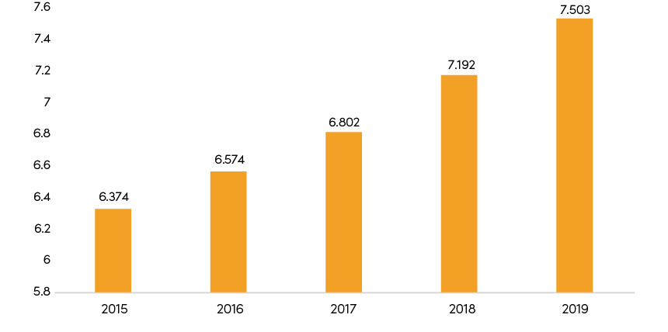

Figure 2-16 The number of data center rack worldwide (Millions)

(Source: CAICT)

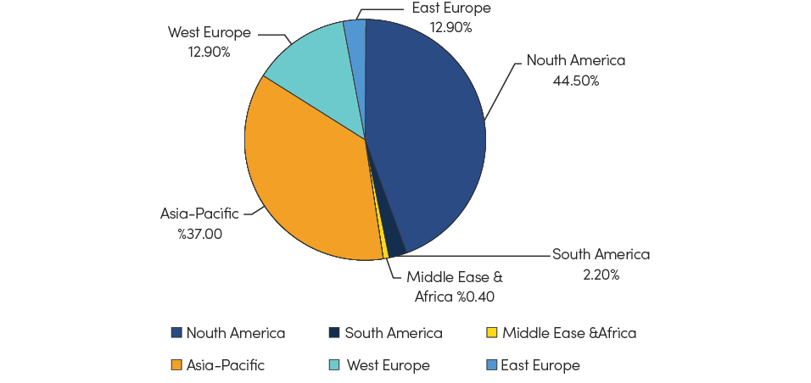

Figure 2-17 The global distribution of data center in 2019

(Source: CAICT)

# 2.3_ Digital Transformation

In the digital economy, products and services are affected by digitalization. Digitalization not only means the emergence of new digital goods and services, but also most of the traditional products and services that were provided non-digitally before, are gradually affected in this economy.

In Iran, moving towards digitalization and the development of the digital economy has been on the agenda of the government since the Third Development Plan. The share of the digital economy in Iran’s GDP is currently around 7%, which is far from its average value in the world economy. According to Minister Zarepour, the share of the “digital economy” in GDP is supposed to reach 10% by 2025, which, of course, is far from global estimates.

## 2.3.1 Digital Government

Iran has made considerable progress by expanding e-government services to enhance efficiency, accessibility, transparency, and accountability in the government sector. The government of Iran offers 201 general services and 734 specific services electronically from judiciary and agriculture to education, health, and culture. More than 450 million transactions have been done in 2018 in the context of e-government, which means a 450 million reduction in face-to-face visits to offices.

The United Nations E-Government Development Index (EGDI) assesses e-government development at the national level. It is a composite index based on the weighted average of three normalized indices of Telecommunications Infrastructure Index (TII), Human Capital Index (HCI) and Online Service Index (OSI). In the 2022 UN E-Government Survey Report[13] , Iran ranked 91st out of 193 countries and was among the “high EGDI” group. Among the three sub-indexes, Iran performs worst in terms of OSI[14]. The Government of Iran needs to further improve its use of ICTs in the delivery of public services.

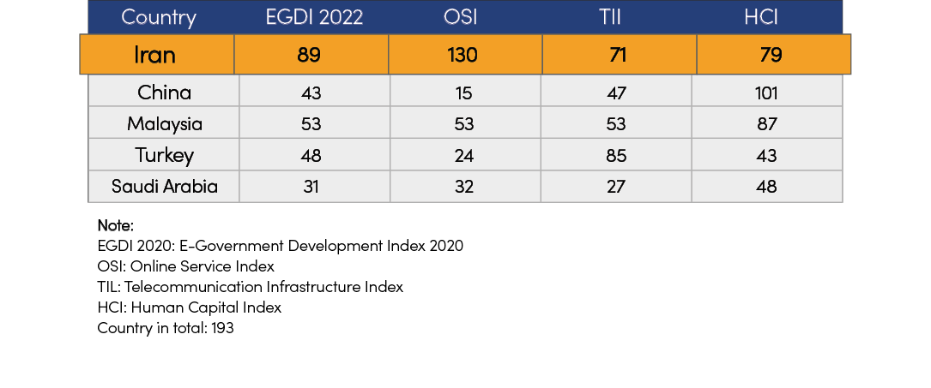

Figure 2-18 Iran’s performance in E-Government Development Index 2022 and benchmarking

(Source: UN)

The E-Participation Index (EPI) is derived as a supplementary index from the United Nations E-Government Survey. A country’s EPI reflects the e-participation mechanisms that are deployed by the government as compared to all other countries. The purpose of this measure is not to prescribe any specific practice, but rather to offer insight into how different countries are using online tools in promoting interaction between the government and its people, as well as among the people, for the benefit of all. As the EPI is a qualitative assessment based on the availability and relevance of participatory services available on government websites, the comparative ranking of countries is for illustrative purposes and only serves as an indicator of the broad trends in promoting citizen engagement. As with the EGDI, the EPI is not intended as an absolute measurement of e-participation, but rather, as an attempt to capture the e-participation performance of counties relative to one another at a point in time.

In 2022, Iran ranked 167 among 193 countries, but the corresponding rank in 2020 was 89, which means that Iran’s rank has fallen by 49 places in 2 years. The chart below shows the value and score of Iran according to EPI[15].

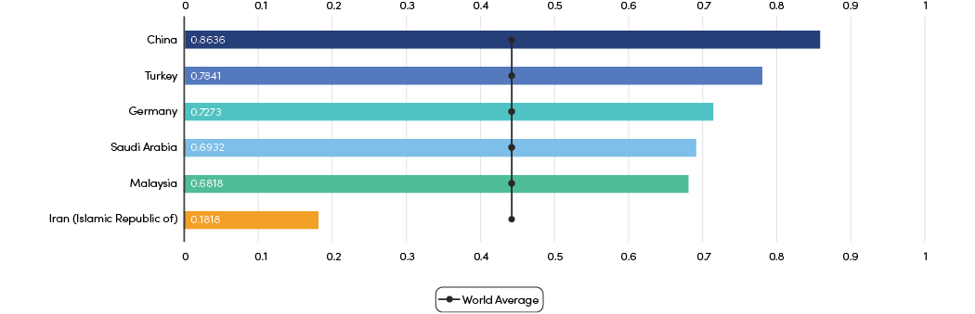

Figure 2-19 Iran’s performance in EPI Development Index 2022 and benchmarking

### 2.3.1.1 Digital government services

Digital governance is the application of ICTs for delivering government services, exchange of information, communication transactions, integration of various stand-alone systems and services between government-to-citizen (G2C), government-to-business (G2B), and government-to-government (G2G).

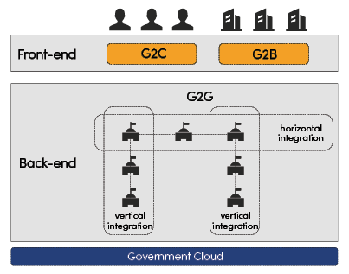

Globally, Governments have continued to increase the provision of digital government services in both 2C and 2B sectors. According to the UN survey, more than 84% of countries now offer at least one online transactional service, and the global average is 14. The most commonly offered services include registering a new business, applying for a business license, applying for a birth certificate, and paying for public utilities.

|  |
| --- |
| Smart Dubai Initiative  Dubai has launched Smart Dubai Initiative since 2014, which is transforming city-wide experiences to inspire new realities, with an aim of achieving a happier life for all. The Initiative consists of a portfolio of digital government services covering 2B and 2C sectors enabled by cutting-edge technologies and a holistic and mature ecosystem. |

With more and more services and departments incorporated in digital government platforms, Governments are under pressure to re-engineer the process for establishing a single point of access to complete services of different departments and at different levels. Business process re-engineering not only achieves cost savings and efficiency gains, but also provides citizens and businesses with better access to digital government services.

|  |
| --- |
| Process Re-engineering of Shanghai Citizen Cloud  With the aim of achieving higher efficiency, Shanghai government has engaged in process re-engineering plan of Citizen Cloud since the end of 2019. Citizens and businesses can receive one-stop-shop government services online through a single window. For instance, birth certificate, which used to take 6 departments 22 procedures and 100 work days for approval, now can be obtained only in 25 work days after the evolution. |

### 2.3.1.2 Data management

With the emerging trends in government data and the mounting risks and challenges, a paradigm shift is occurring that compels Governments to leverage data governance frameworks and data-centric e-government strategies to generate public value in innovative ways. According to 2020 UN E-Government Survey, the number of countries that have set up open government data (OGD) portals has increased markedly rising from 46 in 2014 (24%) to 153 in 2020 (80%).

The collection and use of timely, high-quality data, and a cohesive way of sharing and managing data will prevent siloed planning and decision-making and help governments realize the full benefits of data. The UN [16]summarizes some common approaches to publishing, sharing, linking and exchanging data across government agencies (both horizontally and vertically) and strengthening the interoperability of government data systems.

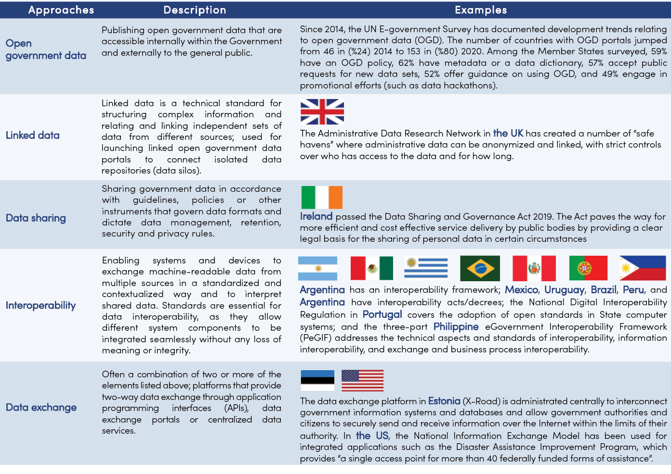

Figure 2-20 Different approaches to sharing, linking and exchanging data and strengthening interoperability

(Source: adapted from UN E-government Survey 2020)

Currently, with the exponential growth of data, Governments are increasingly transitioning from traditional relational database server to cloud server. G-Cloud is designed to meet the needs of data sharing among national, provincial, and local governments.

|  |
| --- |
| Malaysia – MyGDI Data Services Application  Introduce: MyGDI Data Services Application is a web based application which is developed for geospatial data sharing between government agencies. It is an initiative of MaCGDI under the MyGDI program to provide a platform for data sharing between Government to Government (G2G).  Data sharing in this application involves 12 categories of Geospatial Data Centre (GDC) basic data that is Aeronautical, Built Environment, Demarcation, Geology, Hydrography, Hypsography, Soil, Transportation, Utility, Vegetation, Special and General Use through internal secured map services which is secure (government cloud).  Objective:   1. Provide a geospatial data sharing platform between government agencies (G2G) in a secure environment. 2. Facilitate access to geospatial data by government agency users. 3. Encourage geospatial information sharing by data provider agencies. 4. Avoid duplication of effort in collecting, processing and preparing geospatial information between related agencies. |

|  |
| --- |
| China’s experience of G-cloud  **Build physically distributed and logically centralized G-cloud platform–Anhui Province, China**  Obstacles: Different government departments built their own cloud platform without unified standard and interoperability. The data, network, system and services of different government agencies did not integrate with each other. It was impossible for government agencies to realize cross-level (provincial-municipal), cross-agency, or cross-region data exchange.  Experience: The Government of China is now building Digital Government. The G-cloud covers national, provincial, municipal, and county level. In the Digital Government Plan of Anhui Province, a physically distributed and logically centralized G-cloud platform with “1+16+N” architecture is planned.  “1” – one logically centralized provincial G-cloud platform: provide data computing, storage, security and other cloud infrastructure, software and service to meet the demand of cross-level and cross-agency service integration, data sharing and exchange.  “16” – 16 physically distributed municipal G-cloud nodes: the G-cloud platform of each city is built and reformed in line with the national G-cloud standards, and integrated with the provincial G-cloud platform. The data center of each city is inter-connected with the provincial data center. |

## 2.3.2 E-commerce

According to UNCTAD estimation, global online retail sales share of total retail sales from 16% to 19% in 2020, compared to a 2% rise between 2018-2019.

Due to Covid-19, the world witnessed a spike in demand for online goods ordering: when overall retail sales declined by 1% in 2020, online retail grew by 22% Iran ranked 44 out of 152 countries around the world in terms of B2C E-commerce performance 2020, indicating a significant potential for e-commerce development.

A technology policy analyst and also former Deputy Minister of ICT, has notified a bad ICT policy in the field of E-commerce development in Iran; He has recently tweeted that “The total volume of e-commerce [transactions] in 1400 [SH] is 1,237 thousand billion Tomans; which 80 percent of it, that is, about 1000 thousands billion Tomans, will be in crisis due to the limitations of social networks. This policy means reducing economic security.” Moreover, the 2021-2022 report from Iran Center for E-Commerce Development confirms such a claim. It states that 80% of e-commerce units with e-namad license, use social networks in addition to website.

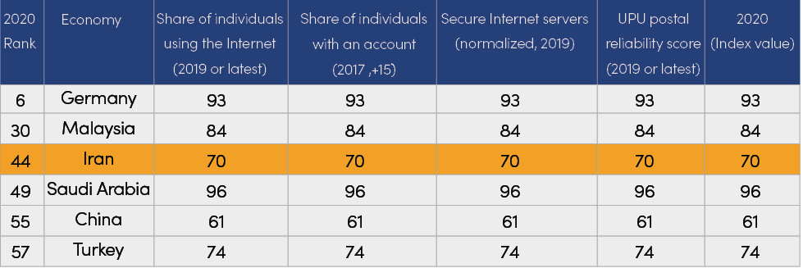

Table 2-1 B2C E-commerce index, 2020, world

(Source: UNCTAD)

E-commerce, as one of the main components of the digital economy, have a significant role in the economic development of countries. According to global statistics, the financial value of E-commerce in the world in 2021, compared to 2020, reached 4.92 trillion dollars with a growth of about 17%.

China, the United States and the United Kingdom were the largest e-commerce markets in the world. Iran, has also experienced a growing trend in the field of E-commerce in recent years. According to the UNCTAD report in 2019, Iran’s rank in the field of E-commerce among 152 countries was 42, which has improved by 7 places compared to previous years. However, Iran’s share of E-commerce income among neighboring countries including Turkey, Saudi Arabia, UAE, etc., is only 7%.

Meanwhile, Iran has significant potential for E-commerce development. By September 2020, the country has a smart phone penetration rate of 65%, an internet penetration rate of 102%, and more than 185,000 electronic signature certificates issued in public key infrastructure. What’s more, the nominal ratio of e-commerce transactions to GDP (without oil) has achieved 36%, increased by 205% compared to the previous year, and the number of new licenses issued for online businesses also tripled, which shows that many Iranians have changed their shopping methods to online shopping, and traditional and offline businesses have tried to sell online.

It is notable that the nominal value of E-commerce transactions was 1,237 thousand billion tomans, which has grown by 13% compared to the previous year.

* The amount of each electronic purchase is estimated at 343 thousand Tomans on average.
* The total number of e-commerce transactions was 3 billion 60 million items, which has grown by 14% compared to the previous year.
* The value of government electronic transactions was 302 thousand billion tomans, which has grown by 65% compared to the previous year.
* The number of government electronic transactions was 345,000, which has grown by 2% compared to the previous year.

Iran Center for E-Commerce Deployment under the Ministry of Industry, Mine and Trade depicted the E-Commerce landscape in Iran. By September 2020, most E-commerce units prefer to shop through social networks and ship through Post Company of Iran. As for payment methods, value of transactions via internet payment gate has reached almost 70% of total E-commerce turnover, increased by 230% compared to the end of 2019. Among the E-commerce units with e-namad license[17], most active fields are sales of goods, education, programming and computer, and advertising and marketing.

E-namad is issued exclusively by the Iran center for E-commerce development. This sign is granted to authorize online businesses (Internet and mobile business) for the purpose of organizing, authenticating, and qualifying. The total number of active e-namad at the end of 1400 [SH] has grown by 35% compared to the previous year by reaching more than 120 thousand.

### 2.3.2.1 Online shopping and the eccentrically prominent share of social media platforms

Currently, the largest social commerce in Iran has been formed on Instagram. 415 thousand stores operate on Instagram, and the volume of financial transactions on this platform is estimated at 18 to 32 thousand billion tomans in 2021. Approximately, 310 to 470 thousand buying and selling orders are made on Instagram every day, which has provided direct employment opportunities for one million people. The distribution of various businesses on Instagram has shown in figure 2-16 in more detail.

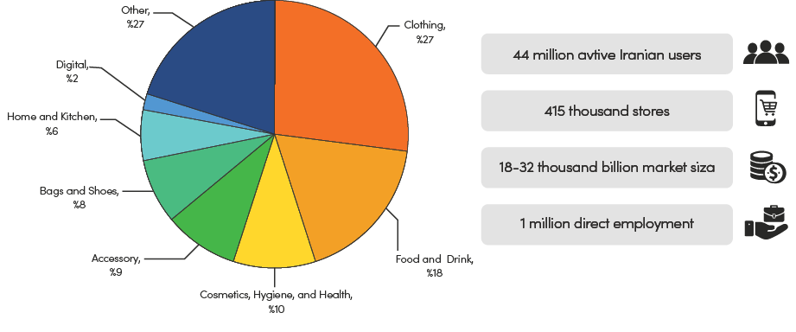

Figure 2-21 The distribution of businesses on Instagram in 2022

(Source: Techrasa Report)

More than 70 Iranian platforms are social business enablers. In addition to the social commerce industry, these platforms also serve the traditional E-commerce industry. For this reason, social media led by Instagram and the activity of 415,000 Instagram stores can be considered the main player in Iran’s social commerce industry. The penetration rate of 71% of social media and messengers among the people of Iran and the presence of 44 million active Iranian users on Instagram confirm this.

Since more than 60% of employment and 55% of GDP in the economy of developed countries are formed by small and medium-sized enterprises (SMEs) and home businesses, the promotion and development of social commerce platforms can flourish a fruitful while innovative grounds for the country’s sustainable economic growth, knowledge-based employment, and more inclusive and equitable business development.

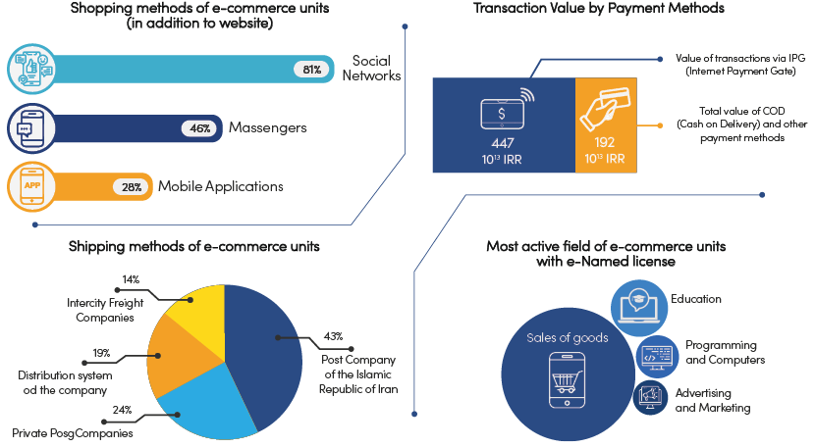

Figure 2-22 Current situation of E-commerce in Iran

(Source: Iran Center for E-Commerce Deployment)

However, because the retail market in Iran is mostly dominated by the informal sector (about 80% of the whole market), the official sectors, including Post Company of the Islamic Republic of Iran have not grown as much as they should have with the E-commerce sector. Besides, the share of e-commerce units with e-namad license only accounts for 23% of the total number, which exacerbates the difficulty of organizing, ranking and validation of E-Commerce websites activities, and protecting consumer rights in cyberspace.

## 2.3.3 Digital Oil & Gas

Oil and gas exploration generates a large amount of geological data dispersed in various processes and places. Many companies are developing a unified exploration platform to collect and store all data from oilfields and chemical plants. It could realize data sharing, technology exchange, and business collaboration by utilizing big data and AI to improve oil and gas exploration efficiency, reduce exploration and production costs, and increase the ratio between production and storage.

Oil storage and transportation digitalization realize centralized control and dispatch, real-time monitoring, and fault warning taking advantage of big data, IoT, HD video monitoring, and SCADA. Existing pipeline conducted digitalization by installing and reengineering the IoT meter, remote controller, and HD camera, while the new-built channel is designed and constructed by smart pipeline standards. Reduce on-site personnel at sites with harsh environments and improve labor efficiency by utilizing smart dives, such as drones, IoT sensors, and HD cameras.

Some oil companies built integrated operation and management systems such as capital, auditing, and financial data sharing to enhance corporate management and business coordination capabilities. Developed maps of the oil and natural gas industry, LNG international trade, etc., to achieve visualization of oil and gas production, supply, storage, and sale to support pricing.

Iran has the fourth-largest oil storage in the world and the second-largest natural gas storage in the world. The oil and gas industry accounts for 13.5% of GPD and is one of the pillar industries and significant foreign exchange sources. However, due to sanctions, digital transformation could be faster.

## 2.3.4 Digital Electricity

With the development of digital technology, the electricity industry has begun to digitalize in generation, transmission, and distribution The electricity grid companies also introduce digital technology in their management and services .

Digitalization of the power grid. The grid companies build fiber-optic cables alongside the electricity line, for example, OPGW, upgrade the traditional meters and instrumentations to IoT-based/online equipment, and build IoT management platforms to realize infrastructure digitalization. The status and change of the grid could be remotely monitored in time to ensure the electricity transmission safe and reliable. The use of digital technology enables the grid to adapt to the large-scale access and consumption of new energy sources, such as wind and solar energy, and reduces carbon emissions in the power industry.

Enterprise digitization. Electricity companies apply digital technology, such as IoT, cloud, big data, and artificial intelligence, to production, operation, and management to drive business process reengineering and organizational structure optimization. Based on the operational data and experience, the company enhances decision-making, collaboration capabilities, and management quantification using big data and AI technology.

Service digitization. The grid companies provide online interaction, automated services, and intelligent experience in customer service through in-depth integration of digital technology into the business and service. Through extensive connection and expansion of customer resources, seamless online and offline connections are realized, and application services with simple processes, rapid response, and flexible customization are created to improve service efficiency and customer experience. Support business innovation, improve user experience, and drive user demand potential to be continuously released and continuously met.

|  |
| --- |
| Mexico: NetCity  Mexico’s electricity company has been facing a high line loss rate, twice as high as the average of OECD member countries. On the one hand, it was due to the high technical line loss rate due to the backward electrical infrastructure; on the other hand, complex and slow fee collection caused profound management line loss. In 2017, the power grid company cooperated with NetCity.  It deployed an advanced metering infrastructure to cover Mexico City, including 88 eLTE-IoT base stations and an innovative metering platform. AMI could remotely read data on meters and allow real-time transaction charges based on bi-directional high-speed communication. It helps Grid Company to reduce line losses and fee collection times, improve the satisfaction of consumers, and increase revenue. |

The electricity system of Iran (production, transmission, and distribution) is centralized and owned by the government. The Ministry of Energy (MOE) is responsible for policy-making and managing electricity generation, transmission, and distribution. TAVANIR (Generation, Transmission, and Distribution of Electricity Company) and its regional subsidiary companies: the Regional Electricity Generating Companies and Regional Electricity Distributing Companies, are responsible for generation, transmission, and distribution.

Iran possesses rich and diversified sources and potential for developing renewable energy: solar, wind, geothermal, and biomass. However, the opportunities offered by renewable energy should be addressed due to abundant petroleum sources (oil and gas).

Electricity consumption continues to increase, and the power supply is insufficient in the summer, leading to a power crisis in past years.

Iran plans to invest 2 billion USD annually in modernizing the electricity network. However, it has not done so. Iran cooperated with Azerbaijan to synchronize Iran, Azerbaijan, and Russia`s electricity networks.

Concluding points

A digital economy is usually characterized by online transactions and engagement – a virtual, paperless and cashless world. It harnesses a range of technologies, services and business models that improve personalization through human-centered design while disrupts the traditional time-consuming ones and create new opportunities and markets. Major economies around the world value ICT and have released their national strategies for the digital economy. Over 170 countries worldwide have released their strategic plan for the national development of the Digital economy. After COVID-19, significant countries have updated their digital strategy to lead in the next round of economic cycles. In July 2020, South Korea released the New Deal, focusing on the digital and green fields, covering ten key areas and creating 1.9 million jobs. Korean government has invested 160Tn won ($133Bn) and is focusing on digital plus green, involving 5G, AI, new energy vehicles and other 10 fields. In 2021, the plan upgraded to New Deal 2.0, adding a “humanity” module, new industries such as Metaverse, etc., expanding investment to 220 Tn won ($183Bn), and create 2.5 Mn jobs.

In April 2021, the China Academy of Information and Communications Technology (CAICT) released the White Paper on China’s Digital Economy Development, which pointed out that China’s digital economy will reach RMB39.2 trillion by 2021, accounting for 38.6% of GDP. In Oct 2021, China adopted the Proposals for formulating the 14th Five-Year Plan and Vision 2035 Targets to initiate the preparation of its economic plan for the next five years. Seven industrial infrastructures as 5G, AI, big data centers, industrial Internet, intercity fast train, charging station, and UHV transmission are the key directions of this plan.

Given that the share of the digital economy in Iran’s GDP in 2012 was only 2.6%, which reached 7% in 2022, the 13th government has targeted 10% of the GDP in 2025.

As studied before, ICT infrastructure as the core layer of the digital economy has proved to make acceptable progress in recent years; however, in some areas, like the adoption of new communication technologies like 5G or high-quality fixed broadband access, Iran still needs to catch up to the other countries. Taken together, adjusting the regulation and supportive policies and initiatives are essential to developing the digital economy through the second and third layers. Therefore, in a forward-looking assessment, the Iranian Government has established strong foundations in addressing these issues to date and will continue to pay close attention to these technology trends, mainly focused on the infrastructure as the essential strategic resource ignored for at least a decade and digital platforms as the most productive potential of the national market in the achievement of the digital ambition.

In addition, adequate training, determining and amending rules, and paying attention to significant software infrastructure are also vital.

Chapter 3: Government’s role in establishing a digital ecosystem

# 3.1_ Towards Better ICT Regulation

Currently, ICT regulation is shifting from silo-style ICT sector regulation to collaborative regulation that is oriented at digital transformation and mirrors the interplay between digital infrastructure, services and content across industries. ITU introduced the concept of five generations of ICT regulation. G1 regulation aims to encourage the improvement of efficiency and service of state-owned monopoly telecom business. G2 regulation aims to achieve partial privatization and promote effective competition. G3 regulation aims to protect infrastructure investment, service quality and consumer rights. G4 regulation aims to stimulate cross-sectoral integration and competition, promote business innovation, guarantee network and information security, improve consumer welfare, and carry out integrated regulation in the digital ecosystem. These are also the common regulatory goals of most countries currently. G5 regulation, which has happened in a few countries, attaches more importance to cross-sectoral coordinated regulation to promote economic and social development and enhance national competitiveness and leadership.

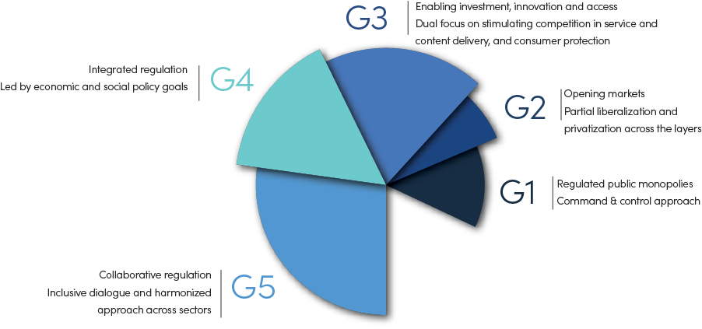

Figure 3-1 Generations of ICT regulation

(Source: ITU)

## 3.1.1 Global ICT regulation characteristics

Currently, global ICT regulation shows the following new characteristics:

Firstly, regulatory goals are upgraded to enhance the overall national competitiveness. ICT regulation in most countries aims to serve the overall economic and social development. One of the top priorities now is to accelerate the construction of next-generation ICT infrastructure such as 5G, so as to lead in the next round of industrial revolution.

second and third layers. Therefore, in a forward-looking assessment, the Iranian Government has established strong foundations in addressing these issues to date and will continue to pay close attention to these technology trends, mainly focused on the infrastructure as the essential strategic resource ignored for at least a decade and digital platforms as the most productive potential of the national market in the achievement of the digital ambition.

In addition, adequate training, determining and amending rules, and paying attention to significant software infrastructure are also vital.

|  |
| --- |
| Body of European Regulators for Electronic Communications (BEREC)  The 5G Radar includes 23 regulatory aspects/developments and is designed around several themes: new business models and value chains, numbering, privacy, roll-out, end-users, sustainability, state aid, roaming, quality of service, security, convergence and interoperability.  EU  The Digital Europe Programme – the first-ever EU programme solely dedicated to digital transformation. It has a proposed overall budget of €9.2 billion aimed at boosting investments (mainly in the five broad areas of supercomputing, artificial intelligence, cybersecurity, digital public services and advanced digital skills) and at ensuring the wide use of digital technologies across economy and society.  Singapore  The Infocomm Media Development Authority of Singapore (IMDA) has both regulatory functions of personal data protection (through its Personal Data Protection Commission) and data innovation. It launched the Data Collaborative Programme. The programme supports businesses to explore how to implement and manage mechanisms that allow for safe and economically sustainable data sharing with the Trusted Data Sharing Framework. The programme also offers Data Regulatory Sandbox to businesses and their data partners to explore and pilot innovative use of data in a safe “environment”, in consultation with IMDA and PDPC. The Sandbox reduces uncertainty in compliance to current and planned policies, and limits the exposure of companies and consumers.  EU  The European Electronic Communications Code Directive for the first time regards machine-to-machine (M2M) communication as a kind of electronic communications network and service, and includes M2M into its general authorization system. In terms of numbering, it suggests member states promote over-the-air provisioning of numbering resources to enable the reprogramming of communications equipment identifiers and facilitate switching of electronic providers without physical access to the devices concerned, with an aim to promote the M2M market and new technologies. |

|  |
| --- |
| South Korea: practice of Regulatory Sandbox  Concept and meaning of Regulatory Sandbox   * Testing Grounds for new business models that are not protected by current regulation, or supervised by regulatory institutions. * A Framework firstly set up by a regulator that allows FinTech startups and other innovators to conduct live experiments in a controlled environment under a regulator’s supervision * A mechanism for developing regulation that keeps up with the fast pace of innovation * The concept of Regulatory Sandbox can be widely applied to all sectors.   In 2018, South Korea introduced a string of regulatory innovation Acts. |

Secondly, regulatory scope continuously expands to incorporate new technologies and new business. The scope has expanded from network to applications, data, content, and new technologies such as IoT and AI. The focus of regulation has gradually shifted from economic aspects such as market access and price control to social aspects such as network security, content management, and personal privacy.

Thirdly, regulatory methods become more balanced flexible, inclusive and prudent to promote digital innovation. As the boundaries of the digital ecosystem keeps expanding, ICT regulators are facing unprecedented challenges. They need to constantly weigh whether to regulate or deregulate and how to promote innovation while protecting the motivation for long-term investment. More and more countries begin to adopt balanced and flexible methods such as principle-based regulation, evidence-based regulation and regulatory sandbox.

Fourthly, the regulatory mechanism is moving towards collaboration and coordination between multiple parties to cope with the trend of integrated digital development. With the advancement of digital economy and industrial integration and innovation, ICT regulators are faced with new challenges, such as a surge in regulatory objects and overlapping of regulatory responsibilities. It is necessary to establish a regulatory mechanism that features clearer delineation of responsibilities and closer cooperation between various regulatory bodies.

Nowadays, the government plays multiple roles in promoting ICT development. It can not only be a regulator, but also a motivator and a practitioner.

|  |
| --- |
| Four models of collaborative regulation  1. Establish a leading mechanism at the national level, responsible for the top-level design of digital economy and coordinating cross-departmental collaboration.  Case: South Korea established a strategic committee on ICT in 2018, with the Prime Minister as the chairman and the Minister of Science and ICT as the executive secretary. It is responsible for formulating laws and regulations to promote ICT integration and innovation and for coordinating the unclear regulatory responsibilities among various departments.  2. In areas with overlapping responsibilities, relevant departments divide responsibilities by signing inter-departmental MoUs.  Case: In the UK, Ofcom signed a MoU with the Information Commissioner’s Office (ICO) to regulate the protection of user privacy. The ICO is responsible for investigation and law enforcement, and Ofcom is responsible for monitoring the misuse of communications networks and services that lead to violation of user privacy.  3. For new technologies and businesses that have not fallen under the regulation of any authority, a multi-party professional research team is formed to study the development trends and possible regulatory challenges.  Case: In Japan, the Ministry of Internal Affairs and Communications (MIC) set up an AI governance committee in October 2016, with members from the academia, industry, and government agencies, to jointly formulate principles and guidelines for the application of AI and assess the impact and risks of the AI industry development.  4. Regulatory agencies enhance coordination and co-governance with industrial associations and non-profit organizations.  Case: In the UK, Ofcom has overall responsibility to make sure that consumers are protected by ensuring appropriate rules are in place and enforced. To achieve this, it has designated PhonepayPlus to carry out the day-to-day regulation of premium rate services. Ofcom can send representatives to the PhonepayPlus board of directors and approve PhonepayPlus’ Code of Practice. |

## 3.1.2 Regulatory technologies

“RegTech” can play a role in ICT actions. Today, digital platforms and innovative services and products challenge regulatory processes. Therefore, traditional regulatory interventions may no longer be efficient in the digital era. The term “RegTech” refers to the application of advanced and/or emerging technologies to solve specific issues and enhance monitoring and regulatory compliance of regulated entities and/or regulators in any sector. The goal of RegTech is to create a balance between restrictive laws and technological growth. In other words, RegTech is the application of innovative technologies to comply with regulations. RegTech is a paradigm that is born on both regulation and technology. Therefore, it can stimulate innovation as well as provide an agile and creative regulatory. Emerging technologies, including artificial intelligence (machine learning, computer vision, speech recognition, natural language processing, and robotics), automation, big data analytics, cloud processing (cloud), smart contracts, and blockchain, have the potential to provide new and advanced solutions for regulation and policy-making in the field of ICT. Innovative applications of these technologies will speed up processes and increase the efficiency of activities.

Using RegTech and moving toward tech-based approaches for policy-making and regulation can provide governments with a secure and intelligent regulatory and monitoring process. At the same time, it can maximize internal private companies’ role in increasing the digital economy’s share. Noting that this approach will result in self-regulation, it can significantly remove barriers and increase innovation and growth potentials.

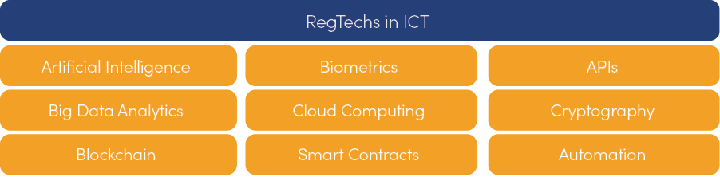

Figure 3-2 RegTechs in ICT

Potential benefits for regulators include:

* Creating systematic changes to redesign regulatory processes in the field of ICT.
* Providing the possibility of data-driven decision-making
* Possibility to increase innovation and creative ideas for regulatory processes
* Improving trust and cybersecurity in digital services
* Providing the opportunity for real-time monitoring and regulation
* Focus on proactive approaches instead of passive ones.

It should be noted that realizing this vision requires an increase in digital potential, sustainable investment of financial resources and political capital, re-engineering processes, and a paradigm shift.

# 3.2_ Supporting ICT Infrastructure Development

ICT infrastructure and services are the foundation for countries to develop digital economy and to increase their overall economic well-being and competitiveness. It is also a key driver of GDP growth. According to a study by ITU on 139 countries’ data between 2010 and 2017, for middle-income countries, every 10% increase in FBB penetration leads to 0.5% increase in GDP growth, and every 10% increase in MBB penetration leads to 1.8% increase in GDP growth. ICT infrastructure has great strategic values and needs the top-level planning and continuous efforts of the government to support its development.

## 3.2.1 Tax Incentives

### 3.2.1.1 Overview of tax for telecom sector

In general terms, most research literature has found that taxation regimes play an important role in driving capital flows, when controlling for economic development, unemployment and currency fluctuations. Taxes affect both the incentives of a company to make investments and reduce the supply of funds available to finance them. When there are large differences in tax rates for different businesses (e.g. wireless, broadband, or other) or in geographic location (e.g. a specific country), telecom companies are most likely to choose businesses and countries with low tax rates to invest.

In addition, taxes also influence a continuous choice: once a business and locations are agreed upon based on taxation attractiveness, levies affect their capital expenditure allocation process. In other words, taxes will influence how much investment will favor certain locations to the detriment of others.

The tax burden on telecommunication companies, especially mobile network operators, is often much higher, especially in developing countries. Sector-specific taxes include excise taxes, higher-than-normal value-added tax (VAT), license fees, spectrum fees, and universal service obligations. In a study of taxes in the mobile sector in 2017, the GSMA found that mobile taxes on consumers and industry accounted for 22 per cent of market revenue and almost a third of these payments are in sector-specific taxes (GSMA 2019, 5).

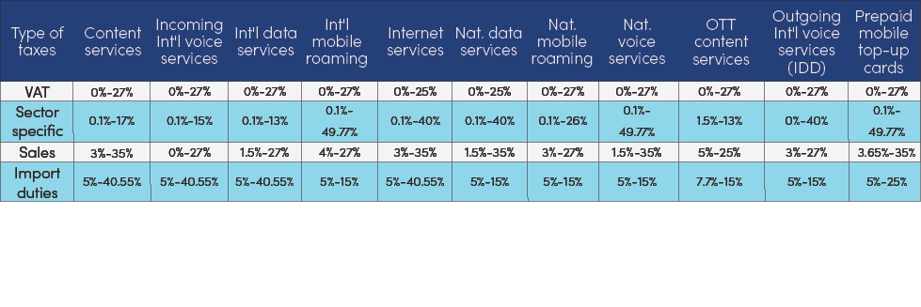

Table 3-1 Types of taxes applied to the ICT sector, world percentage, 2019

(Source: ITU. Note: Int’l refers to International and nat. to national)

### 3.2.1.2 Tax reduction could promote the development of ICT infrastructure

Taxation on telecommunication operators can have an important impact on investment. A decrease in taxation affecting equipment purchases increases investment, generating in turn positive effects in terms of GDP growth. According to ITU report, A 50% reduction in profit tax affecting the business sector is associated with an increase of fixed and mobile investment of nearly 14%.

A 50% reduction in administrative time required for doing business is linked to an increase in ICT investment of 17%. This suggests the relevance of government and institutional efficiency, in terms of reducing the required time for permits and other red-tape costs constraining network construction. The bureaucratic burdens related to institutional deficiencies can increase adjustment costs to investors, and as a result, to discourage investment decisions.

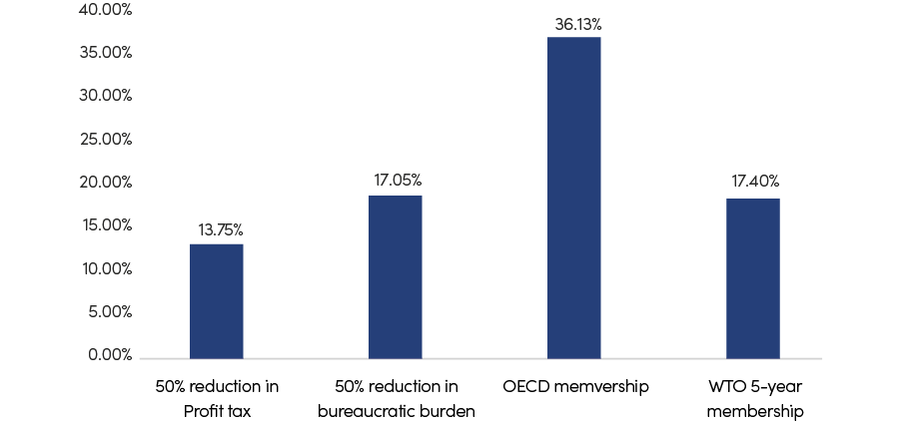

Figure 3-3 Simulations of variables impact on telecommunication capital investment

(Source: ITU)

Taxation has also been found to have an impact on service adoption and on innovation that high taxation will rise the affordability barrier and reduce adoption of telecom service. A reduction of taxes on telecommunication services and devices may have a positive impact on service adoption as a result of demand elasticities. For instance, in 2017 Colombia opted to remove value-added tax (VAT) on low-cost handsets and laptops and to exempt low-cost plans and lower-income consumers from VAT increases. As a result of these targeted policies, mobile phone sales increased in 2017, even for devices that exceeded the VAT exemption for low-cost devices. Some device manufacturers repriced their devices to move from just-above the VAT threshold to just-below, thereby providing Colombians with a wider range of devices at more affordable prices

|  |
| --- |
| China: lower tax rate for telecom sector  The tax on telecom sector in China are similar with other countries, mainly including general taxes (e.g VAT, corporate income tax) and sector-specific taxes.  Value-added tax. The general rate of VAT in China is 17%, the telecom companies enjoy subsidies. The basic telecom service (including voice communication, lease or sale of network resources) is at a rate of 11%, while the value-added telecom services (including Internet access services, short and multimedia messaging services, transmission and application service of electronic data and information) are at a rate of 6%, and sales of telecommunications terminals and equipment are a rate of 17% which could be reduced to13% in some certain period of time.  Corporate income tax. The corporate statutory income tax rate is 25% while the effective income tax was slightly lower, for example the effective income tax for Unicom and Telecom were 21.5% and 23% in 2020, respectively.  Spectrum usage fee. Telecom companies are required to pay radio frequency occupancy fees. The standards are 17 million/year below 960MHz, 15 million/year for 960MHz-2300MHz, and 12 million/year for 2300MHz-2690MHz. In the initial stage of 5G construction, telecom companies enjoy incentives and exemption, the radio frequency occupancy fee will be exempt from 1st to 3rd year, while the radio frequency occupancy fee is charged at 25%, 50%, and 75% of the national charging standard from 4th to 6th year.  Based on China Unicom`s annual financial report and spectrum occupied; it was estimated that all type of taxes was account for less than 20% of its annual revenue. |

### 3.2.1.3 Tax policy for telecom sector in Iran

Mobile operators in Iran are required to allocate 28.1% of revenue to government for the license fee at present[18]. In addition, the telecom companies are also required to donate 3% of revenue for universal service mandatory, numbering costs. While, fixed operators enjoy the low obligation, 5% of data income and 13% of voice income.

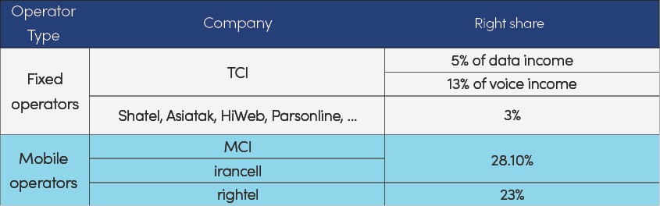

Table 3-2 The right share of Iran government in telecom operators

(Source: Iran)

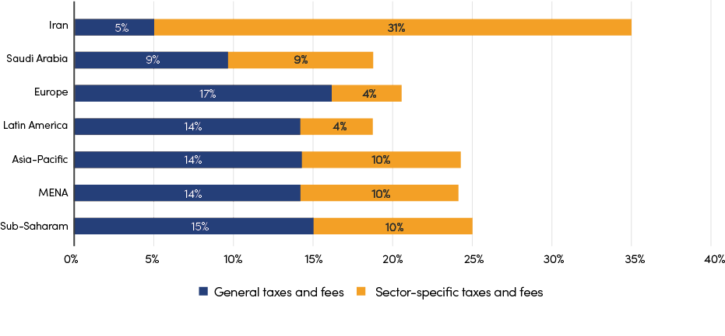

Figure 3-4 Simulations of variables impact on telecommunication capital investment

(Source: based on GSMA reports, rethinking mobile taxation to improve connectivity, MENA taxation study, Iran market insight)

Generally, sector regulators try to keep a balance between increasing revenue and negative impact of higher fees and taxes on the economy as a whole and on the process of digital transformation. Compared with average level of tax rate for telecom sector in globe, the telecom companies of Iran are bearing higher tax burden which weaken the competitiveness and limit the sound development of telecom sector in Iran.

Therefore, it is suggested that the obligation of telecom sector should be reduced to the average level of major regions in the globe, that is, between 25% and 30%, to promote the ICT infrastructure investment and development in Iran.

## 3.2.2 Tariff Adjustment

Tariff freezing in the FBB and MBB markets during the last five years in Iran has led to nothing but an obsolete, outdated, and old infrastructure, which now faces congestion even with the end of Covid-19. Turning into a daily routine, this congestion is also exacerbated by the massive imbalance between the 12% and 140% penetration rates of fixed and mobile internet, respectively. Price freezing, again, has been the main culprit for sending the wrong signal of a cheap mobile internet to society at the expense of a fully developed fixed network like many regions of the world.

This has been the case not only in the retail market but also in the wholesale broadband market. Telecommunication Infrastructure Company of Iran (TICI) suffers from inefficient allocation and management of resources and price controls in such a way that the bottom line is negative. Telecommunication Company of Iran (TCI), responsible for providing fixed-line services in residential and business sectors, bears the same burden.

Concerning the competition issue, price control, besides endangering the financial vitality of internet operators, specifically the fixed ones, has been working as a weapon to block access to wholesale and retail broadband markets. To reap the real benefits of an uncompetitive market, the duopoly in the mobile broadband market has been using price freezes to justify predatory pricing. So powerful has been this duopoly that the policy of introducing Mobile Virtual Network Operators (MVNO) around six years ago bears no resemblance to its promised goal of a competitive market. Mobile operators are also disrupting the competition in other layers, such as content and platform, through Mergers and Acquisitions (M&A).

TICI and TCI, in their wholesale markets, are enjoying a lack of competition yet by means other than pricing, which is political support from governmental stakeholders. Assigning TICI as the sole distributor of international bandwidth in Iran depicts an example here. Therefore, despite these companies’ financial risks, they can remain significant market powers (SMPs) and hinder market entry. No surprise that Public-Private partnership (PPP) fails to exist in such a context.

Another layer of the analysis is denying access to the incumbent’s infrastructure (TCI) for fixed internet service providers (FCPs). Once fixed broadband companies want to fight the high churn rate, they are forced to deal with it. If they wish to increase their customer base, access to this unduplicatable public good, internet exchange infrastructure, on a market-based contract with the incumbent would be inevitable. Due to the partial privatization of TCI in 2008, there has yet to be room for fixed ISPs to access and utilize ducts and cables; a few bit stream contracts have been signed, but still not enough for these deals to come to fruition. So, substantial uncertainties about these efforts’ impact on internet quality development still need to be clarified as its sustainable improvement.

With these obstacles and challenges in the Telecommunication markets in Iran, especially those of broadband deficiency, a series of policy recommendations could be appropriate, including:

* Regulation of wholesale and retail markets concerning tariffs and competition.
* Cost-centered design of tariff regimes; once such a regime is defined, both wholesale and retail markets can be regulated with incentive-based regulatory mechanisms such as a price ceiling reflecting the inflation rate and covering X-inefficiency.
* Pursuing an infrastructure-based competition strategy in the long run by providing access to the incumbent’s infrastructure for fixed ISPs after regulating tariffs.
* Monitoring anti-competitive behavior constantly to make sure that markets mature toward competition.

### 3.2.2.1 The development of telecom tariff regulation

Traditional price regulation focuses on SMPs. Before market liberalization, governments set all prices for telecommunications services as part of the annual budget. The range of services was limited, prices varied little from year-to-year and were generally high because telecommunication was a revenue source. After liberalization governments sought to expand the sector through competition and to collect revenue from the sector primarily through “Licensing and authorization” and “Taxation”. Price controls were then focused at the wholesale level, while retail price regulation was relaxed – just how much depended on the extent of competition, but generally the focus was on SMP providers.

Digitalization and Internet bring challenges to telecom tariff regulation. In the past decade, with digital transformation and the development of the Internet, content providers have relied on innovative services, which seem to attract a large number of users without any cost (or very little) from customers, and rely on data to create value, such as Internet advertising. However, digital platforms are operating outside of the traditional regulated space of telecom sector, and in some cases, undermine telecommunications network providers, for example, OTT service providers have greatly impacted the traditional revenues of telecommunications network providers, especially in voice and SMS. With increasing direct and indirect competition from unregulated digital platforms, retail tariffs of all telecommunication providers, even those with SMP, are severely constrained. Although network providers and internet content providers are in a symbiotic relationship which each feeds off the other and requires the other to help it generate revenues and profits, network providers take more responsibility in terms of the cost of construction and maintaining a universal and inclusive network due to the asymmetry of supervision. Regulators should explore partnership models in which digital platforms share the cost of national ICT infrastructure.

Tariff regulation more concerns quality and affordability. With the digital economy development, the role of price regulation is changing. It is now more concerned with ensuring fair competition amongst facilities-based service providers rather than protecting end users directly. The regulatory risk is not in overcharging, but in predatory pricing that leads to underfunding of network development. In order to meet the challenge of OTT service providers, telecommunication network operators are increasingly using zero-rating, and bundled tariffs (e.g. for “quad-play” combining broadband Internet access, television, fixed-line telephone, and wireless service) and making greater use of price-promotions to circumvent legacy regulatory price controls. The traditional telecommunications service tariff supervision process, especially analysis and evaluation take a long time, and it is necessary to further simplify and use ex-post regulation for development of digital economy. A specific focus of regulator should be on entry-level products (especially for Internet access) to ensure affordability, acceptable QoS, and sufficient capacity.

|  |
| --- |
| China: China’s telecom tariff reform towards marketization  The development of telecom tariff regulation origins from three concerns antitrust regulations, fostering/protecting active competition in the market, and increasing speed and fee reduction.  Monopoly operating stage. In the initial phase of the telecom sector, China adopted a government-enterprise integration way to provide telecom services whose price was set by the Ministry of Posts and Telecommunications. The local services were at a low rate, while international and long-distance calls were subject to higher tariffs of the low telephone penetration and income of Chinese households. Then, the telecom tariff was set high and included additional fees, such as initial installation and network access fees, to raise the necessary investment to construct telecom infrastructure.  Market competition stage. Market competition was introduced to the telecom sector of China with China Unicom, and Netcom was set up. Accordingly, serval state-owned telecom operators were established, split, and merged during this period Seeking better levels of effective competition, such as Netcom, Satcom, and Railcom. Consequently, the mechanism of telecom service price-setting was gradually developed to be fully market-adjusted from the price set by the government. Capitals from overseas, state-owned and private, were attracted into the telecom sector to boost the infrastructure and telecommunications service development. The role of regulation majored in creating a fair competition development environment during this period.  Network speed increase and fee reduction stage. With the development of telecom infrastructure in China, especially “Broadband China” and the completion of the world’s largest 4G network, ICT infrastructure has been positioned as a “strategic public facility” by the State Council of China, which plays a fundamental role in economic restructuring. State Council encouraged telecom operators to tap the potential for network speed increases and fee reductions. The per-bit cost has been reduced while fixed broadband’s data consumption and bandwidth have increased since 2015. The “network speed increase and fee reduction” does not hurt the sector’s profitability. The revenues of China Mobile, Telecom, and Unicom have maintained growth in the past five years.  They started reselling mobile services, issuing mobile virtual network operator (MVNO) licenses, and opening the fixed broadband access network. Released policies mandated that the wholesale price should be lower than the average price of similar services of SMPs. In adapting to the developing/emerging telecommunications market, the wholesale price should be adjusted at least once a year, and encouraged to modify the wholesale price timely according to market conditions and commercial contracts. |

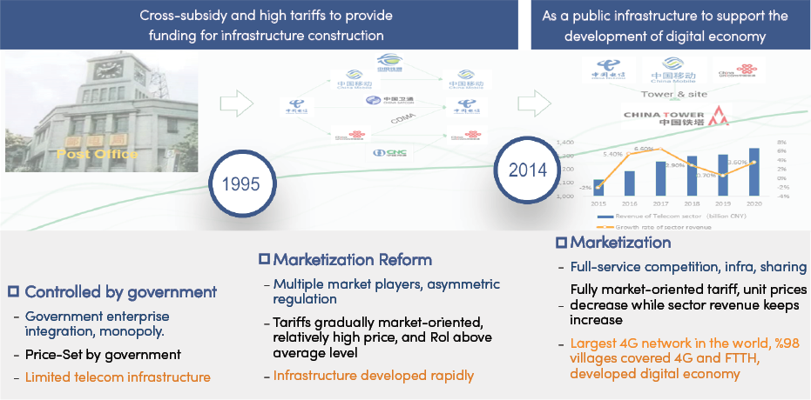

Figure 3-5 Telecom tariff reform process in China

(source:CAICT)

|  |
| --- |
| Telecom Tariffs adjustment  Turkey: Tariff cap adjustment follows the CPI change in Turkey  In August 2016, BTK ( Information and Communication Technologies Authority of Turkey) suspended minimum price regulation for retail mobile voice and messaging services which had been imposed solely on Turkcell since 2009, but on 1 January 2019 the regulator reintroduced retail price caps via amendments to the GSM licensing conditions of Turkcell and Vodafone, applicable to domestic/international calling and SMS services, while implementing new price caps on fees for other services including account activation/deactivation/user detail changing and SIM changing. The licensing terms include a formula for adjusting maximum tariff ceilings on a six-monthly basis: the Consumer Price Index (CPI) minus 3% of the CPI (using Turkish CPI for domestic tariffs and the US Consumer Price All Item Index for international tariffs) . A UAB policy decision had been expected to impose similar obligations on TT Mobil, but BTK announced on 17 November 2020 that the latter remained exempt from maximum retail tariff regulation following a court ‘stay’ ruling. On 31 March 2021 BTK set maximum retail ceilings for Turkcell and Vodafone at TRY0.806 per minute for national voice and TRY0.58 for national SMS, effective 1 April 2021. |

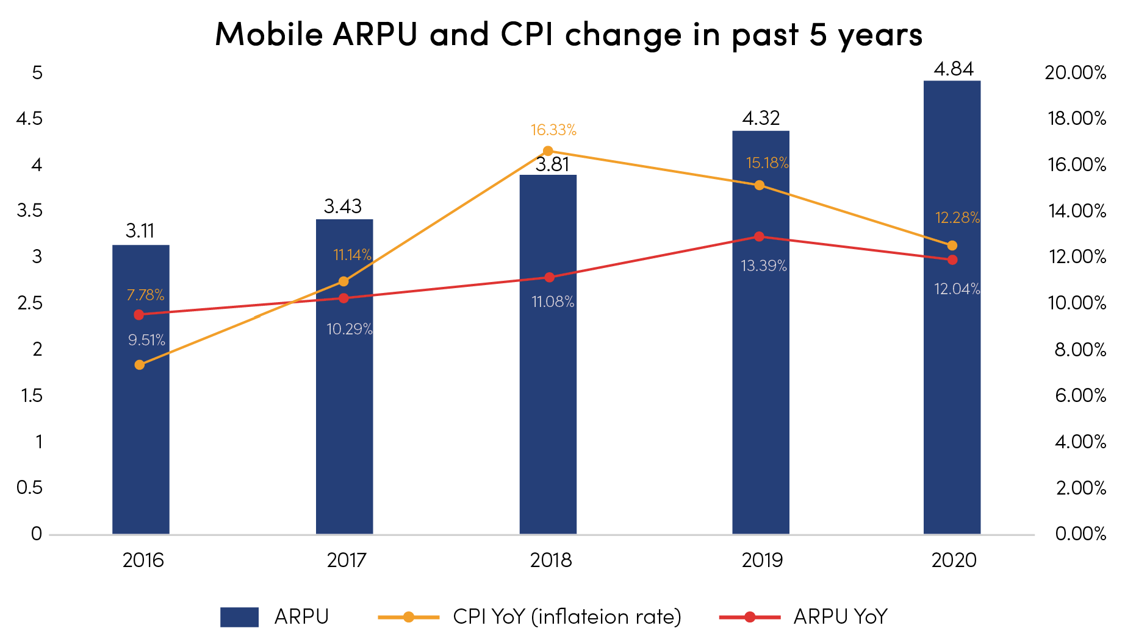

Figure 3-6 Mobile ARPU and CPI change in past 5 years

(Source: GSMA)

|  |
| --- |
| Telecom Tariffs adjustment  A red flag with a white crescent and a star  Description automatically generated with medium confidence India: low rates threaten the sound development  The telecom market of India is fully competitive and there were more than ten telecom operators. Jio, as a new player, built a 4G network to enter the telecom sector in 2016, and launched a series of free and heavily discounted services strategies to quickly gain hundreds of millions of users. As a result, other operators were forced to cut prices, which pushed small size operators, for example Telenor, to be merged and closed due to customer loss. Vodafone, the second largest operator, and Idea Celluar, the third one, had to merge due to huge losses. Since 2018, the telecom market share has gradually stabilized, which Vodafone & Ideal, JIO, and Bharti Airtel together account for more than 85% of the market share.  However, after the price war, the profitability of the entire industry has been weakened, the operators are facing loss of profits and billions of dollars in debt. Therefore, operators reached an agreement to support government intervention on the telecom tariff by set a floor price before March 2020. |

|  |
| --- |
| Telecom Tariffs adjustment  A red flag with a white crescent and a star  Description automatically generated with medium confidence Sudan: Sudan to adjust telecoms tariffs to maintain service quality and keep the same ARPU level in USD  In year 2022 Sudan Increases Communication Tariff By 100%.  In September 2022, South Sudan’s National Communication Authority (NCA) has announced it is adjusting the exchange rate for telecoms tariffs following requests from the country’s mobile operators. The current tariff exchange rate was set at SSP300 to USD1 back in 2020 but the effects of the COVID-19 pandemic and a rise in global oil prices (which led to higher costs for operators to power and maintain their networks) have prompted a review of the rates in order to ensure the continuity of networks and services. The move aims to gradually adjust the exchange rate for telecoms tariffs to the same level as the SSP600 holding base rate for the Bank of South Sudan. The adjustment has been carried out gradually over a 90 day period from 15 September to 15 December 2022.  The telecommunication service providers in South Sudan include, Digitel telecommunications, South African-owned mobile giant MTN, and Zain telecom. |

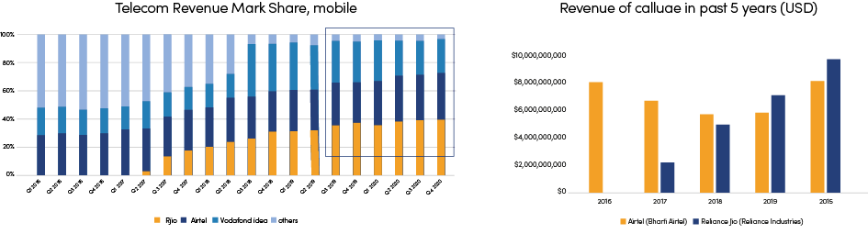

### 3.2.2.2 the procedures for telecom tariff in Iran

In 2016, the CRA of Iran introduced comprehensive procedures for filing all telecommunications tariffs and continuously reviewing and approving those that required specific approval.

Before 2016, the CRA reviewed all tariff filings and subjected all filings to similar processes. The new procedure ensured that regulatory resources were directed to greater scrutiny of tariffs for services in markets where the operators had significant market power (SMP) and were not directed to the ex-ante examination of tariffs for existing services to set effectively competitive or to time-bound or other promotional offers .

The CRA undertook a market analysis in which markets were defined and assessed in terms of competitiveness. The participants on each market were identified, and they were assessed in terms of significant market power. The relevant markets defined by CRA included both retail and wholesale markets, and within the wholesale category, some related to infrastructure access and some related to fully defined services (such as services for resale by wholesale operators). In the wholesale markets, suppliers designated with SMP have to offer cost-based prices, generally based on TSLRIC+ (total service long run incremental costs plus a mark-up for common costs).

In the retail markets, SMP operators have to follow the tariff approval procedures described below. For non-SMP suppliers, less onerous tariff notification rules apply for all retail services and for some wholesale services.

According to the recommendation on digital regulation by ITU, the procedure of telecom tariff in Iran needs updating on telecommunications price to enhance the capacity of regulation on digital economy and digitalization era.

### 3.2.2.3 the status of telecom tariff in Iran

According to GSMA data, the telecom tariff of Iran is in low level, compared with neighboring countries and similar size countries. For example, the ARUP of mobile business is about 1 US dollar in Iran, while as is 8.5 US dollars in Turkey, 19.36 in Saudi Arabia, 22.8 in Germany, 18.1 in Malaysia.

In terms of telecom business expenditure, the ARPU account for GNI per capita in Iran is 0.23%, which is also the lowest in the benchmarking countries. Compared with benchmark countries, the investment is at normal level but the capex per capita is lowest. The detail is as the following.

Regarding mobile data package, the average Unit price per GB in Monthly Packages is 0.21 USD, which is almost the lowest price in the globe compared with 200 countries and regions according to the data from Cable.co.uk.

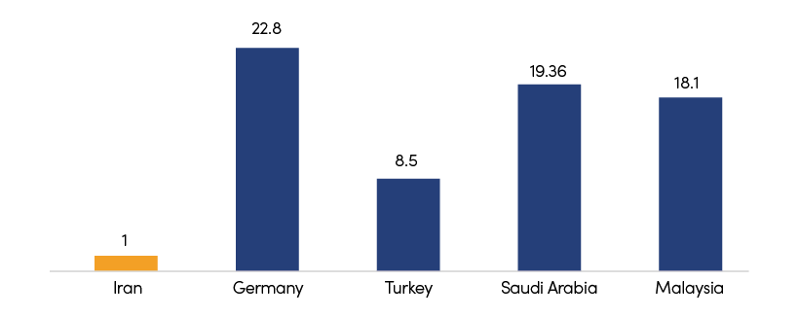

Figure 3-7 Benchmarking of ARPU by unique subscriber, 2020 Q4 (USD)

(Source: GSMA, Iran market insight)

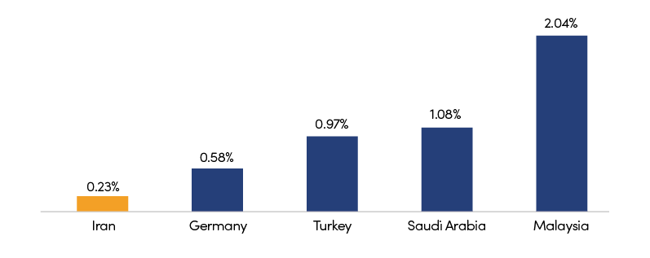

Figure 3-8 Benchmarking of ARPU as % of GNI P.C.

(Source: GSMA, Iran market insight)

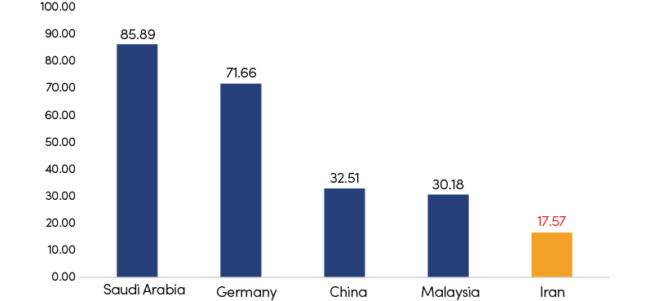

Figure 3-9 Benchmarking of capex per capita (USD) in 2020

(Source: GSMA)

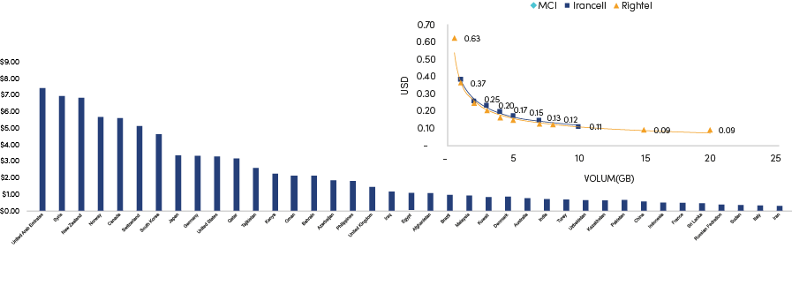

On the other hand, the ratio of investment to income of telecom sector in Iran is in the same level, about 22%, with benchmarking countries. As mentioned previously, the ICT infrastructure development level of Iran is at a slow pace, therefore it is necessary to adjust policies and regulation on telecom, for example marketization price-setting, to promote the sound development of the ICT sector.

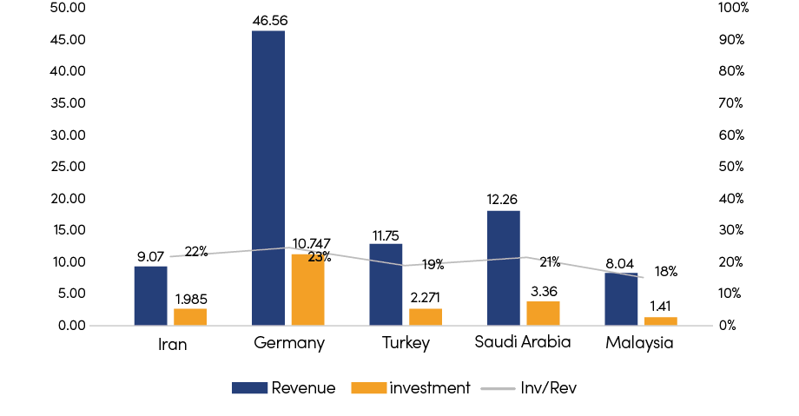

Figure 3-10 Benchmarking of revenue and investment in 2019 (bn USD)

(Source: ITU)

Generally, when the government develops telecom tariff policies, sector development, and affordability are two key factors to consider . In the initial stage of new-generation technology, a considerable amount of investment is needed in ICT infrastructure; for example, the acquisition of a 4G network is above 900 billion CNY, so the telecom operators set a high service price correspondingly. While in the mature technology period, operators cut costs and promoted to obtain more users. Compared with the development of the telecom sector in China, the telecom market of Iran is fair competition with three mobile operators and more than five fixed operators . According to Iran`s current policies, telecom operators cannot timely set the service price in a market-oriented manner to adapt to the development of the ICT sector.

Based on the tariff regulation of Iran and the best practices of other countries, it is suggested that:

1. Price discrimination between domestic and non-domestic data (based on the origin of the traffic), or the so-called zero-rating, is the sole domain of Service Providers. So, the government has to stop intervening in the market and, at best, can encourage SMPs to zero-rating using financial and non-financial support.
2. Along with considering zero-rating as a matter of business and not policy, regulating the retail broadband market regarding tariff (and competition) is of the highest importance for two reasons. First, the domestic content value chain will flourish strongly, and second, investment in broadband infrastructure will meet the demands of SMPs and society.
3. Regarding these two aspects, regulation of retail mobile broadband comes first, and basing that upon costs is a must, a fact that the government neglected for years. Tariff regulation means (re)setting a cost-based internet price per gigabyte. Though tariff regulation in retail markets is frowned upon due to the duopoly in the mobile operators’ market anti-competitive acts they conduct to block market entry and also consumer protection, such a policy proposal is inevitable.
4. To safeguard the consumers against high tariffs the duopoly could impose and also to make sure that increased revenues by the new price regime leads to a higher Capex in broadband infrastructure, an incentive-based regulation mechanism or price-cap is proposed that reflects both inflation and X-inefficiency for 3-5 years:

Pt=Pt-1 (1+It-X)± φQt

1. Pt is the price cap allowed in period t, It  is an indicator of inflation in period t and could be proxied by CPI, PPI or a weighted average of both. X represents the inefficiency and is calculated by with regards to forecasts on demand for internet usage, Capex, Opex and a few of other parameters. Qt denotes quality of service in time t and its parameter are defined the regulatory commission. Since QoS cannot jump over a night due to the needed investments, it is a matter of time. Yet, if both mobile operators improved/worsened the ranking of Iran in terms of speed and quality, say for 5 to 10 ups or downs, the regulator can increase/decrease the price cap in that period by a coefficient of φ. If only one of the operators could improve/worsen the ranking, financial and non-financial rewards/penalties could be attributed.
2. Since there cannot be two price caps, X will be calculated through an average. To compensate the less inefficient operator for smaller X, the yearly royalty operators pay each year to the government will be different.
3. Since inflation rates have been high in Iran compared to X, mobile operators may free-ride this remarkable gap and remain addicted to inefficiency or even increase it. To act ex-ante against such a violation (by one of them or two), a threshold for deviation from X (especially with regards to Capex) will be defined, and any jump above that will result in heavy penalties to bring down the actual price of each gigabyte of internet sold severely. Since price caps during the regulatory period are predictable, investors could enter this market more efficiently.
4. If prices are to move higher and higher each year, consumers have to be protected. One way is to oblige the operators to provide their customers with entry-level packages with a partial price cap. Also, the penalties collected by the government have to be distributed with a subsidy card to residents in poor regions.
5. Regulation of wholesale markets concerning tariffs and competition will also be made.

## 3.2.3 Cost Reduction

There are many ways for government to help reduce the construction costs of ICT infrastructure, such as reducing energy price or providing subsidy for energy use, promoting inter-sector and intra-sector Infrastructure sharing, and promoting fiber pre-deployment, etc.

### 3.2.3.1 Energy cost reduction and subsidy

To promote ICT infrastructure development, energy is a crucial issue to consider. Today, some of the considerations include:

* Energy increase in 5G: with network densification and increased traffic demand, energy consumption may increase.
* Energy impacts operators’ network construction incentive. RAN and base stations make up 20-40% of network operation costs of many operators.
* Climate change: considering Paris Agreement’s objective of keeping the rise of global average temperatures to well below 2 degrees Celsius above pre-industrial levels, green energy should be a key consideration in ICT infrastructure construction.
* Cost of energy sources: on the one hand, cost of carbon-based energy is volatile and affected by geopolitical events. On the other hand, cost of renewables has been declining. Cost of renewables are now cheaper than the grid in many countries.

To promote construction of new ICT infrastructure such as 5G and data center, many countries provide favorable energy prices or subsidies for telecom operators to construct and use ICT infrastructure. Some countries also encourage the use of renewable energy to supports data center operation.

|  |
| --- |
| China: Favorable electricity price and subsidy for 5G base station  To guarantee electricity supply for 5G base stations, Shanxi Province of China has taken three measures:   1. Convert the way of electricity supply from indirect to direct electricity supply for existing base stations. Streamline the approval process for electricity supply application of 5G facility. 2. Support telecom operators to participate in the electricity trading market. Calculate the electricity consumption of base stations through smart meters and include it into the universal electricity trading market based on a city’s or province’s basis. 3. Set a target electricity price of 0.35 RMB/kWh. After the transactions on the electricity trading market, if 5G base station pays a fee exceeding the target electricity price, it will be given subsidy. The subsidy is provided by the province, city, and county/district with a proportion of 5:2:3.   Shenzhen of China develops policies to support 5G network deployment, technological innovation, application demonstration, and environment construction. Telecom operator that completes 5G base station construction targets as planned can receive subsidies, which is CNY10,000 for every base station constructed using the SA model. Each operator capable of receiving a maximum of CNY150 million in compensation. The government also support 5G industry in various ways, including direct funding, subsidized loan, and risk compensation. |

|  |
| --- |
| Strategies to decarbonize the ICT sector until 2030  The rapid growth of the ICT sector stresses the importance of addressing and limiting any increase in its carbon footprint. Decarbonizing the ICT sector is not only necessary to realize the goals of fighting climate change but also a sustainable way of reducing costs.  In order to establish an ICT sector trajectory, ITU, in collaboration with Science Based Targets (SBT) initiative, GSM Association (GSMA) and Global Enabling Sustainability Initiative (GeSI), has developed the Recommendation ITU-T L.1470, which provides sectoral decarbonization pathways in order to help ICT companies set targets in line with climate science.  According to the Recommendation, for the period 2020–2030, the main strategy to decarbonize the ICT sector seems to be the implementation of simultaneous, vigorous and urgent actions in the following fields:   * implementation of energy efficiency plans; * switch to renewable or low carbon electricity supplies; * encouragement of carbon consciousness among end-users. * The following figure shows some examples of categories of supporting actions. |

### 3.2.3.2 Fiber pre-deployment

There are at least 20 countries who already issued a guideline for the fiber pre-deployment in new buildings, such as China, Singapore, South Korea, Switzerland, UK, and UAE, etc. Fiber pre-deployment has a lot of benefits:

* Total cost of Fiber deployment is minimized. Developers can share the construction teams;
* Rollout time is saved significantly, because permission is not mandatory when the homes are not handed over to users;
* Users will enjoy the less lead time for a service provisioning, because Fiber is already there in their home; it is easier for users to choose service provides, by which the market competition is encouraged;
* Economic benefits will be significant, because operators spend less time for Fiber rollout and service commissioning and possibly have a higher take up rate.

|  |
| --- |
| China: National mandatory standards for FTTH deployment in residential buildings  A red flag with yellow stars  Description automatically generated with medium confidence In 2013, China has issued the Code for design of communication engineering for fiber to the home in residential districts and residential buildings and Code for construction and acceptance of fiber to the home in residential districts and residential buildings, which requires that since April 1st, 2013, the communication facilities of new residential buildings, in urban areas at and above the county level, should adopt FTTH mode.  The two national standards have set out the FTTH design and construction specifications in new residential buildings. The residential developers must simultaneously construct communications facilities, such as pipeline, in-building optical fiber, equipment room, within residential areas and open to operators in an equal manner. Since then, the local housing and urban-rural authority and communication authority have organized inspections on the FTTH construction to ensure the implementation of the standards. |

|  |
| --- |
| Iran: supporting the development of fiber optic access network (FTTP)  In December 2021, Iran’s ICT regulatory body approved the resolution  “Governing Principles for Supporting the Development of Fiber-Optic Access Networks.” This resolution aims to cover (penetration coefficient) 80% of fixed broadband access for households in a period of 8 years. In this resolution, the government has reduced its royalty to 0.1% for FTTP service providers, considering the long payback period and encouraging investors to enter the development of optical fiber network infrastructure.  To increase competition at the retail level, there will be no pricing rules in the eight years from the regulatory/government side, and end users will benefit from fiber optic services according to the price caused by the natural mechanism of supply and demand. Also, the whole package will not include introductory pricing to encourage the development of bundles of fiber optic service with other communication services (including data/voice/SMS). This policy will encourage mobile operators to enter the fiber optic service market.  So far, this resolution has been implemented in Kish Island with the investment of two Iranian companies; the Telecommunication Company of Iran and Pasargad Arian communication technology (FANAP Telecom), which has led to the installation and setting up of 284 km of fiber optics. |

### 3.2.3.3 Infrastructure sharing

Network construction requires huge investment and the majority of costs are caused by infrastructure. Infrastructure sharing is an effective way of reducing costs and potentially resulting in greater coverage, improved quality of service and lower retail prices, whilst having a positive environmental impact and optimizing national scarce resources. Network sharing may take many forms, ranging from passive sharing of cell sites and masts to active sharing of radio access networks (RANs) and the core networks. There are also various forms inter-sectoral infrastructure sharing.

According to different business/ownership, infrastructure sharing agreements can be classified to four types.

* Unilateral service provisioning: only one company provides its sites to be shared, and ownership remains separate
* Mutual service provisioning: two or more companies provide their sites to be shared, and ownership remains separate
* Joint venture: companies enter into an agreement to form a joint venture (can operate as a tower company) to own and operate the networks but do not directly own the sites
* 3rd party service provider: an independent company (not necessarily affiliated with a mobile operator) owns and leases sites to mobile operators to use. The municipalities or the government can become the 3rd party provider of infrastructure under a public private partnership.

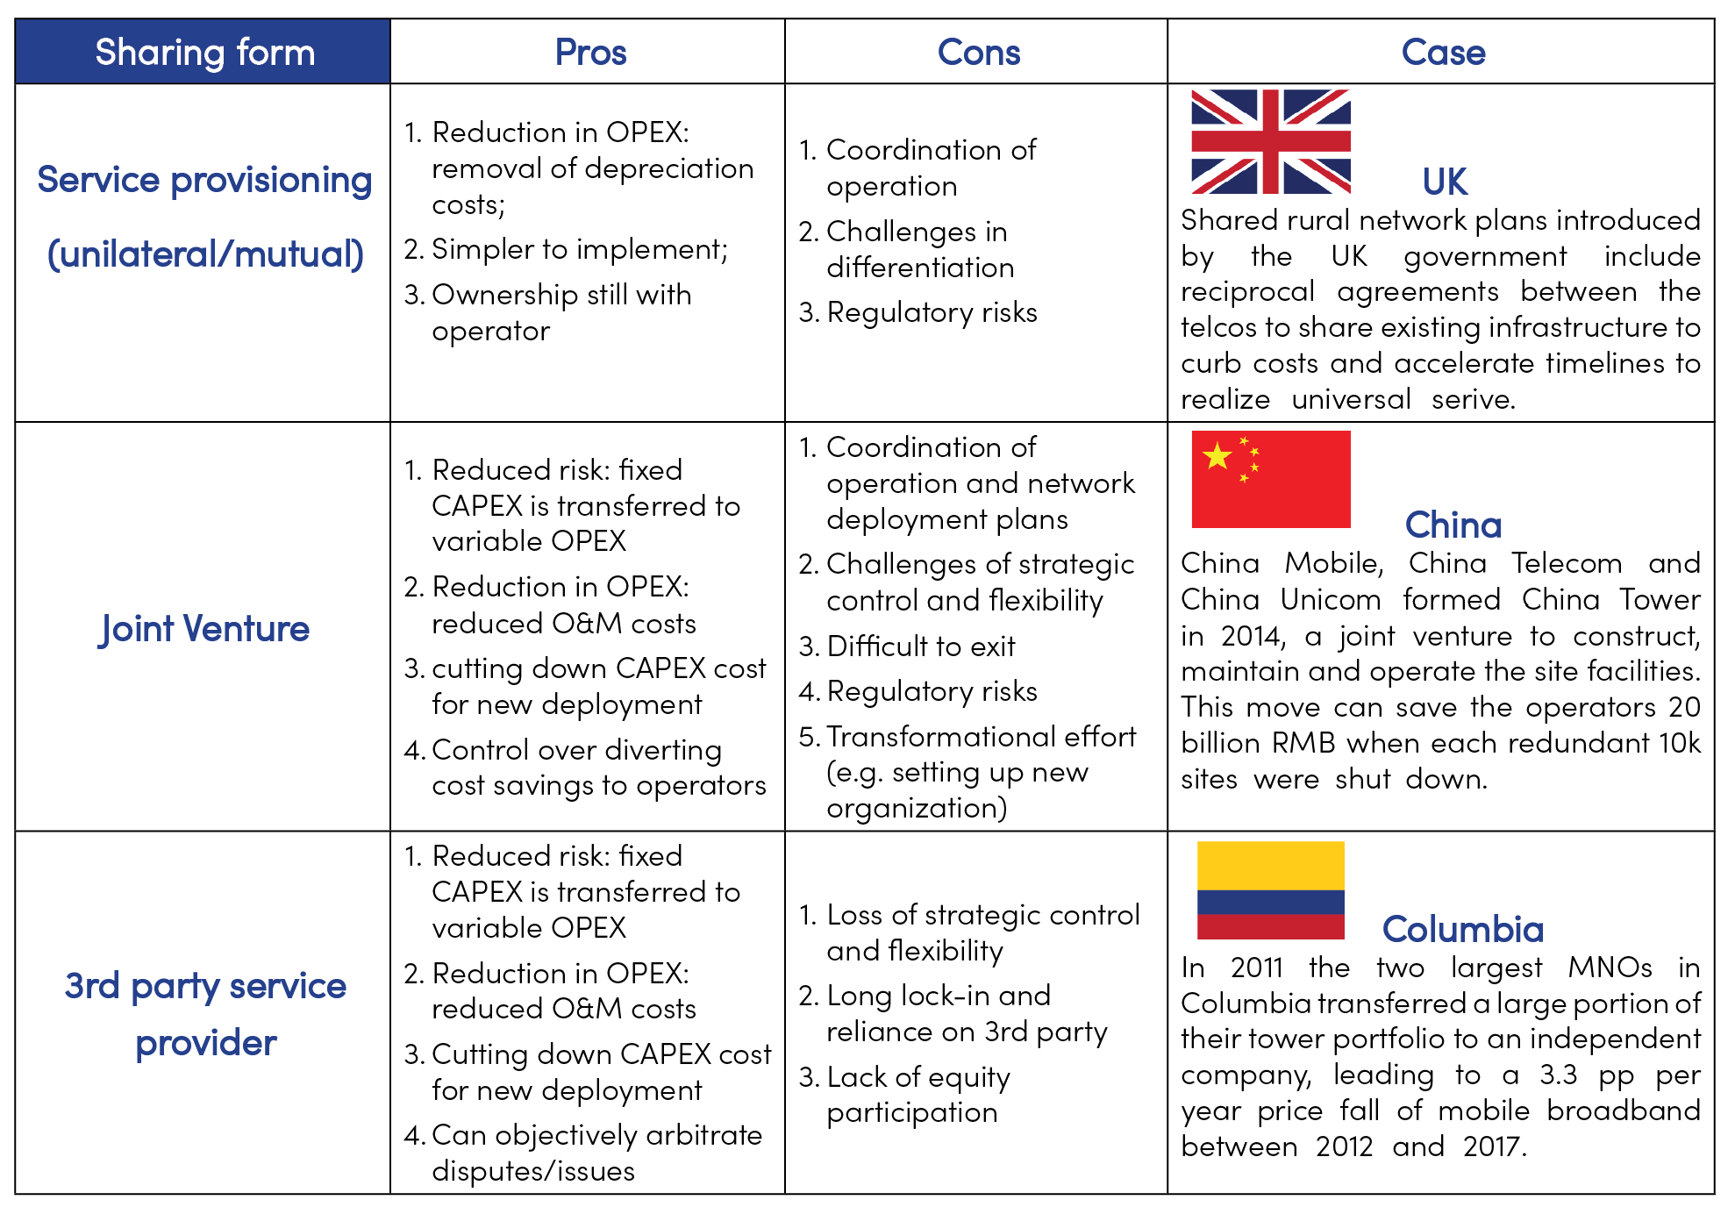

Table 3-3 Comparison of infrastructure sharing forms (business/ownership)

(Source: GSMA)

|  |
| --- |
| China: Releasing Guidelines on Infrastructure Sharing on a yearly basis to promote broadband infrastructure development  In China, the Ministry of Industry and Information Technology has issued the Guidelines on Promoting the Co-construction and Sharing of Telecom Infrastructure for six consecutive years from 2015 to 2020. Currently, a well-developed landscape of co-construction and sharing has formed in the ICT industry. The infrastructure sharing regime is comprehensive, covering all aspects from organization to evaluation.So far, this resolution has been implemented in Kish Island with the investment of two Iranian companies; the Telecommunication Company of Iran and Pasargad Arian communication technology (FANAP Telecom), which has led to the installation and setting up of 284 km of fiber optics.    The content of the Guidelines, such as the scope and participants of sharing, has been continuously widening and deepening. |

|  |
| --- |
| Several forms of inter-sectoral infrastructure sharing  1. Multi-purpose utility tunnel  A Multi-purpose utility tunnel (MUT) is one of the civil infrastructures in urban areas, which accommodates several networks, such as electrical, telecommunications, gas, water, and sewer pipes, inside a tunnel. There are several benefits of MUTs compared to buried utilities. However, MUTs are not widely used currently due to the high initial construction cost and the need for coordination among utility owners.  Many big cities around the world, such as Paris, Moscow, Beijing, and Tokyo, have been promoting the construction of MUTs. It is recommended that Iran consider construction of MUT including telecom network first in big cities or central areas, to achieve better level of urban utility management.    2. Multi-purpose utility pole  Multi-purpose utility pole (MUP) is an infrastructure that integrates multiple functions such as intelligent lighting, video monitoring, traffic management, environmental monitoring, wireless communication, information interaction, and emergency response. In the background of 5G and smart city construction, MUP will serve as an important carrier for 5G equipment and infrastructure of a comprehensive sensor network.  Shenzhen is a leading city in building MUP. By the end of 2020, Shenzhen has built over 9700 MUPs and several demonstration projects covering over 30 application scenarios such as 5G communication.  To support MUP construction, Shenzhen has developed and released several top-level policies and standards, such as Shenzhen Action Plan for the Construction and Development of MUP (2018-2020) in 2018, Code for Design and Engineering Construction of MUP in 2019, and Measures of Shenzhen for the Management of MUP in 2021.    3. Open public space for network infrastructure construction  Currently, municipal governments all over China have released policies that require opening up public spaces to promote joint construction and sharing of communications infrastructure. Relevant public spaces may include:  Public places and buildings of government bodies, enterprises, institutions, and universities, transportation hubs, large event venues, residential communities, tourist attractions, roads, bridges and green belts are required to provide necessary space resources for ICT infrastructure construction and facilitate the relevant approval procedures.  All levels of government, departments of public security, transportation, municipal gardens, urban management and power supply companies shall fully open their public resources such as lamp poles, public security monitoring poles and power poles.  The housing and construction departments at all levels should urge the property management enterprises to cooperate in the construction and maintenance of ICT infrastructure, coordinate and open the building roofs, lampposts, and monitoring poles etc. for the construction of the communication infrastructure, in order to achieve good network coverage. They are prohibited from charging overly in the name of entry fees.  4. Infrastructure sharing with the power sector  A power network can provide a more universal network or be better suited to FTTH rollout in certain locations based on space availability and infrastructure robustness. There are four possible business models for FTTH deployment by a power company on its own or in partnership with telecom operator. |

## 3.2.4 Enhance Digital Resilience

Currently, due to the unauthorized activity of foreign digital platforms in Iran, a significant share (about 80%) of user traffic is allocated to international traffic. As a result, these platforms play an important role in Iran’s digital economy. Unfortunately, Iran has a low regional impact despite the high content volume. Regarding the goals in the ICT field to increase the digital economy’s share in the GDP, dealing with the issue of these platforms has been thoughtfully placed on the agenda of the ICT ministry.

Although the actions taken so far have not succeeded in meeting the expectations and policy goals in this area, activities are still being carried out to improve the digital platforms and increase their potential to play a significant role in enhancing the digital economy, for instance:

* The formation of at least one social media platform with a capacity of 50 million active users and with the possibility of obtaining a share from regional and international users
* Provision of essential domestic functional services with a traffic share of 70 to 30 compared to similar foreign essential digital services and an annual growth rate of 15%.
* The ICT ministry has been required to support the infrastructure, providing financial facilities, etc., designed to help domestic social media platforms and offer a competitive advantage over foreign digital platforms.

Recently, some international digital platforms, such as Instagram, WhatsApp, and Google Play, have been temporarily or permanently filtered, which caused the Internet traffic revenue to a sharp decrease of over 20% For instance, Internet disruption reduced more than 740 billion Tomans and 22 8% from MCI`s revenues in one month Hiweb(ISP) performance report in October of this year and its comparison with previous months show that this fixed operator has reduced income by nearly 99 billion Tomans and about 60% .

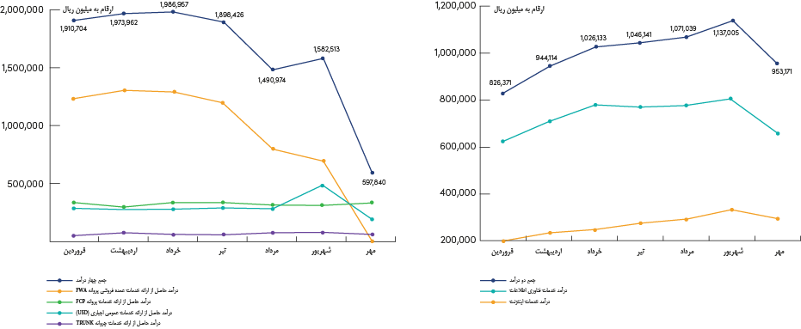

Figure 3-11 Consequence of Internet shutdown in Iran

It is necessary to maintain the growth of data (Internet) consumption for the development of digital economy. ICT ministry and other stakeholders should develop policies to encourage the development of Internet services or digital platforms,

* Foster friendly policy environment for innovation and entrepreneurship, simplify business registration procedures, reduce or exempt taxation for start-up technology-based enterprises, and provide legal and taxation advice.
* Promote competitions in ICT application and innovation to encourage startup and SMEs innovation with seed funds provided by government and investment institutions.
* Encourage ICT innovative companies to develop local application based on Persian and Arab culture, such as local newspapers, TV stations and videos, and expand the business to Middle East.
* Launch the pilot activities of fixed-mobile convergence (FMC), issuing FMC license to selected telecom operators to encourage service and business innovation.

Telecom operators should actively develop digital services, for example Voice/Video over LTE (VoLTE/ViLTE), to accelerate the transformation from traditional services to IP (digital) services for high QoS and increased revenue. Meanwhile, telecom operators are encouraged to develop digital platforms and Internet services, such as social media/ network, streaming video/music services, IPTV, e-payment, to enrich product matrix and enhance business competitiveness. Besides, telecom operators should develop FMC products and services to improve the product competitiveness, so as to effectively reduce churn rate and increase revenue.

Private sectors should make full use of the opportunities of International digital platforms banned in Iran to develop various digital products, cooperate with telecom operators to promote the development of domestic Internet ecosystem and digital economy.

Some international experiences that can be considered a successful sample of governments’ actions for developing local content platforms are stated below.

|  |
| --- |
| Turkcell: Digital services strategy, layout and performances  n order to maintain strong operational performance and profitable growth, Turkcell offers its customers value-added and innovative services in accordance with its strategic focus areas, namely digital services, digital business services and techfin services.   * Digital Services: a broad portfolio of services to address growing digital needs * 29% YoY digital OTT services revenue growth * 4.8 million standalone paid users   Turkcell delivers innovative and inclusive services to customers with digital offerings, including music streaming, TV, personal cloud storage, instant messaging platform, search engine, e-mail, digital ad and gaming. In 2021, Turkcell achieved a key milestone by exceeding 1 million standalone paid users in our TV+ and lifebox services. With its enhanced features, BiP reached over 90 million downloads and 26 million 3-month active users.   * Digital Business Services: end-to-end support for digital transformation of corporate customers with digital business service * 107% digital business services revenue growth * TRY 1.5 billion (USD 80.4 million) system integration projects backlog   Turkcell offers cloud, cyber security, IoT Platform, big data analytics, vertical business solution, managed services and artificial intelligence to support digital transformation of a large number of industries from healthcare to education, production to retail, transportation to logistics, finance to energy, and continue to deliver numerous value added projects in areas as required by organizations, and act as the strategic technology partner of our customers.  Turkcell has 3 main business partnership ecosystem, namely subcontractors, products/solutions co-developers and sales partners.   * Techfin services: facilitate customers’ financial transactions with innovative services and solutions * 105.4% YoY Paycell revenue growth * 56.7% YoY Financell revenue growth * 7.3 million 3-month active Paycell users * 1.3 million Financell credit customers   Turkcell offers innovative solutions to customers with three brands; Financell, Turkcell Sigorta and Paycell.  Financell provides financing solutions to both individual and corporate customers enabling them to meet their technological product and service needs;  Turkcell Sigorta delivers innovative solutions with fast and easy-to-access products to address risk management needs;  Paycell offers solutions targeting acclerated digitalization need in payments, which has emerged along with the changing user habits as a consequence of the COVID-19 pandemic.  Note: Data as of Q3, 2022 |

|  |
| --- |
| News Corp; Australian media conglomerate  Newscorp, the owner of about two-thirds of Australian metropolitan news sources was one of those media companies that tried to persuade the Australian government to ask Google and Facebook for media links through which it generates revenue in this country. The dispute between Facebook and Newscorp made Facebook ban access to its news sources in this country. This dispute eventually led to a contract between Facebook and News Corp. Based on that, in case of non-compliance, the regulatory body of the Australian government could fine the parties who violate the rules.  According to the results of the research of the Australian Competition and Consumer Commission (ACCC);  “The power imbalance between local newspapers and the world’s social media giants had caused the survival of local news agencies to be threatened. Newscorp, the pioneer of lobbying in Australia, with the support of its old rivals, was able to persuade politicians to force technology companies to pay for the news content of their websites. The Australian government legislated a law to make the terms of this contract between the media and tech giants impartial. Also, ACCC proposed a bargaining system, based on which the local news media platforms will be paid for the content they produce.” |

|  |
| --- |
| BBC; how the partnership can rescue?  BBC has recently launched an experimental platform called ‘’Together BBC’’ that allows people in different places to watch a program at the same time. BBC is trying to use technologies that increase interaction and personalization, bring people together, and lead to the creation of a new user experience.  In order to survive this competition, BBC has partnered with iTV (its British competitor). The result of this cooperation is BritBox, which is used to compete with global platforms such as Netflix. This service was launched in North America in 2017 and has 650 thousand of active users. So compared to 60 million active users of Netflix, BritBox still has a long way to go.  BritBox exclusively represents local British content, and this is the most obvious difference between BritBox and Netflix and also the reason why this platform stands against Netflix. It’s a big deal that Britain’s arch-rivals are willing to team up to stand against Netflix...BBC and iTV hope that the income from BritBox will increase their budget so that they can create new exclusive content for BritBox.  Based on the experience of the British government regard to content development, it can be concluded that with the growth of VoD services, the integration model can be one of the appropriate strategies for content market development. The integration of several VoD services can bring more technological, marketing, and even production advantages. Most of the BVoD services are national or local and by merging with each other they will be able to compete with international platforms. |

|  |
| --- |
| FMC plays an important role in driving VEON’s core telco businesses.  VEON accelerates fix ed–mobile convergence across its markets with the aim of potentially reducing some costs by network optimization and of introducing new value-added services to its customers.  The FMC customer base grew by 18% year on year (YoY) in 2Q19 to more than 1.1 million, which represents a 47% FMC customer penetration in the broadband customer base, supporting improvements in broadband customer churn. Total FMC revenue has grown to $126m, 46% up from end-2017 levels and 271% up from end-2016 levels.  In Russia, Veon’s core market, the triple-play package ranges from $9.9 for the basic package (500 voice minutes, 300 SMS, unlimited mobile data, up to 100Mbps home broadband, and 77 TV channels) to $39 for the most expensive package, which includes 4,000 voice minutes, 300 SMS, up to 100Mbps home broadband, and 192 TV channels. |

Government’s role in enhancing digital resilience

1. Strengthening venture capital in social media platforms: Since venture capitalists often invest in companies that are in the early stages of their activity and have cheap shares but have high profitability capacity, this investment model can create a competitive environment that increases innovation.
2. Applying practical legal approaches and tools: Clarifying the responsibility of social messengers in publishing illegal content and user personal data protection are two of the leading legal gaps in the field of social messengers.
3. Optimal and effective provision of public electronic services in social messengers: Supporting the development of super applications that provide a wide range of activities such as paying bills and taxes, online taxis, holding virtual courts, financial affairs, etc.
4. Providing infrastructure and technical assistance based on key performance indicators (KPI): Providing facilities in the field of infrastructure, based on KPI, motivates the social media platform to improve and prevent the waste of public resources.
5. Supporting research on methods of using new technologies.
6. Establishing legal requirements for using technologies, such as requiring platforms for real-time content monitoring.
7. Making platforms responsible for the content they host and penalize them in case of violation of laws.
8. Supporting research on methods of using new technologies: supporting the new methods of producing and distributing the content by legislation law, budget allocation, tariffs, etc.

## 3.2.5 Promote 5G Deployment

### 3.2.5.1 Subsidy for 5G deployment

Several countries make polices to subsidize 5G network construction to stay ahead in the global 5G race over the next few years. 5G first movers, such as China, America, Europe, Japan, South Korea and the Middle East countries provide favorable policies and financial incentives and subsidies to boost the construction of 5G.

South Korea has led the world in mobile broadband service experience and use cases in previous and is the first country to announce 5G commercialization. The Korean government is still heavily subsidizing in different ways. On the one hand, South Korea cut taxes on 5G deployment by 3% to encourage operators to build a nation-wide 5G network quickly, on the other hand it also promised to boost the development of vertical industries such as autonomous driving and digital healthcare to create a wider range of 5G use case. Taking autonomous driving as an example, the South Korean government announced it would operate self-driving shuttle buses in major cities like Daegu and Pangyo by 2020, and by 2025, Korea’s provincial-level municipalities will provide about 1,000 5G-enabled buses. In terms of the digital healthcare system, the government said they would develop 5G-based emergency medical services by 2021, where about 20% of the emergency medical centers would have access to this system by 2025.

Middle Eastern countries like the UAE, Saudi Arabia, Kuwait, and Qatar were also among the first to embrace and invest in 5G deployment. They competed on vertical industry applications such as 5G smart cities, 5G smart tourism, and 5G smart oil fields. For example, Dubai of the UAE announced in 2018 that it would invest US$7 billion over the next five years in deploying 5G networks to build a 5G-based smart city. Data shows that by 2019 all member states of the Gulf Cooperation Council (GCC) in the Middle East had started 5G deployment, with some already commercializing it. According to a GSMA Intelligence report in late 2018, mobile operators in Arabian GCC member states had quickly transitioned from 5G trial into early-stage commercialization through strong governmental support, and this laid the foundation for their world leading position in 5G deployment.

### 3.2.5.2 Defining coverage commitments

According to GSMA data, the average development of 5G is 2 times faster than 4G. For instance, in China the deployment of 1 million 4G took about 6.5 years while it took about 3 years for 5G base station. In many countries, such as Brazil, Chile, and France, commitment in performance or coverage is widely used for efficient use of spectrum.

|  |
| --- |
| Thailand: coverage obligation bonded with deferred spectrum payment term  In Thailand, grace period for deferred payment term was given for 2.6GHz. With 3 years of grace period from 2021-2023, MNO has more cash flow to rollout first 4 years.    This deferred payment is bonded with 5G rollout commitment set by the Thai government. To be specific, to get 2.6GHz grace period term, the MNO need to complete the rollout obligation of covering 50% of the geographical coverage of the EEC (Eastern Economic Corridor) region in one year and 50% geographical coverage of 6 big cities in 4 years.  It is worth noting that Thailand’s 5G network deployment was the fastest 5G network deployment in Southeast Asia by adopting the correct deployment policy. Almost 30,000 sites were deployed by True and AIS in 3 years. |

|  |
| --- |
| Brazil: 5G spectrum fee changed to investment commitments  In Brazil the 5G spectrum fee was changed to investment commitments. As the 5G coverage scheduled according to inhabitants in the cities. |

|  |
| --- |
| France: 5G spectrum auction with coverage and performance requirements  In France, in the 5G spectrum auction, a commitment to cover with performance was requested. As a coverage commitment based on the site quantity and its speed mentioned in the table below. |

For Iran, it is recommended to consider 20% of population coverage in the two main cities of Tehran and Mashhad in the first year, 50% of population coverage in the top 50 cities in the second year, and 70% of population coverage in 150 cities in the third year. The following picture is showing the details.

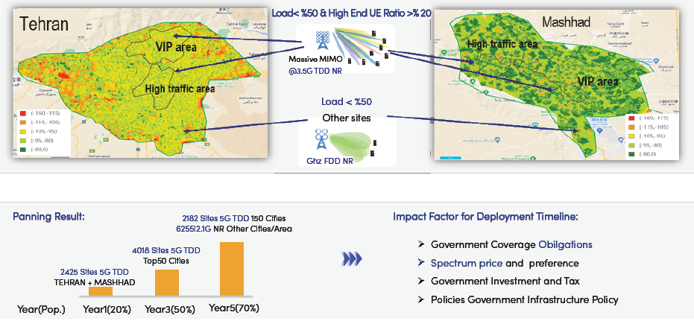

Figure 3-12 Recommendation for 5G population coverage in Iran

### 3.2.5.3 5G spectrum auction

Statista forecasts that the number of 5G subscriptions will increase drastically worldwide from 2019 to 2027, from over 12 million to over 4 billion subscriptions. Due to the growing number of LTE users and traffic in Iran which is shown in CRA statistic, it has been committed to launch 5G as early as next year. It is anticipated that Iran will see increasing number of 5G users in the coming years. According to the growth trend of 4G subscribers in recent years and the growth rate of other countries where the 5G network is currently deployed, it is anticipated Iran will have nearly 164 million mobile subscribers, including 63 million 5G subscribers and 12.6 million FWA service subscribers by 2027. The QoS that is considered for further analysis is listed in the following tables.

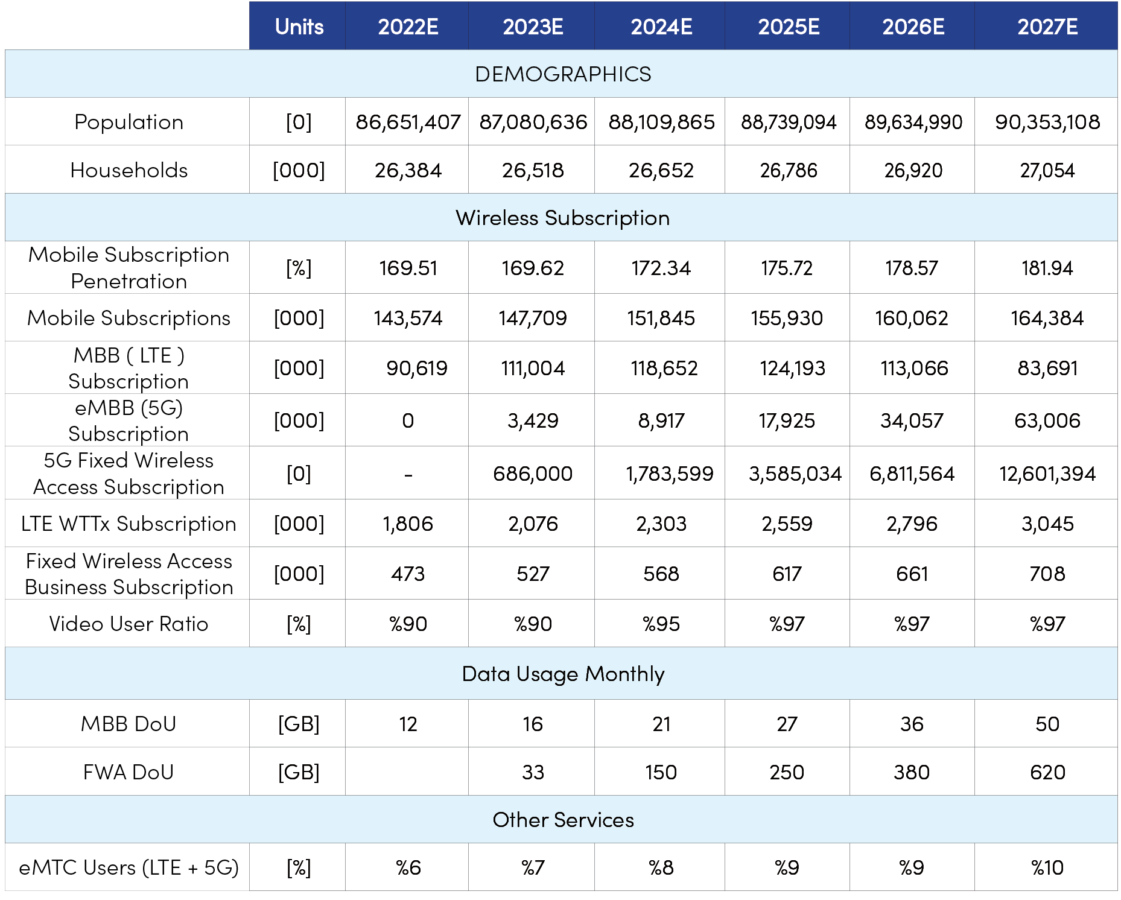

Table 3-4 QoS assumptions for further analysis in Iran

With such an assumption, it is predicted that Iran will need a higher range of spectrum in the coming years. There is a need for 157 MHz spectrum in C-Band to start the commercial 5G lunch in 2023 to be followed up to 400 MHz in 2027. It is also recommended to use the 2.1GHZ spectrum which is already used for LTE for LTE and 5G from 2026. For band 1800, it is recommended to utilize it for LTE and GSM for voice connectivity and coverage. For 800 MHz, it is also recommended to change the application from GSM/UMTS/LTE to GSM and LTE from 2026. And the shutdown of 3G network need to happen by then.

Generally, by 2027, 862Mhz of spectrum is needed to cover the need of traffic and technologies. Details are brought in the following figure.

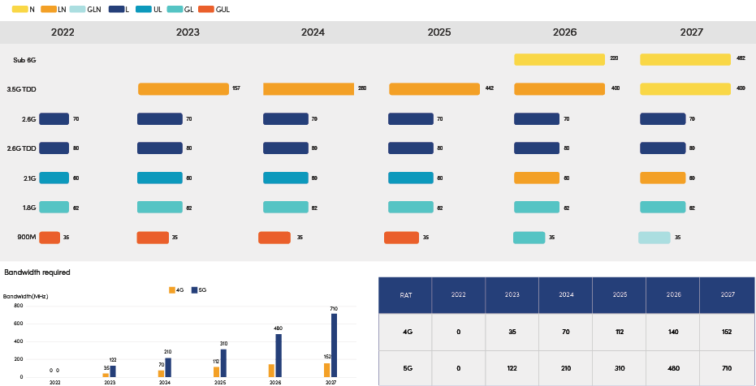

Figure 3-13 Predicted spectrum demand in Iran in the future

Mobile operators need timely and affordable access to a sufficient amount of spectrum in order to support high speed, mobile broadband services with good coverage. When operators are spectrum-constrained, they are likely to have to invest more on densifying their network in urban areas than they would otherwise. This in turn can constrain their ability to invest in the rest of the network and, especially, improve coverage.

Globally, the spectrum costs are declining. A Coleago Consulting study [19]computed the Spectrum Price Index (SPI), i.e., total spectrum cost divided by monthly mobile revenue. The SPI is 6 for 3G, 4 for 4G, and 2 for 5G. This equals an annualized spectrum cost at 3% of revenue for 3G, 2% for 4G, and 1% for 5G. In countries such as China, the UAE, Saudi Arabia, and Kuwait, the number is below 1%. For instance, in the UK EE, which has the first and largest 5G network in UK, the SPI for 5G rollout is about 1.02 and the total spectrum price is $1,762 million.

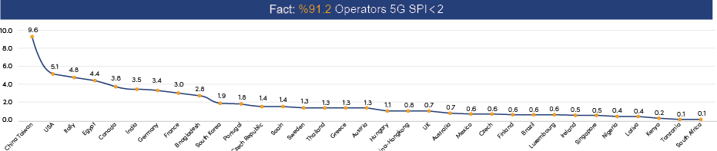

Figure 3-14 5G Spectrum Price Index by country

The Coleago study also calculated the impact of annualized cost of spectrum on MBB investment and drew the following findings:

* A cost of spectrum of up to 5% is unlikely to slow down investment in mobile broadband and 5G. There is also evidence that lower percentage is likely to deliver better outcomes for 5G deployment.
* In many well developed 4G markets the annualized cost of spectrum is 5-9% of mobile revenue. This indicates that below 10% the annualized may not have material negative impact on network deployment.
* When the cost of spectrum amounts to 10% of mobile revenue, operators may hit budget constraints, i.e. investment in mobile broadband and 5G is likely to be slower than it otherwise would be. A cost of spectrum above 10% of revenue presents a threat to the development of 5G.

Spectrum price in Iran

In Iran, it is recommended to set the SPI less than 2 to guarantee the success of spectrum allocation as well as network rollout. For example, if we set SPI at 1, considering the ARPU of Iran at around 1USD and the number of mobile subscribers predicted to be 164M in 2027, the total cost of spectrum for 300MHz (100MHZ for each operator) is predicted to reach 164M USD for 3 operators. Therefore, the price of spectrum will be around 0.5M USD/MHZ.

## 3.2.6 Promote FTTX Deployment

Improved broadband connectivity is crucial in accelerating economic growth and increasing the GDP, particularly in developing markets. The increased opportunities in ICT accelerate job creation by unlocking new digital opportunities in critical sectors of the economy, including e-health, e-agriculture, e-education, and transport.

In the past, several highly developed broadband territories that rank lower in the FDI index of OMDIA —such as the US, Australia, and the UK—tended to suffer from less clear or ambitious national plans, providing weaker incentives for operators to invest. This was often linked to less favorable geographical and demographic conditions that made government initiatives expensive and likely to face significant political opposition. However, due in some part to the COVID-19 crisis demonstrating just how essential broadband networks are, governments around the world are now strengthening their broadband targets and increasing their focus and investments in fiber-based infrastructure.

With increased efficiency stimulating more significant innovation, high-speed broadband has been proven to drive not just consumer satisfaction but national economic indicators, with additional GDP growth of 0.25% to 1.5% for every 10% increase in household broadband penetration and a further 0.3% increase for every doubling of speed. Only by maximizing investment in next-generation access can countries optimize their growth potential, and fiber-optic technology is vital to that investment, whether in the backhaul or access network.

Fiber also brings a range of other benefits to an operator, including higher overall quality of service (QoS), lower maintenance costs, lower energy costs, and more minor physical infrastructure requirements. Such characteristics must be considered when developing fiber investment plans and make it more difficult to calculate the real return on investment.

Full-fiber networks require much less active equipment in the field to power them, significantly reducing energy consumption. An optical distribution network (ODN) requires zero electrical power. In addition, the fiber’s significantly higher bandwidth capacity at a fraction of the size and weight of copper wiring requires considerably less energy per bit.

In 2019, Telefónica (Spain) stated that its FTTH network was 85% more energy efficient than its old copper infrastructure. Over three years, the operator said its FTTH initiative had saved 208GWh, representing a reduction of 56,500 tons in CO2 emissions. In Belgium, incumbent telco Proximus noted that data transmission over its fiber network uses up to 12 times less energy than on its copper network. A large part of this energy saving is down to the significant reduction in the number of street cabinets and the size reduction of the remaining ones.

Key points and recommendations

National strategic plans containing robust regulatory policies to facilitate fiber deployment, uptake, and QoE is essential: One of the most cited barriers in fiber rollouts is either the lack or inefficiency of regulation. To promote fiber development, governments must adopt concrete legislation that targets inefficiencies such as insufficient access to existing telecoms and public infrastructures, improves rights of way, and encourages investment and partnership agreements. Most countries in the FDI have a national broadband agenda; however, it is not enough to publish a national broadband strategy without ensuring its implementation. Countries with success stories follow through on their broadband initiatives, creating sufficient supporting funding and tracking the progress of reaching the goals set out in the broadband plans while taking advantage of new technologies and innovations that may be better suited to achieve these targets.

(See Figure XXX). Some countries, such as the UK, have only recently recognized the importance of fiber in their national broadband strategy and have since made significant and rapid progress in fiber deployment. In 2021, the UK government launched a £5bn government infrastructure project called “Project Gigabit,” aimed at getting gigabit broadband access to more than one million hard-to-reach homes and businesses.

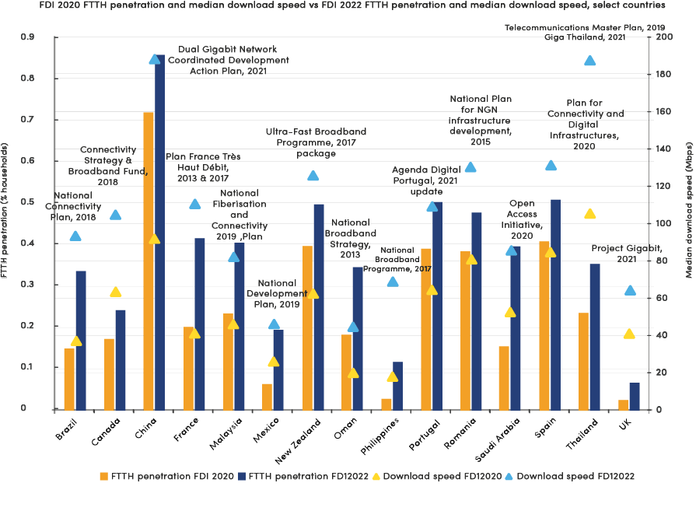

Source: Omdia, Ookla

Fiber-to-site penetration is as essential as FTTH: The determining parameter in fiber development is not limited to FTTH penetration and speed; FTTS and the number of mobile sites equipped with fiber are other factors in FBB development. As seen in the FDI index from OMDIA, FTTS has the same weight as FTTH penetration and FBB speed.

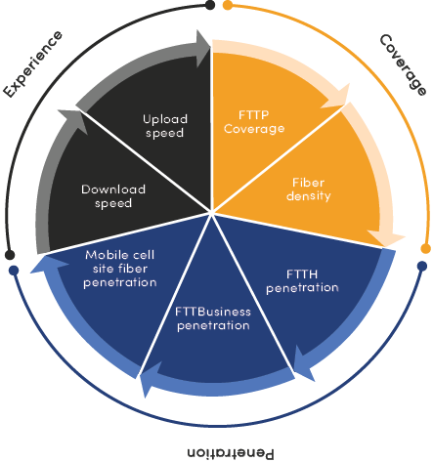

In Iran, the FTTS rate for MTN, MCI, and Rightel is about 32% and still needs to reach the standard level of Cluster 1 and 2 countries of the FDI index from OMDIA. FTTS penetration has been increasing in the last three years for all countries. Once Iran persuades mobile operators to participate in fiber deployment, it’s better to consider incentives for FTTH or FTTP and FTTS.

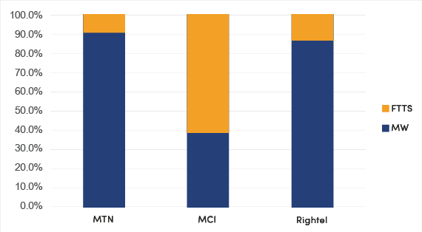

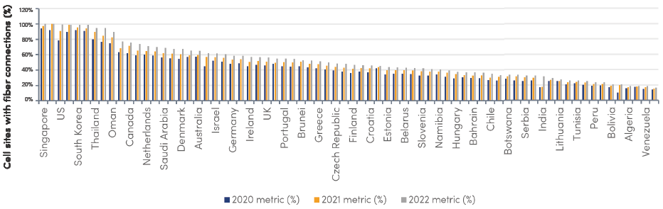

Figure 3-15 FTTS fiber penetration

Set and implement national broadband strategies and plans with specific, achievable, and measurable goals: The goals and incentives currently set by the regulator in Iran are attractive, but the allocation method still needs to be improved for mobile operators to participate actively in fiber deployment. After defining the subsidy from the government, it is better to assign the incentives to the operator with specific goals and commitments. If the plans are not met, consider the fines at the end of the year.

Develop policies and regulatory frameworks to accelerate broadband network infrastructure deployment, including network sharing and open access: The deployment of optical fiber networks in some parts of the world has often been vertically integrated, in that each service provider deploys, owns, and operates their network infrastructure, which is detrimental to faster optical fiber broadband infrastructural development. Regulators should develop policies that promote network—infrastructure sharing by service providers to reduce the cost and duration of the deployment process. The network-sharing model could be shared trenches (civil works), ducts, or optical fiber cables. In Ethiopia, Safaricom will use Ethiopia electric power’s ( EEP) dark fiber for transmission backhaul in a deal worth KES1.6bn ($13.2m). In Egypt, Telecom Egypt signed a 10-year EGP12.5bn ($645m) FTTS agreement to provide optical fiber access to Etisalat Misr’s mobile cell sites. Telecom Egypt also leases optical fiber backhaul capacity with Vodafone Egypt. In 2017, the Ghanaian government commissioned a study on infrastructure sharing and open access models that recommended developing an infrastructure-sharing policy to support the implementation of network sharing for the faster and more affordable deployment of ICT services in the country.

Develop policies to accelerate broadband networks through public and private partnerships: It is essential to convince the private sector to participate in investing in fiber and broadband network infrastructure, as is the case in Chile.

Mundo was originally a tiny cable operator belonging to a family group in Argentina, focusing primarily on pay-TV services and gradually adding fixed voice, broadband, and mobile services. In addition, the company also produces its TV content.

In 2019, Mundo was bought by a private investment fund, Linzor Capital Partners, which allowed the company to expand its fiber-optic network rapidly. In March 2022, Mundo was acquired by US fund DigitalBridge, enabling further investment into network rollout and other innovative services.

Mundo’s market share has grown from 4.9% in 4Q18 to the third fixed broadband provider behind Movistar and VTR in 4Q21, with a 14.1% share of total fixed broadband subscriptions. In 4Q21, Mundo had 624,000 fiber broadband subscriptions, according to Omdia’s WIS database.

Fiber pre-deployment strategy: Governments should ensure that telecommunications infrastructure can be deployed most efficiently by requiring all new developments/real estate to be equipped with in-building mini ducts, fiber, in-building access points, or other physical infrastructure to accelerate deployment and reduce rollout costs.

In China in the year 2013, the Ministry of Housing and Urban-Rural Development issued two national mandatory standards for FTTH deployment in residential buildings, which require FTTH deployment in all new buildings and transformation to FTTH in old buildings.

Since 2015, MIIT and MOHURD have conducted field inspections on implementing the FTTH standards for three consecutive years. Local governments have actively explored innovative measures to promote the implementation of FTTH standards.

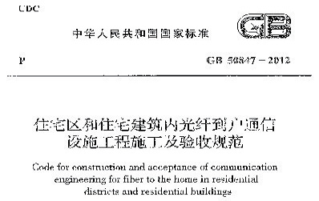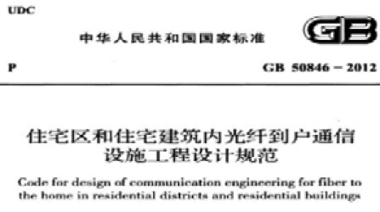

Review taxes and offer some incentives for broadband services and access devices to promote affordability by consumers, especially in low ARPU areas: In China, local governments also provide various subsidies and financial incentives. Jiangsu province provided rural users free wireless broadband access for 3-6 months through subsidy or service purchase. In Xiamen, a household user that changed from ADSL to fiber was subsidized 150 RMB for an optical modem. Yibin municipality allocated 420 million RMB to fund FTTV construction. The government has subsidized £3,400 per household in the UK for universal broadband services and the gigabit voucher scheme. In the Gigabit Voucher scheme, the main aim was to rapidly increase the take-up rate of superfast broadband, so £67m of funding was released in March 2018 to subsidize each household by up to £500. Companies can claim up to £2,500.

# 3.3_ Promoting Digital Transformation

## 3.3.1 Carry Out 5G Application Pilots

On the way to the gigabit society, 5G technology plays a key role, especially in the field of vertical industries. In addition, 5G will facilitate the continuous connectivity of wearables, assistance systems, and household electronics as well as of a variety of sensors and actuators on the Internet of Things via convergent data networks. Major countries have been conducting 5G application pilots in various verticals.

As of March 2021, 258 trials have been conducted in 31 countries (209 trials in 25 of the 27 EU member states and the UK and 49 in Russia, San Marino, Norway, Turkey, and Switzerland). The share of technical tests dropped significantly in the past year, on the contrary, trials concerning 5G Standalone networks and Open RAN have increased. Media and automotive are the verticals majorly driving trials. The most trialed verticals are media and entertainment (39 trials) followed by transport (34 trials) and automotive (24 trials).

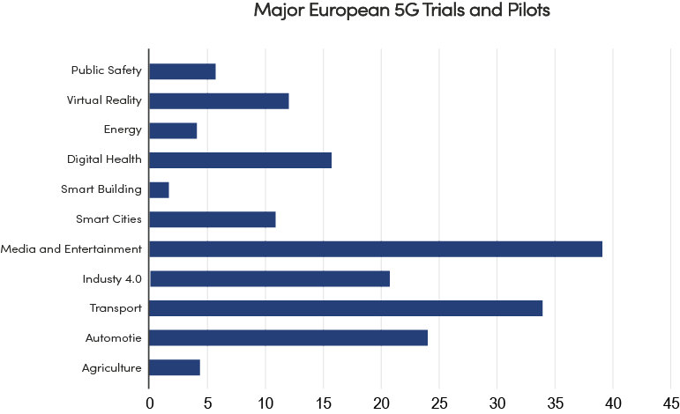

Figure 3-16 Number of 5G tests by vertical in EU27, UK, Norway, Russia, Switzerland and Turkey

|  |
| --- |
| Germany: 5G to become key technology of digital transformation    In a paper released in September 2017, the Federal Government of Germany describes the national 5G strategy (context, actions, rollouts) over the period to 2025. The paper outlined application domains of 5G networks to facilitate and support the digital transformation which include eHealth, future media, intelligent mobility, industry 4.0, smart farming, and smart grids.  Timeline of 5G application pilots in Germany |

## 3.3.2 Promote the Application of New technologies

Numerous nations have developed AI strategies to advance their capabilities, through investment, incentives, talent development, and risk management. Many governments have developed emerging technologies, such as AI, big data, blockchain, frameworks to help spur economic and technological growth. For example, in the field of AI, these range from the US executive order on AI leadership and China’s “Next Generation Artificial Intelligence Development Plan” to “AI Made in Germany”. These strategies focus on talent and education, government investment, research, and collaborative partnerships.

In 2018, China proposed to accelerate the pace of 5G commercialization and strengthen the construction of new infrastructure such as artificial intelligence, industrial Internet, and Internet of Things. In 2020, intensively mentioned the need to speed up the construction of new infrastructure. What is more, China declared to become the world`s leading AI innovator by 2030 in its “a next generation AI development plan” which announced plans to invest tens of billions of dollars in AI research and development. Tens of cities also make plans in AI development, for example Beijing announced a US$2.1 billion AI-centric technology park, and Tianjin plans to set up a US$16 billion AI fund.

For years, the United States has been a leader in public and private AI research. According to a Deloitte report, US has continued to investment in AI sector in last several years. In 2012, venture capitalists funded US$282 million in AI initiatives, and that number skyrocketed to US$5 billion by 2017. The following year, AI investments by VCs topped US$8 billion.

The German government is looking to accelerate the adoption and development of AI technologies. As a result, it was planning to invest 3 billion Euro in AI research from 2019 to 2025 to help implement its national AI strategy (“AI Made in Germany”). Like many countries, Germany hopes that adopting AI will expand its broader economy and improve the competitiveness of its existing industries. Germany’s strategy is holistic, emphasizing not only improved competitiveness but the responsible use of AI and its impact on the German workforce.

Iran is playing the leading role in the region in the field of new technologies, such as AI, FinTech. Iran has the largest startups in the region in various fields of ICT and biotechnology and efforts to develop artificial intelligence have begun in the country with investment in this area and are continuing in earnest.

## 3.3.3 Promote the Digital Transformation of State-owned Enterprises

For some countries like Iran and China, state-owned enterprises (SOEs) are an important pillar of economic and social development and a key link in the industrial chain. The digital transformation of key SOEs will promote the restructuring of the industrial chain and reshape the industrial ecosystem. It will also drive ICT infrastructure development and technological innovation and provide solutions for carbon neutrality. Therefore, it is significant to encourage the SOEs to actively promote digital transformation.

Currently, most of the SOEs have started the journey of digital transformation and reached different stages. However, due to the fact that digital transformation is a complex cause involving the reform of business, management, talent, and technology, etc. and that SOEs have their own characteristics compared with private enterprises, the digital transformation SOEs is a challenging task. Take China as an example, most SOEs are still in the initial stage of digital transformation. According to a study by Inspur [20], by the end of 2020, most SOEs are in the primary or intermediate stage of digital transformation, and only about 5.3% of SOEs have reached the advanced stage. According to Deloitte[21], the progress of digital transformation varies significantly among different sectors. For example, the level of digital transformation in sectors such as ICT and media is higher, while in traditional sectors such as automobile, electric power, machinery, oil and gas, and chemical, digital transformation is still at the early stage facing critical difficulties.

In China, digital transformation has become one of the priorities of the reform of SOEs. In August 2020, the State-owned Assets Supervision and Administration Commission of the State Council (SASAC) issued the Notice about Accelerating Digital Transformation of State-owned Enterprises, which provides overarching guidance, makes comprehensive arrangements and sets the directions for SOE’s digital transformation. In March 2021, SASAC collected and released 100 typical application cases of SOE’s digital transformation, to summarize the experience and practices of digital transformation and give full play to the exemplary and leading role of SOE. A total of 100 typical cases were selected in 8 categories, including product and service innovation, intelligent production and operation, digital marketing service, digital ecosystem, new generation information technology, industrial control and security, management system of integration of ICT application with industrialization, and others.

Concluding points

The government plays a key role in promoting ICT infrastructure development and digital transformation.

ICT infrastructure is a key driver of GDP growth and lays the foundation to develop digital economy. According to ITU, for middle-income countries, every 10% increase in FBB and MBB penetration leads to 0.5% and 1.8% increase in GDP growth, respectively.

It is recommended that the government of Iran create a favorable policy environment to promote the ICT industry’s development, with measures of tax incentives, tariff adjustment, reducing cost of infrastructure development, enhancing digital resilience, and promoting 5G deployment.

Telecom operators in Iran are experiencing heavy obligation and strict telecom tariff control. At the same time, due to the fluctuation of exchange rate, inflation and block of some international digital platforms, the revenue of telecom operators grows slowly, which leads to insufficient investment for the construction of new-generation ICT infrastructure such as 5G and FTTx. To increase the telecom sector’s revenue and foster its long-term development, it is suggested to

* reduce the obligation of telecom sector to 25%-30%, which is the average level in main regions of the globe,
* start marketization reform of tariff to give telecom operators more initiative in setting the price for the services they provide,
* issue FMC licenses to telecom operators to encourage business innovation and competition,
* and encourage the development of local digital platforms.

The government of Iran could also reduce the cost of ICT infrastructure development by introducing favorable energy prices or subsidies for telecom operators to construct and use ICT infrastructure, promoting fiber pre-deployment in new buildings, and encouraging network co-deployment and sharing.

With increasing number of 5G users in Iran anticipated in the next five years, it is recommended that the government of Iran introduce subsidies for 5G deployment, encourage telecom operators to make 5G coverage commitments, and provide adequate spectrum at affordable price.

There are also various measures that the government could take to promote digital transformation, such as encouraging 5G application pilots in various vertical sectors and promoting the application of new technologies like AI, etc. It is also recommended to accelerate the digital transformation of key SOEs, so as to promote industrial chain restructuring and reshape the industrial ecosystem.

Chapter 4: INNOVATION & TALENT DEVELOPMENT

# 4.1_ Digital Innovation Framework

ITU developed the Digital Innovation Framework in 2017, enabling countries to map key challenges and opportunities in their ICT innovation ecosystems and assists stakeholders through their innovation journey. The Digital Innovation Framework offers comparable measurements to actively foster vibrant innovation ecosystems, and so nurture digital transformation for sustainable growth.

ITU Digital Innovation Framework identifies six main stakeholder groups and what they need in the innovation system. Using the Framework, a country can develop the innovation journey map to confirm whether each stakeholder’s role during the life cycle of innovation from pre-ideation to high growth is well supported or not, setting out the work that needs to be done within the ecosystem to harness innovation.

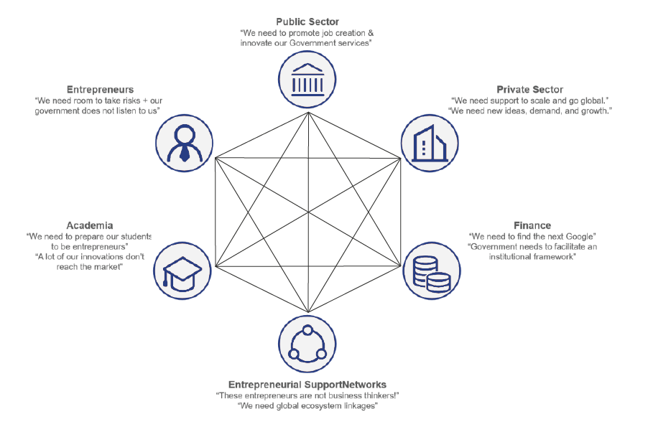

Figure 4-1 What main stakeholder groups needed in digital transformation

(Source: ITU)

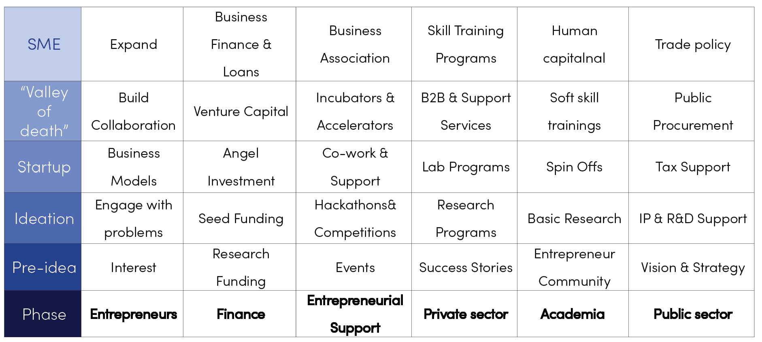

Table 4-1 Middle-income country innovation journey map

(Source: ITU)

The framework also outlines seven critical pillars of an innovation ecosystem. They need to be assessed to obtain a comprehensive view of the system’s performance. Combined with stakeholders’ journey map, the issues pertaining to each pillar helps identify the opportunities of, and barriers to, digital transformation.

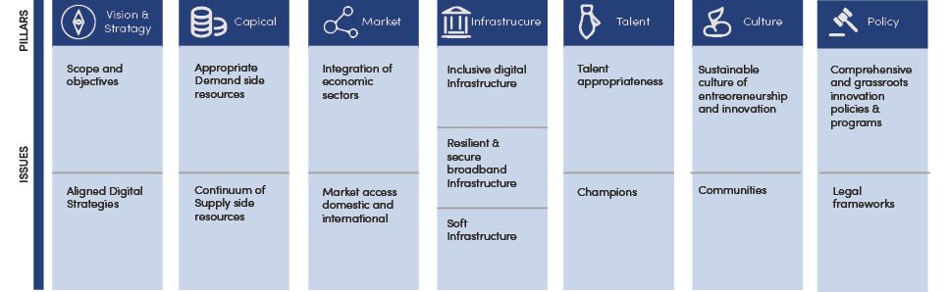

Figure 4-2 Critical pillars of an innovation ecosystem

(Source: ITU)

# 4.2_ Global Digital Innovation

The global Internet innovation is not balanced, China and US have outstanding advantages in digital innovation, US has 8 tech giants of top 10 largest market-value Internet company and China has the others. Tens of ICT companies have developed various Internet websites, mobile applications and platforms, such as search engines, social media, e-commerce, transportation, travel, map, sharing economy among others.

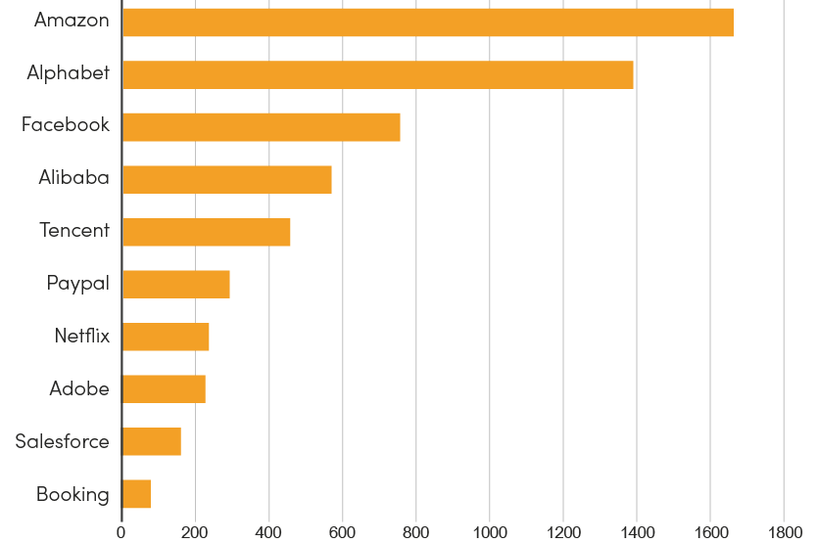

Figure 4-3 Top internet companies worldwide by market value (in billion US dollars) as of Feb. 2021

(Source: Statista)

Priority and advantage in major countries’ digital innovation

* China is expanding to Southeast Asia, Middle East and Africa as well as depth into AI algorithms, robot, and chips.
* US has built a high ground for Internet through technological innovation, which products covers chips, operating systems, and applications.
* European countries such as Denmark, Finland, Norway, France, and the United Kingdom have invested more in the innovation of government and enterprise informatization.
* South Korea, relying on the advanced information infrastructure, has promoted the innovation of 5G network equipment manufacture. KakaoTalk, the biggest Internet company in South Korea, has developed a set of innovative Internet applications, such as social networks, mobile payments, and online music.
* Japan, relying on unique culture such as Japanese comics, cartoons, and games, developed message application Line, which has successfully occupied the market in Japan and expanded to Southeast Asia, Latin America, Spain and other regions. Russian companies, Yandex and Mail.ru, become the most popular search engine and news website in Russia and Russian-speaking countries.

# 4.3_ Digital Ecosystem and Landscape in Iran

Based on the ITU Digital Innovation Framework and current digital landscape of Iran, Iran’s digital ecosystem can be concluded as in Figure 3-4. The digital ecosystem encompasses the policies & strategies, infrastructure, technologies, applications and finance. The manner in which this system is constructed and operates is an aspect of emerging paradigms that consider the interplay between ICT multi-level usage by various stakeholders. MICT plays a key role in this ecosystem.

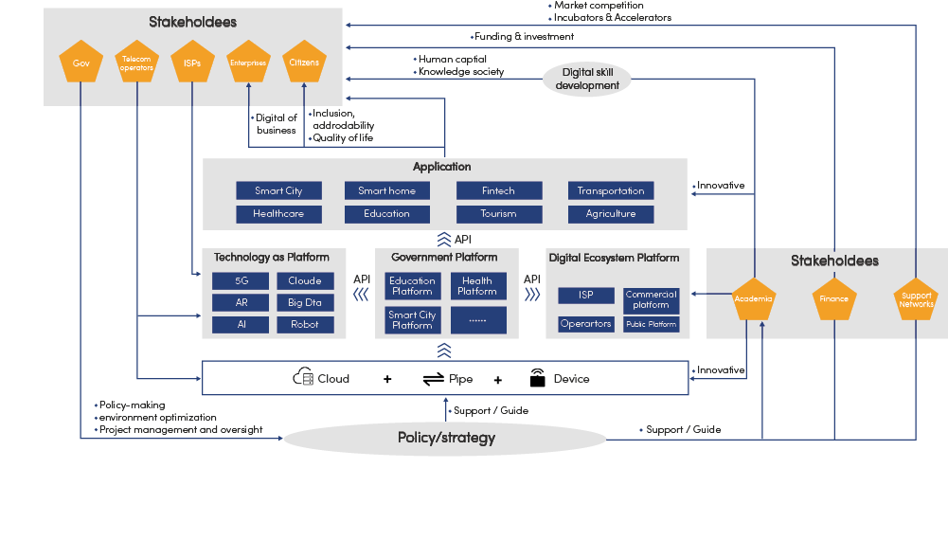

Figure 4-4 Digital Ecosystem of Iran

Iran has by and large established a fully-fledged digital landscape, bringing together public and private players, both domestic and global, in sectors of smart devices, telecom, and digital platform and vertical industries.

Iranian ICT companies continue to innovate in software, hardware, digital platforms, network services, mobile Internet applications, artificial intelligence, etc. Some SMEs have developed localized digital productions, for example, Sky room in online education, Digi Kala in e-commerce, Bazaar Café in app store, tens of companies in digital healthcare, financial technology, smart city. However, most of ICT innovation companies are startups and SMEs. What`s more, ICT innovation companies face challenges and difficulties such as insufficient human resources, insufficient investment, and poor network infrastructure.

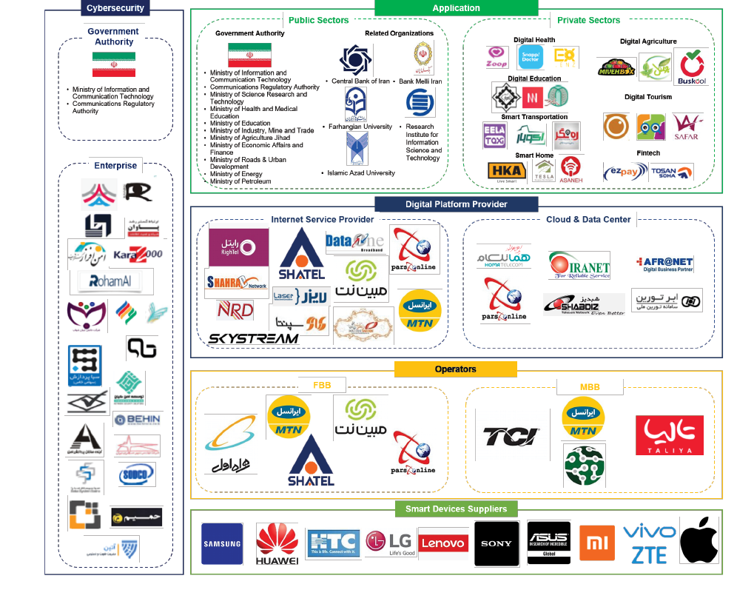

Figure 4-5 Digital landscape in Iran

SibApp and Cafe Bazaar has in respect occupied the largest share of IOS and Android market in Iran. SibApp witnessed a significant decrease of application developers in 2019 and 2020 due to the issue of apple sanctions against Iran. While Cafe Bazaar has achieved 43M+ registered subscribers, 67K+ developers, 4,770+ Billion IRR developer income, and 90M+ transaction per day in 2019. Among the developers, 43% of them are active with 24K focusing on app development and 5k on game.

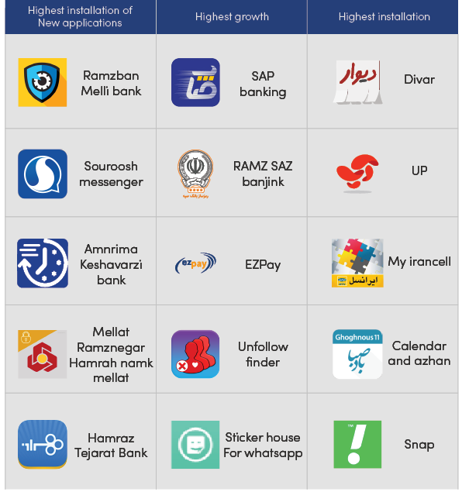

Figure 4-6 Top applications in Iran

(Source: CafeBazaar)

# 4.4 Talent Competitiveness

The digital talent gap is a challenge for employers everywhere and will continue to be a huge problem worldwide. Hiring demand is increasing as HR and business leaders worldwide are experiencing digital talent shortage, and are concerned about finding the right skills, according to PwC’s 21st CEO Survey. In 2018, 80% of CEOs say they are worried (up from 77% in 2017), and 38% are extremely concerned (up from 31% in 2017) about losing ground in the digital world because of failure to find and hire employees with the key skills.

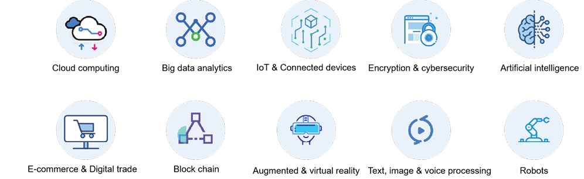

Figure 4-7 Based on WEF: The Future of Jobs Report 2020

all of the top ten rising skills are digital related.

Iran is striving to transform from a hydrocarbon economy to a knowledge economy where scientific innovation will be the main momentum to sustain socioeconomic growth. In fiscal 2018-19, Iranian crude oil and natural gas exports accounted for 18 percent of GDP, while in contrast, the same figure of Saudi Arabia was about one-third, indicating Iran is becoming less dependent on energy. However, Iran’s current dependency on hydrocarbons is still heavy enough to put its economy in a vulnerable position facing US sanctions, according to a report released by the Research Center of Iran’s Chamber of Commerce on Iran’s economic risk and its 10-year forecasts[22]. Therefore greater investments in talent development, are still needed to transform the country into more diversified, innovative and creative economies.

Iran demographics

* 60% of population is under 35 years old
* High literacy rate of 96.6% (between 10-49 years old)
* Annually about 60,000 graduated students in computer and electric fields (from 2019-2024 potentially nearly 300,000 students of STEM fields will be graduated)

Table 4-1 shows the competitiveness performance of selected countries in terms of talent and skills market, with Malaysia and Germany taking the lead, while considerable gap can be observed between Iran and the leading countries, and there is a holistic downtrend from 2018 to 2019 (except Redundancy Cost which remains the same level).

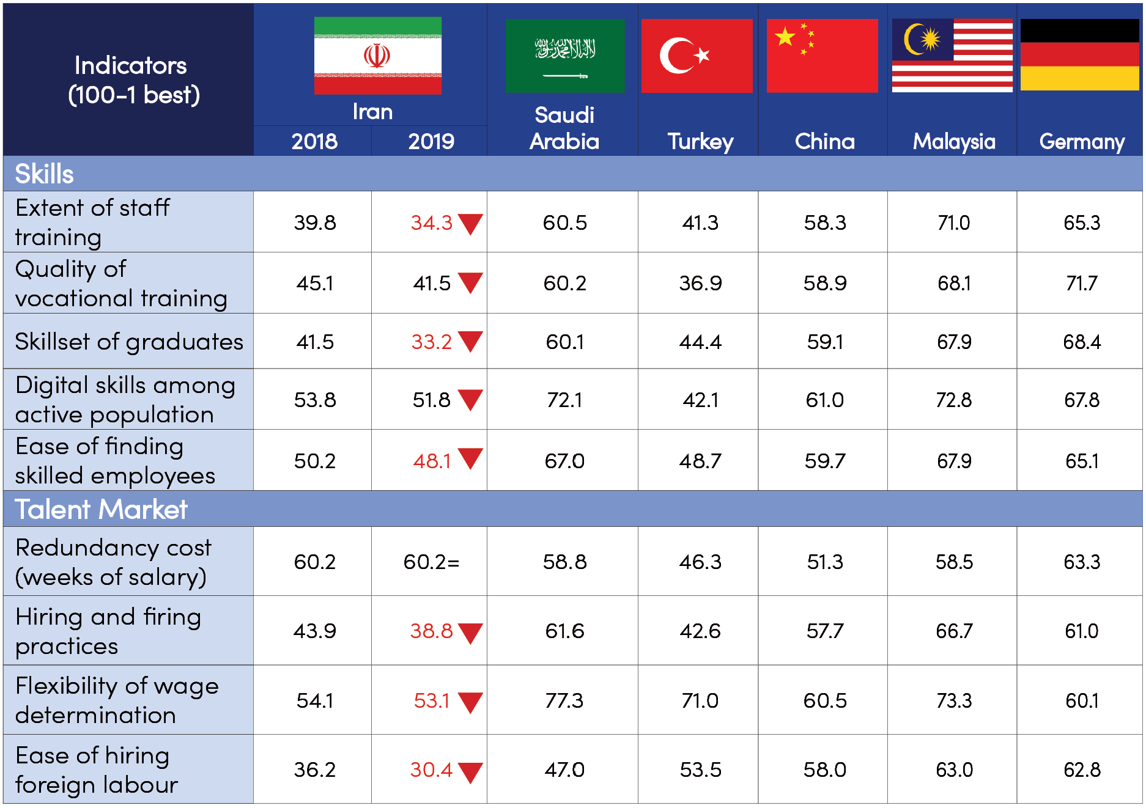

Table 4-2 Performance benchmarking of talent skills and market

(Source: Global Competitiveness Report 2018 and 2019)

# 4.5_ Challenges in Talent Sector

From the benchmarking, several issues emerged, namely education system quality, talent shortage and skills deficit, which impacts Iran’s ability to progress, innovate and compete globally.

CHALLENGE 1: STAGNANT EDUCATION SYSTEM

Decline in skillset of graduates, digital skills among active population, and quality of vocational training reflects that the education system in Iran has not been geared to socioeconomic development.

Iran is facing an over-education crisis. According to UNESCO statistics, in 2018, more than 3.6 million were studying in Iran’s universities, equivalent to 4.4% of country’s total population. For comparison and better understanding, the corresponding figure for China was 3.2% while China’s economy is about 30 times the size of Iran’s economy. The education system in Iran is producing far more college graduates than the domestic economy can absorb.

The conclusion can be easily proven. Statistical Center of Iran figures[23] put Iran’s unemployment (age 18-35) population at 2,429,270 (19.6%) in 2018, and unemployment of higher education graduates at 1,271,729 (18.3%), inferring that half of these unemployed youth are college graduated. This trend has gotten worse, for the share of the unemployed higher education graduates out of the unemployed youth has increased from 52% to 56% within one year from 2018 to 2019.

With regard to Science, Technology, Engineering and Mathematics (STEM) field, from 2016 to 2018, more than 40% of graduates (annual average) are from STEM in tertiary education, remaining a share by a wide lead compared to the selected countries (except Malaysia). While the skillset of graduates and the ease of finding skilled employees are instead undergoing a downward pressure as reported by the Global Competitiveness Index, reflecting most of Iran’s high-school and university education method is stagnant and theoretical rather than skill oriented.

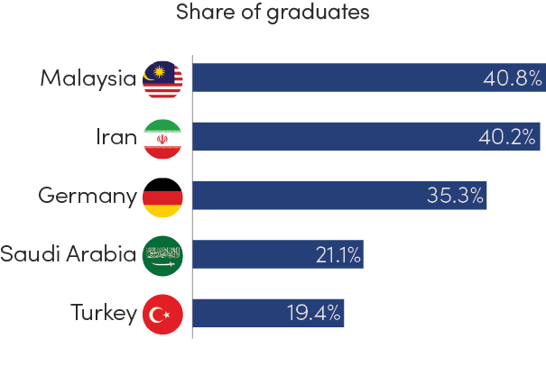

Figure 4-8 Share of graduates from STEM tertiary education programs in selected countries in 2018

(Source: UNESCO Institute for Statistics)

CHALLENGE 2: TALENT SHORTAGE

Iran has been overwhelmed with massive brain drain. Every year between 150,000 and 180,000 elites and specialists leave Iran, ranking first in the world, costing the country (by some estimates) what it makes from selling oil[24]. The number of students migrating from Iran is also growing. US, Turkey and Germany are the most popular destination among Iranian students for migration. 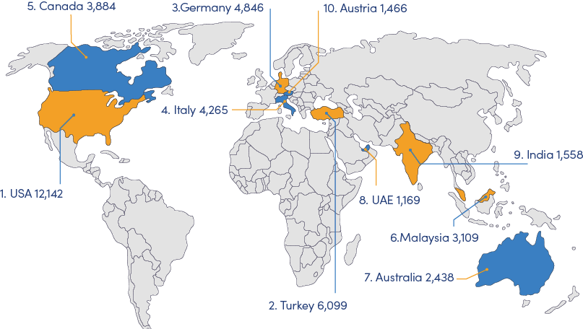

Figure 4-9 Which countries hosted the most Iranian students

Economic problems are among the most important reasons to the brain drain issue. During the parliament’s open session on March 7, 2021, MPs pointed out that a professor with 40 years of experience can only earn an income of $560 each month in Iran, yet a member of the managing board receives $2,000 a month. Looking overseas, Iran’s neighboring countries offer between $10,000 and $15,000 to faculty members of universities and elites.

Despite livelihood pressures, burdens also come from politics and society. Although paralyzing US sanctions pushed Iran’s education system to be more creative, they have posed complex challenges for students and scholars. For example, sanctions on the Iranian banking system incurs failure to pay for access to international academic journals in many universities.

Another form of oppressing professors in Iran is the regime’s interference in their teaching. Uneducated regime officials or affiliates in the management of universities sabotage the work of independent professors through inappropriate and unprofessional interference. Those who comment on professors’ performance do not have scientific competence themselves, or if they do, use other criteria as the reason for assessing the professor.

CHALLENGE 3: SKILLS DEFICIT

The benchmarking and YoY comparison of performance in Global Competitiveness Report exposed reasons of skill deficit in Iran.

Growing difficulty of hiring foreign labor reflects the lack of programs to attract high-skilled global talent to fill specific skills gap. As the Global Talent Competitiveness Index reported in 2020, Iran ranked 131 out of 132 economies in terms of attractiveness indicator.

Extent of staff training is declining, reflecting the employers’ reluctance to invest in training their employees. In 2017, Alireza Ashraf, Secretary General of ICCIMA pointed out that neglecting the required skills training in the industrial sector had become one of the serious problems of Iran[25]. According to PwC, the disruption that an immersive upskilling programme can have on staff’s day-to-day business activities is the biggest concern of Middle East CEOs.

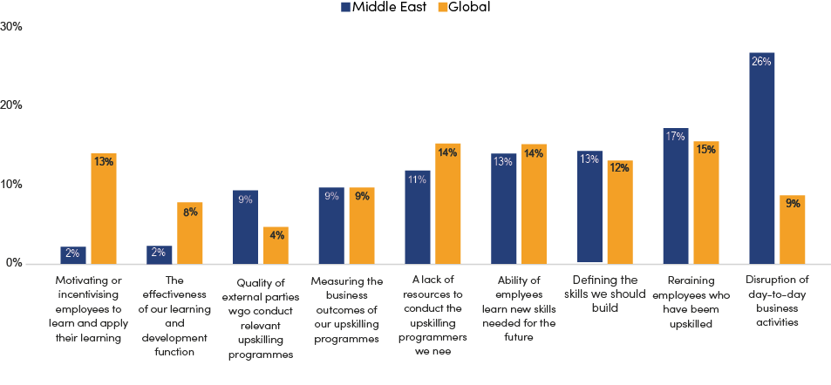

Figure 4-10 CEOs’ ranking of three greatest challenges their organization currently faces in its upskilling efforts

(Source: PwC’s 23rd Annual Global CEO Survey)

Quality of vocational training has also experienced a decline. Iran’s Technical and Vocational Education and Training (TVET) system is consist of two parts, one is formal vocational education system presented according to a pre-planned curriculum, and the other is non-formal TVET presented by the Technical and Vocational Training Organization (TVTO), executive organizations and economic enterprises. According to Instructor Training Center (the biggest center in the fields of expertise training in Iran and Middle East), Iran’s TVET system is facing challenges from development of a national qualification framework (NQF), market need identification, capacity building of teachers and trainers, and funding diversification.

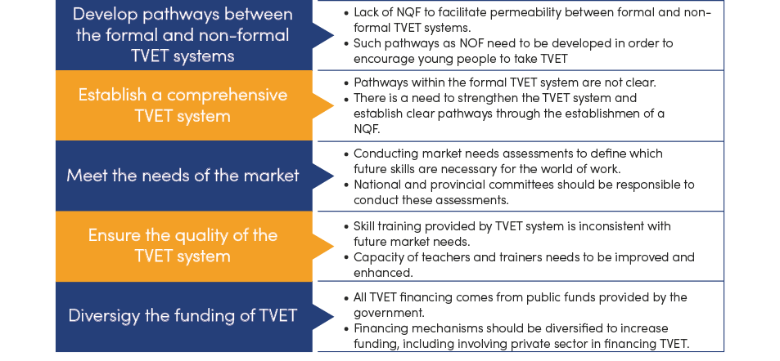

Figure 4-11 Challenges to the TVET system in Iran

(Source: UNESCO & UNEVOC, TVET country profile)

From the analysis above, it is urgent for Iran to identify the needs of talent market, grow and retain talent and attract high-skilled global talent to bridge the fast widening gap in talent development.

# 4.6_ Key Priorities of Talent Development

PRIORITY 1: IDENTIFY MARKET NEEDS

As Iran is progressing from a hydrocarbon economy to a knowledge economy, a larger pool of talent and a highly skilled workforce are required to motivate and accelerate the transformation. Before massive investment, it is vital to precisely identify what industries requirements are.

Iran has launched 99 Monitoring Plan which, according to the Ministry of Science, Research and Technology, calculates the employment statistics of 14 industry fields in three levels of bachelor, master and doctorate. 88 universities, research institutes and governmental and non-governmental higher education centers have their contribution in this study. By monitoring the employment status of graduates, it is possible to obtain useful information of what business market requires and, in addition to improving programs, to guide students to the appropriate labor market with job counseling.

As the Plan results revealed, the highest employment rate come from technical and engineering fields, humanities and basic sciences, and the highest unemployment rate is related to art fields. Mechanical, accounting and electrical engineering at the master’s level and civil engineering, computer and materials at the doctoral level have the highest employment.

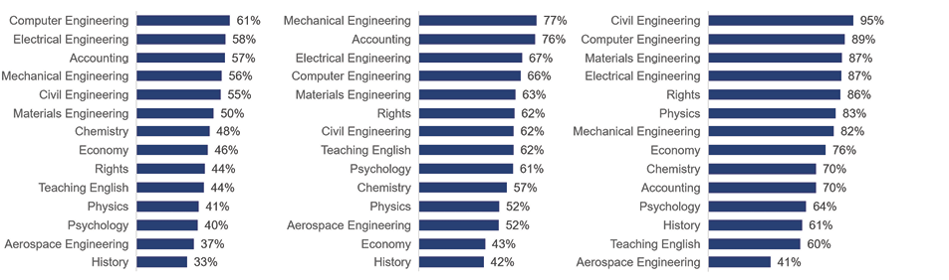

Figure 4-12 Employment rates of graduates in different fields and levels of education

Other countries like Malaysia have developed a set of instruments, monitored by an independent agency (Critical Skills Monitoring Committee), to produce insights into talent shortage identification. The results will be utilized as the basis for policy-making and coordination across different government departments and public institutes, to accelerate policy response to the changing market needs.

|  |
| --- |
| Malaysia: Critical Occupations List (COL)  The Critical Occupations List (COL) is a set of occupations in demand that identifies the skills imbalance across 18 economic sectors in Malaysia. It aims to be the primary instrument to promote better coordination of human capital policies aimed at attracting, nurturing and retaining talent.  Collated on an annual basis by the Critical Skills Monitoring Committee (CSC), led by TalentCorp and the Institute of Labor Market Information and Analysis (ILMIA) under the Ministry of Human Resources (MOHR), the COL was developed based on recommended international practices. Its compilation process is based on regular consultations with the World Bank.  Because the COL is developed with the data from employers, it provides a big picture of the skills and occupations that are in demand within the industries. It also gives you a better idea of the occupations that will be prioritized by policymakers, especially in the aspects of immigration, education and upskilling opportunities.  How the COL is created and utilized    (Source: TalentCorp, Malaysia) |

PRIORITY 2: GROW AND RETAIN TALENT TO BRIDGE THE FAST WIDENING GAP

As organizations and countries seek to be more competitive in today’s changing digital ecosystem environment, ensuring an adequate supply of high-potential and high-performing workers will be a critical success factor particularly for knowledge-intensive industries. Key actions should include enhance Technical and Vocational Education and Training (TVET), foster talents through greater cross-sector collaborations and accelerate talent return.

It is a priority for Iran to build a scientific National Qualifications Framework (NQF) in order to strengthen Technical and Vocational Education and Training (TVET). Germany has created an eight-level NQF for lifelong learning based on learning outcomes. The framework aims to increase transparency and comparability of qualifications and permeability in the education and training system, to increase the skill and learning outcomes orientation of qualifications, to support learner and worker mobility and to promote lifelong learning. It also aims to support the validation of non-formal and informal learning, by acting as a guiding tool in the identification and assessment of skills during validation procedures.

\

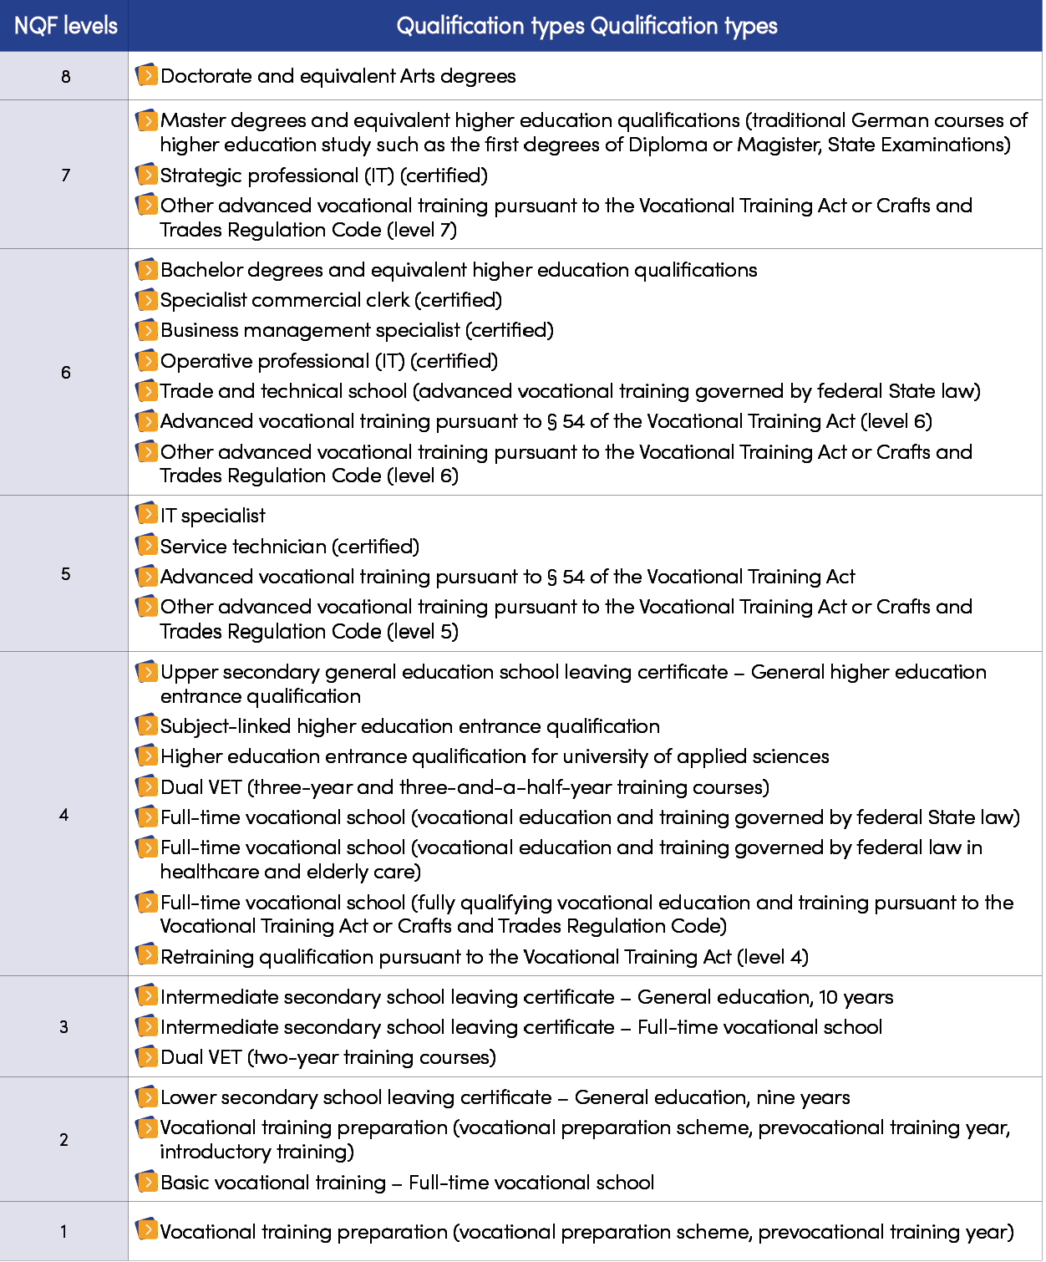

Table 4-3 National Qualification Framework of Germany

Cross-sector collaboration is highly valued by governments worldwide in terms of fostering talent, which includes industry-academia collaborations and cross-industry collaborations. Collaboration between companies and universities is to address skills mismatches in talent market and strengthen the graduate readiness for the workplace. Partnerships and collaboration cross industries will be most effective to address sectorial challenges, uplift digital knowledge and emerging digital skillsets, and cultivate innovation with cross-industry experiences.

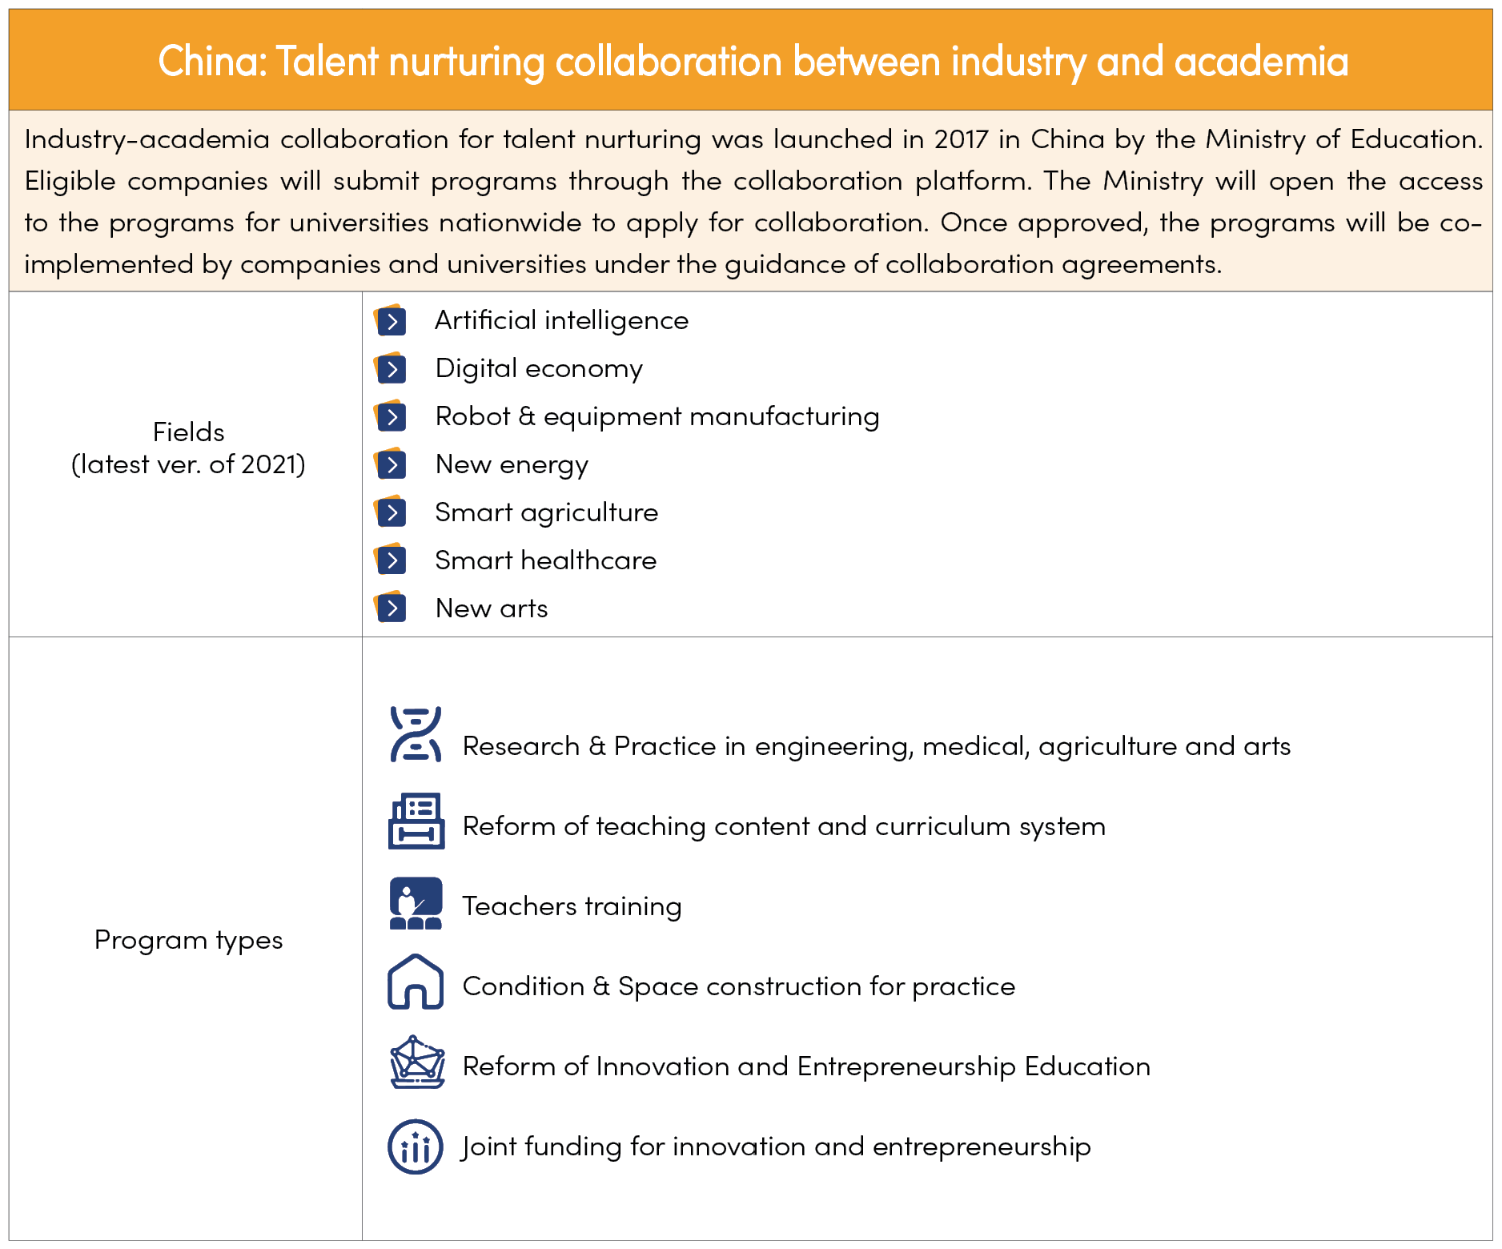

(Source: Ministry of Education, China)

Iran experiences high levels of emigration of highly trained or qualified people. If current underlying issues are not addressed, brain drain can set off a potentially vicious cycle of talent leakage and weakened economy in the long run. It is urgent for Iran to optimize incentives and policies, and to facilitate the return of Iranian professionals.

While developing towards a high-income country, to keep up with the salary expectations of talent and remain competitive, Iran could take into account of optimizing salary amount based on skills complexity and market benchmarking. Salary benchmarking, also called compensation benchmarking, is a process by which compensation professionals match internal jobs and their descriptions to similar jobs and descriptions in a salary survey or other source of market pay data, in order to identify the market pay rate for each position.

To facilitate the return of Iranian professionals, the government should connect job opportunities through job portals and career fairs, and create an enabling environment, such as enabling non-national spouses to work and facilitating schooling of children.

Malaysia: REP-facilitate the return of Malaysians

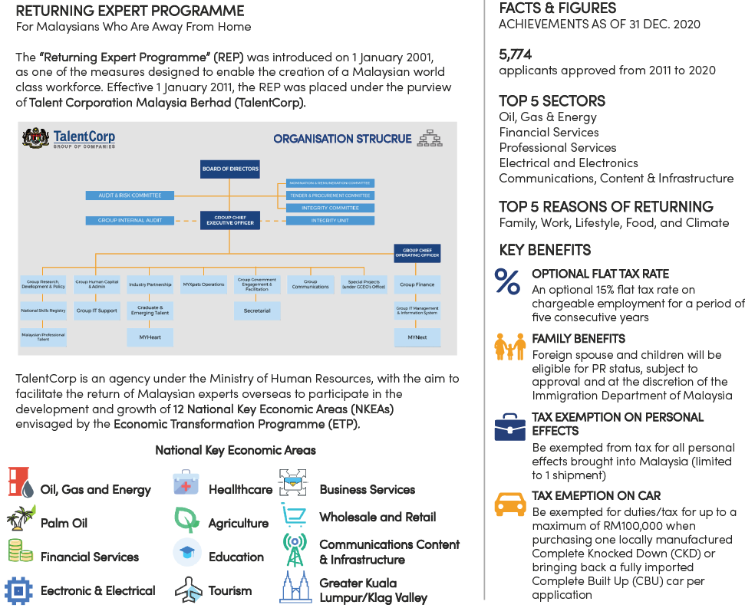

PRIORITY 3: ATTRACT HIGH-SKILLED GLOBAL TALENT

Talent nurturing is a long-term method to increase talent supply, while in short term, attracting global talent to work for Iran can quickly fill up the current gaps that exist in relatively new capabilities and skills, in order to meet the growth demands, to have positive spillover effect on local talent development and to help global companies to expand into foreign markets. Such measures as visa and tax reform have been implemented around the world.

|  |
| --- |
| Singapore: launch Tech Pass to attract global talent  Despite 20% of Singapore’s workforce being foreigners, the Government is starting a new programme to get more foreigners to work in Singapore. The Economic Development Board (EDB) announced plans to launch a new targeted employment pass called Tech. Pass to attract founders, leaders and technical experts with experience in established or fast-growing tech companies, so as to contribute to the development of Singapore’s tech ecosystem. |

|  |
| --- |
| Italy: provide tax incentives to attract foreign talents  Italy has revised and extended the benefits for workers who transfer their tax residence to Italy. This reduction is one of the widest across Europe and will allow foreign people (employees, freelancers or retired) to come to Italy with a relatively low tax rate on their worldwide income.  DIFFERENCE  The benefit has been extended to all workers.  The benefits also apply to business income produced by people who return to Italy who start a business from 2020. |

Chapter 5: POLICY RECOMMENDATION

# 5.1_ Improve ICT Regulatory Adaptiveness

* Adapt to the rapid changes in the ICT market, technology, and applications, accelerate reform of the ICT regulation, and adopt more flexible, inclusive, and prudent regulatory methods such as principle-based regulation, Regulatory Sandbox, etc.
* Consider the RegTech as the savior. Since traditional regulatory interventions may no longer be efficient in the digital era, RegTech solves specific issues, stimulate innovation, provide an agile regulatory approach, and enhance monitoring and regulatory compliance of regulated entities and regulators in any sector.
* Build collaborative regulatory mechanisms: a) Highlight the strategic significance of ICT development and digital transformation and build a high-level mechanism that involves the ICT regulator as leader and regulators of other sectors, including health, education, finance and energy, etc. b) Reduce unclear delineation and overlapping of regulatory responsibilities by adopting methods such as signing inter-departmental MoU, building a joint regulatory mechanism, etc.
* Build dialogue and cooperation platforms among the ICT regulator, the industry, and third-party organizations to deeply understand the various opportunities and challenges of ICT development and facilitate evidence-based regulation. Enhance bilateral and multi-lateral cooperation in the ICT field.

# 5.2_ 5.2 Support ICT Infrastructure Development

Accelerate the construction of fiber optic network

* Create a favorable policy environment that encourages telecom operators to accelerate the construction of fiber optic network and provide high-bandwidth and high-reliability broadband services to subscribers, especially for governments, public institutions (schools, hospitals, etc.), and large enterprises, etc.
* Develop and implement regulation on fiber pre-deployment in new buildings, to lay the ground for large-scale rollout of FTTH in the future.

Accelerate the construction of 5G

* Develop national strategy and roadmap for 5G development; reduce spectrum costs to deploy 5G; stimulate investment through tax exemptions in the industry; enhance cross- sector collaboration for 5G deployment.
* Develop pilot projects: Encourage companies to pilot new ideas, business models, and new products in various verticals.

Promote data center development

* Expand the scale of data centers, and promote MCI, Irancell, and large data center companies to develop data centers, from targeting 5,000 racks in 2026.
* Promote various government services and localized applications, financial services, and industry services to be deployed in cloud and data center. Attract International Internet companies to invest in data centers in Iran.
* Reduce the cost of electricity for data centers, and shift from transmitting electricity to neighboring countries to transmitting information.

Encourage investment in ICT infrastructure development

* Reduce the tax rate and government loyalties of the ICT sector, especially in the infrastructure-related field, such as equipment import tax, to attract more funds into Iran’s telecom market and furthermore generate positive effects in socio-economic development.
* Reform the regulation on telecom tariff, increase market flexibility and reduce government intervention. So, the telecom operators will have the enthusiasm for investing in ICT infrastructure, especially in the initial stage of 5G construction, which requires a huge investment. A reasonable rate of return on investment could attract more capital into new infrastructure construction, such as 5G, data center, and AI, and promote the sound development of the ICT sector in the long run.

Authorize the private sector to play a significant role in development

* Consider Multi-Sim Technology (MST) as a requisite for the broad adoption of VoLTE/ViLTE technologies to make them competitive with OTTs’ ability to work with multiple numbers simultaneously.
* Cross their hearts to provide people with the highest quality of service, and this must be achieved by defining monitorable KPIs. Early days of adoption by people are so sensitive that if operators forget what they promised, people won’t forgive, and the market for VoLTE/ ViLTE is all gone.
* Bear in mind the difficulties and time-consuming nature of defining interconnection and roaming agreements while OTTs are not subject to them.
* Consider wider accessibility of OTTs on desktop and laptop computers, a feature that VoLTE/ViLTE technologies cannot offer, for they are limited to mobile and tablets.
* Calculate the population of users with devices compatible with VoLTE/ViLTE technologies. Different operating systems and firmware add to the complexities operators confront in developing the market for these technologies, and an OPEX overshooting might be a consequence
* Remember that higher gains of VoLTE/ViLTE technologies come with more considerable pains of privacy/security breaches, among which are overbilling, DDOS, and users’ geolocation disclosure.
* The policy paper recognizes that the government is enabling – local businesses and individuals will ultimately determine the success. The recommendations are built around the following steps:
* Stop tariff freezing and instead focus on retail tariff regulation based on costs as a matter of urgency since VoLTE/ViLTE technologies need a move from Circuit Switches (CS) to IP Multimedia Systems (IMS), and that means higher CAPEX.
* Recognize the independence of the market and avoid any pressure on operators, for they will develop the 5G technology across Iran as soon as tariffs are regulated. Evolving towards 5G will ease up efforts to adopt VoLTE/ViLTE.
* Be aware of the enormous risks that VoLTE/ViLTE technologies impose on the nascent ecosystem of OTT platforms in Iran. Coming up with a multi-stakeholder solution like the one Google and Verizon followed is a must so that VoLTE/ViLTE technologies are not pursued at the expense of OTTs’ market viability.
* Earn social trust with all they can since the Iranian society might still choose the privacy of foreign OTTs over that of VoLTE/ViLTE technologies. More precisely, VoLTE/ViLTE technologies require users’ registration and authentication due to the need to use a physical sim card, while OTTs do not bear the same burden.
* Learn from successful experiences worldwide, like that of Korea. This country owes much of its success to the competitive market of mobile operators. So, policymakers must monitor the anti-competitive acts of the duopoly in the market and ensure that market entry is not blocked.
* Free up the 698-850 MHZ frequency to accelerate the development of VoLTE/ViLTE technologies and assist the operators in reaching better signal coverage.

Reduce the construction costs

* Provides favorable energy prices or subsidies for telecom operators so as to encourage construction of new ICT infrastructure such as 5G and data center. Encourage the use of renewable energy in ICT infrastructure.
* Promote infrastructure sharing. Establish an infrastructure sharing regime among telecom operators on the principles of neutrality, non-discrimination, and equal access. Use existing public infrastructure, especially the power infrastructure, to build FTTx network. Strengthen coordination with relevant government agencies and public institutions to open public buildings and street infrastructure (bus stations, street light poles, etc.) for ICT infrastructure deployment for free or with favorable charging standards.
* Promote fiber pre-deployment. The relevant government bodies of Iran jointly release guidelines or standards that promote fiber pre-deployment in newly-developed buildings.

# 5.3_ Promote Digital Transformation

Enhance top-level design of digital transformation in various sectors.

* Develop national transformation strategies in major sectors, formulate industry digital development strategies, plan digital transformation roadmaps, clarify new technology application directions and promotion plans, and progressively promote strategy implementation.

Establish a data asset management system.

* Clarify data collection and management responsibilities, formulate unified data standards, to ensure the data completeness, readability, accuracy
* Dig the value of data by applying technologies such as big data and AI, to lay a solid foundation for digital transformation.

Build digital infrastructure in vertical sectors.

* Promote the construction of ICT infrastructure in vertical sectors. For example, in oil and gas sector, build a private network to connect various terminals, such as wells, metering station, water injection station, and handset. Accelerate the upgrade of oil and gas pipeline to digital and visual pipeline by installing IoT sensor, remote control and monitoring equipment.

Improve digital government by migrating to citizen-driven/business-driven smart services and enhancing data management.

* Develop common platforms that supports further service development, cross-function integration, and therefore create new models for sharing and collaboration among government agencies. Develop a central portal that delivers all government services to the citizens/businesses through simple online and mobile application interfaces.
* Deploy government data center at “national – provincial – municipal” levels. All levels of data center should be built in a unified manner to avoid duplication and system isolation. Link data from all government agencies, regardless of ownership, and promote integration of data and services among government agencies.
* Adopt cloud as a preferred deployment tool (Cloud First Policy) for administration as well as delivery of public services.
* Enhance legislation to protect online consumers from fraud, including e-commerce laws ensuring cyber security of online contracts and transactions; promote the process of awarding e-Namad license; improve the construction of supportive infrastructure, including 4G network, secure internet servers, etc.; and accelerate the transformation of the National Post Company into a national e-commerce platform and a national service operator.

Encourage state-owned companies to implement digital transformation

* Attach importance to the exemplary and leading role of SOEs in implementing digital transformation. Launch an initiative of SOE’s digital transformation. Guide SOEs to devise their digital transformation plans. Collect and release typical application cases of SOE’s digital transformation for demonstration and sharing.
* Encourage SOEs to cultivate digital transformation talent teams, improve the ICT infrastructure, apply cutting-edge technologies such as the IoT, big data, blockchain, mobile Internet, and AI, and carry out digital transformation pilot projects at different links of the business process according to their own characteristics.

# 5.4_ Foster ICT Innovation and a Better Ecosystem

* Foster friendly policy environment for innovation and entrepreneurship, simplify business registration procedures, reduce or exempt taxation for technology-based start-up enterprises, and provide legal and taxation advice.
* Enhance ICT infrastructure to facilitate ICT innovations in broadband network, public cloud, IXP, international bandwidth and others.
* Promote competitions in ICT application and innovation to encourage the innovation process in startups and SMEs with seed funds provided by government and investment institutions.
* Develop roadmap of digital transformation for governments and large state-owned enterprises, synchronize online and offline businesses and services, and build up digital teams.
* Encourage ICT innovative companies to develop local applications based on Persian and Arab culture, such as local newspapers, TV stations and videos, and assist them in expanding their busineses across the Middle East.

# 5.5_ Enhance Talent Development

* Update 99 monitoring plan to better identify market needs and talent shortage, increase its utilization in the policy coordination between government departments.
* Create suitable environment to tackle brain drain crisis, such as political & operational stability, regulatory quality, competitive salaries for specialist and adequate supply of jobs.
* Establish a holistic vision to fill in the digital talent gap. Not only leaders from private sectors but also public sectors should recognize the importance of skills development within an existing workforce and in previously untapped talent pools.
* Leverage formal and non-formal education channels. Establish National Qualification Framework (NQF) and digital literacy centers nationwide
* Build cross-sector collaboration in both industry-academia and cross-industry to develop ICT curriculum or establish ICT academy, and conduct joint program in cutting-edge technology field.
* Reform visa and tax incentives system to attract foreign founders, leaders and technical experts so as to contribute to Iran’s talent development and tech ecosystem.

# 5.6_ Empowering the Internal Digital Platforms

The Internal Digital Market Empowerment (IDME) strategy ensures positive discrimination in access to online digital platforms in Iran for consumers and businesses over foreign ones, for example, by removing barriers to cross-border e-commerce and accessing to online content while increasing affordability through the value chain.

The Internal Digital Market Empowerment (IDME) aims to create a fertile environment for digital networks and services within the domestic market by providing high-speed, interoperable, secure, and trustworthy infrastructures and services supported by the facilitated co-creating regulatory conditions.

The ICT ministry has been required to support the infrastructure, provide financial facilities, etc., to help domestic social media platforms gian a competitive advantage.

* Support forming at least one social media platform with a capacity of 50 million active users and the possibility of obtaining a share from regional and international users.
* Provision of essential domestic functional services with a traffic share of 70 to 30 compared to similar foreign essential digital services and an annual growth rate of 15%.
* Strengthening venture capital investments in social media and content platforms to create a competitive environment that fosters innovation.
* Applying practical regulatory approaches and tools and clarifying the responsibility of social platforms in publishing illegal content and user personal data.
* Supporting the development of super applications
* Introducing facilities in the infrastructure layer based on KPI stimulates the internal market players to improve and prevent the waste of public resources.
* Supporting research and development on emerging methods of applying new technologies, producing and distributing the content by legislation law, budget allocation, tariffs, etc.
* Making platforms responsible for the content they host and penalizing them in case of violation of laws. In order to deal with content issues in a time of rapidly changing technology, safe harbor can be a solution. Safe harbor is a legal provision that minimizes legal action or liability in certain situations if some requirements are met.

1. DIGITAL ECONOMY REPORT 2019 by UNCTAD
2. For example, see Toolkit for Measuring the Digital Economy compiled by the G20 Digital Economy Task Force.
3. See DIGITAL ECONOMY REPORT 2019 by UNCTAD. Methodological details are available in the UNCTAD Technical Note 3 International Trade in ICT Services and ICT-enabled Services: Proposed Indicators from the Partnership on Measuring ICT for Development, online at Https://unctad.org/system/files/official-document/tn_unctad_ict4d03_en.pdf
4. CAICT’s methodology can also be found in G20 Toolkit for Measuring the Digital Economy.
5. 5. Https://financialtribune.com/articles/domestic-economy/68936/ict-role-in-iran-economy-expanding
6. Https://en.mehrnews.com/news/175934/Almost-all-Iranian-citizens-have-access-to-internet-ICT-min
7. Data source of MBB and FBB penetration rates, fiber network, and international bandwidth: CRA
8. Https://www.tic.ir/en/news/19078/Iran-among-three-countries-with-highest-ICT-growth
9. Https://cybershafarat.com/2020/06/01/iran-digital-economy/
10. Speed test data is as of August 2022, updated statistics will be applied once the entire report is completed
11. Speed test data is as of August 2022, updated statistics will be applied once the entire report is completed
12. https://www.pna.gov.ph/articles/1119302
13. https://publicadministration.un.org/egovkb/en-us/Reports/UN-E-Government-Survey-2020
14. 14. The OSI is calculated based on five weighted subindices. Specifically, Member States are assessed for services provision (45 per cent), technology (5 per cent), the institutional framework supporting e-government development (10 per cent), content provision (5 per cent), and e-participation (35 per cent).
15. https://desapublications.un.org/sites/default/files/publications/2022-09/Web%20version%20E-Government%202022.pdf In the 2022 Survey, the e-participation questions were further reviewed and expanded to reflect current trends and modalities on how governments engage their people in public policy-making, implementation and evaluation. New questions were added to address the complexity along with the different types of interactions that can take place in e-participation services, through its three dimensions further categorized into six sub-dimensions as: e-notification and e-enabling (under e-information), e-discourse and e-dialogue (under e-consultation), and e-collaboration and e-empowerment (under e-decision-making)
16. UN E-Government Survey 2020
17. E-Namad license: e-trust seal to prove an E-Commerce website has been accredited by a government body
18. In 2021, the government decided to invest in the content market and infrastructure development related to providing advanced online audio-visual platforms and services through a 10 percent increase in royalties. Still, the policy was not implemented, and after a year, it changed its approach . In some instances, it tried to encourage the private sector to develop the content market by reducing royalties (such as fiber optic network development).
19. Coleago Consulting. Sustainable spectrum pricing
20. Inspur. Digital Transformation of State-owned Enterprises under the New Situation
21. Deloitte. Digital Transformation of State-owned Enterprises to Comprehensively Improve Quality and Efficiency
22. https://www.entornointeligente.com/06/07/2021/world-insights-u-s-sanctions-impede-irans-robust-economic-recovery/
23. https://www.amar.org.ir/english/Statistics-by-Topic/Labor-force
24. https://www.weforum.org/agenda/2015/08/6-trends-shaping-iran-tech-sector
25. http://english.irantvto.ir/index.aspx?&siteid=92&pageid=8608